Dear Friends of Austria!
A few March mid -month reminders:
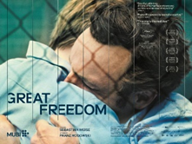 March 18 – 27: !! WA State Premiere of GREAT FREEDOM (Grosse Freiheit)!! -
the latest film from Austrian writer-director Sebastian Meise, featuring German shooting star Franz Rogowski and Berlinale Silver Bear Awardee Georg Friedrich in the leading roles.
The film paints a stirring portrait of gay resistance and resilience in post-war Germany. It is Austria’s official submission to the 2022 Academy Awards​. The film was released in the US just a few days ago and will be shown in-person at the Northwest Film Forum https://nwfilmforum.org/ between March 18-27.
The Co-Sponsors of this showing, Goethe Pop Up Seattle, is offering a special discount to members of the Austrian Community. They can use the discount code GoetheFr33dom to purchase $7 tickets as guests of Goethe Pop Up Seattle.

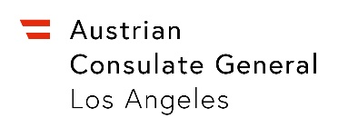 April 11-14: Visit of Consul General of Austria in Los Angeles, Dr. Michael Postl and Austria’s Trade Commissioner Volker Ammann from Advantage Austria Los Angeles will be visiting Seattle. If you or your company/employer are interested in a meeting with our honored guests, please contact Eva Kammel office@austrianconsulateseattle.org. A social get-together is in the planning. Details TBD.

!!! VOLUNTEERS FOR AUSTRIA TABLE ARE NEEDED!!!
The annual International Children’s Friendship Festival is back in person! April 23, 2022; 11:am - 6pm; Fisher Pavilion, Seattle Center. http://childrensfest.tacawa.org/about-us/. Creating opportunities for young people to experience different cultures at an early age through music, folklore, art, and cultural displays.
In the past we participated with a “Cultural Table”, an opportunity to showcase Austria’s culture with a display table and young people of the Austrian community presenting as “ambassadors”. Please contact Eva Kammel (office@austrianconsulateseattle) if you have ideas for this event and/or you and your child(ren)/grandchild would be interested in volunteering. It is a fun way to connect and present our homeland!
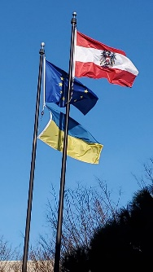 There are many ways to help the battled people in the Ukraine. Here is a list of possibilities to contribute to efforts from Austrian organizations which are coordinating help for Ukraine: https://www.derstandard.at/story/2000133660733/wie-man-menschen-aus-der-ukraine-jetzt-helfen-kann . The Austria Club of WA is working on the set-up of fundraising efforts also here in WA. Please stay tuned for further details.
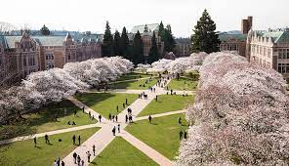 Finally, after 2 years, the University of Washington welcomes the community and visitors to enjoy the iconic Quad cherry blossoms this spring.
Don't miss the beautiful sign of spring at the UW Campus for the next 2 weeks!

Mit herzlichen Grüβen
Eva Kammel
Honorary Consul of Austria in Seattle
office@austrianconsulateseattle.org | www.austrianconsulateseattle.org

