HC Seattle Newsletter January 2020 – Final

Dear Friends of Austria!
Rain, snow, rain, … well it is January in Seattle! Let’s make the best out of it … fresh powder is waiting on the ski slopes!

NEWS FROM AND ABOUT AUSTRIA
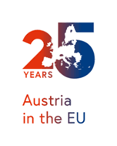 January 1, 1995: 25 years ago, Austria joined the European Union together with Finland and Sweden; these were the first countries to join the EU after the end of the cold war. Austria’s membership of the EU has been a win-win situation. Austria has benefited economically while the EU was able to look to Austria as a key strategic partner when it came to EU enlargement and matters concerning East and Central Europe. After years of EU skepticism, today a solid majority (74%) of Austrians are in favor of being a member of the EU.

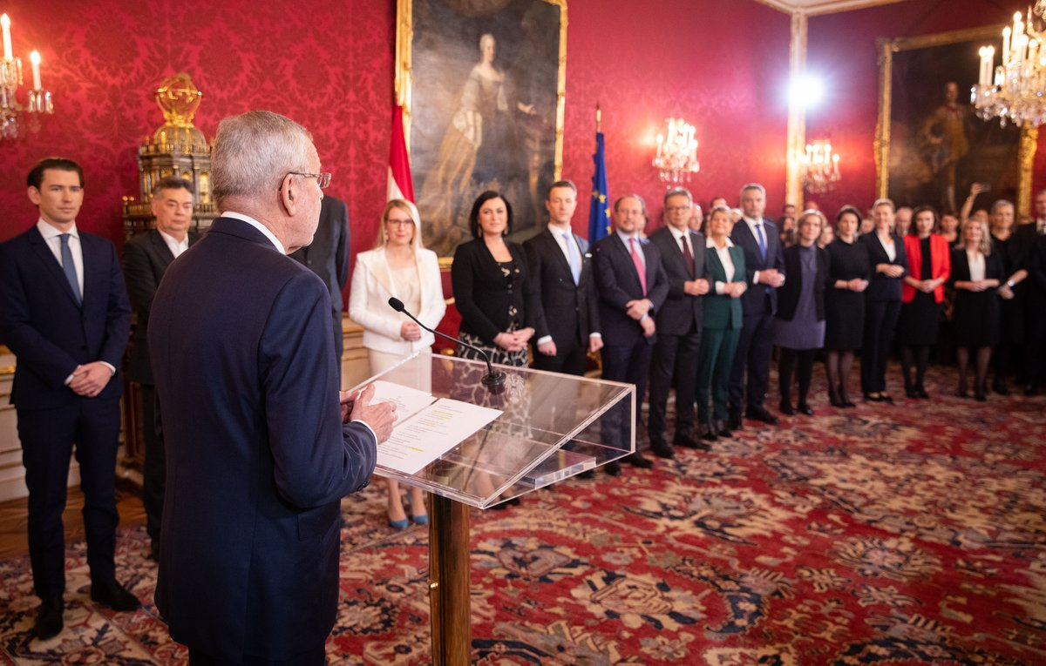 January 7: Austria has a new government!
After 7 months of the well-respected Interim Government under the leadership of Brigitte Bierlein, on January 7, 2020, Federal President Alexander Van der Bellen swore in a new Austrian Federal Government formed by the conservative Austrian People’s Party (ÖVP) and the ecologist Green Party. He demanded a governing in the spirit of “rot-weiss-rot”. The new Government is once again led by Federal Chancellor Sebastian Kurz, who already served in this capacity from 2017 to 2019. Werner Kogler of the Green Party was appointed Vice-Chancellor. Alexander Schallenberg was reappointed Federal Minister for Europe, Integration and Foreign Affairs. This is the first time the Conservative Party ÖVP and the Green Party are working together in a coalition. The hopes and expectations for this constellation are high and the Austrian public is expecting a forward-thinking government confronting the most pressing issues including the economic and environmental welfare of the people. It's a government of two firsts: 1st conservative-green coalition and 1st time women as a majority among cabinet ministers!
For a list of ministers: https://www.bundeskanzleramt.gv.at/en/federal-chancellery/the-austrian-federal-government/ministers.html

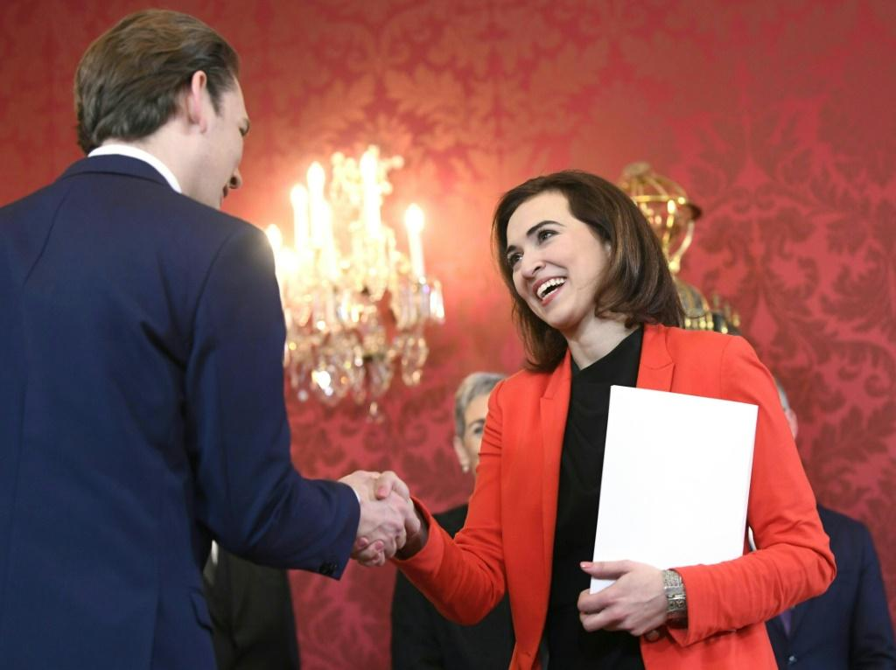 What sounds like a ‘typical American success story' just happened in Austria: As a 10-year-old, Alma Zadic fled the Bosnian War with her parents and settled in Vienna. Now, at 35, she became Austria’s Minister of Justice!
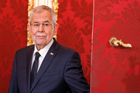 January 2020: Polling shows that 75% of the Austrian voters are satisfied with President Alexander VanDeBellen. This is a remarkable improvement after the very divisive elections in 2016. Especially his handling of the “Ibiza” crisis and the fall-out thereof was very well received.
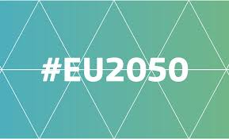 January 15: A major investment program of about a trillion EURO over the next 10 years was decided on by the EU-commission making Europe’s economy more environmentally friendly. It will provide support for regions that suffer most by climate change and/or switch to carbon neutral energy sources, including coal regions, to support career switched and attract new “green” companies. EU’s goal is to become the first Carbon Neutral continent by 2050.
The new conservative-green Austrian government has set itself ambitious environmental goals - has vowed to make Austria a front-runner in climate protection by beating the EU-wide target of carbon neutrality by 10 years, in 2040.

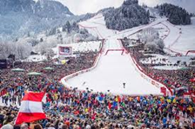 January 25: At the 80th anniversary of the Hahnenkamm race in Kitzbühel the Austrian Ski Team can celebrate a double victory at the most exciting, dangerous and thrilling alpine downhill in the world: Matthias Mayer won just 0.22 sec before Vincent Kriechmayer who shared 2nd place with the Swiss Beat Fenz.

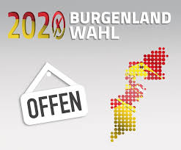 January 26: State Election in Burgenland: SPÖ (social democratic, 50%, +8%) achieved the absolute majority, ÖVP (conservative, 31%, + 1.5%) and Green party (7%, + 0.3%) also gained votes, FPÖ (right wing, 10%, -5%) lost considerably. The other parties did not meet the threshold to enter parliament.

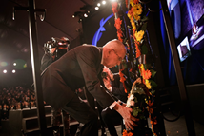 January 27: 75 years of Liberation of Auschwitz: together with over 150 heads of states Austria’s President VanDerBellen participated in Jerusalem in the celebration at the 5th World Holocaust Forum 2020: “the message is simple and clear: there is no place for Antisemitism in our global society. Remembering the Holocaust, Fighting Antisemitism. Together.”
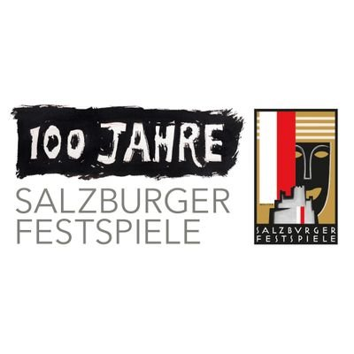Preparations are already in high gear for the 100-year celebration of the Salzburg Music Festival. The NY Times ranked Salzburg as the 8th out of 52 best places to visit in 2020. https://www.nytimes.com/interactive/2020/travel/places-to-visit.html

Meet the newest members of circular economy, the Pinzgauer goats, who are busy eating through Vienna's Christmas trees that are being collected and recycled. Well, they could not devour all 160,000 Christmas trees collected, the rest got used for thermal energy production.

Allegedly the invention of the „bagel“ dates back to 1683 in Vienna when it was created in honor of Polish King Jan III. Sobieski, who was crucial in the defeat of the Turkish invasion of Vienna. He was a horse lover: „Steigbügel -> Bügel -> bagel. Eastern European Jewish immigrants introduced this bakery to the USA at the end of the 19th century.

Seattle based Composer Miguel del Aguila who studied and spent many years in Vienna was named the 2020 Composer in Residence with the Orchestra of the Americas with performances of his works The Fall of Cuzco and Conga-Line in Hell. The Orchestra of the Americas is a Pan-American symphony of top musicians representing 25+ countries in the Western Hemisphere and ranks among the most competitive music platforms in the world. Congratulations to Miguel!!

Weltbund and Austrians in Oregon
The Oregon Austrian American Society under its President Egbert Kunrath wants to foster closer relationships among Austrian organizations in the USA. This is a great opportunity to exchange ideas and cooperate with the Oregon-Austrian community! Any ideas? Mr. Kunrath (egbert.kunrath@gmail.com) is also the representative of North America at the “Weltbund”, the organization for all Austrians living abroad. In this capacity he is working on improving the process for dual citizenship, e-voting for Austrians abroad, establishing a representative of the “10th Bundesland” in the Parliament, among others. This year’s annual meeting of the Weltbund will take place in Vienna from 27. – 30. Aug, 2020. The Weltbund is issuing the magazine “Rot-Weiss-Rot” 3x/year featuring articles interesting especially to Austrians living abroad: https://www.weltbund.at/. Do you want to receive this magazine and/or become a member, any ideas for cooperation with Oregon, etc: Please contact Rosie Mulholland at muhol@comcast.net or Eva Kammel office@austrianconsulateseattle.org .

Goethe Pop-Up Seattle: Check out their interesting ongoing program: https://www.goethe.de/ins/us/en/sta/gps.html?wt_sc=seattle

UPCOMING EVENTS:

February 8: 2-5pm: SAGA KINDERFASCHING at the SAGA School 11010 Greenwood Ave N, Seattle. A costume Party for children of all ages with music, games, crafts, food, drink, and magician! Everyone is welcomed! Questions? Email info@sagaschool.org or call 206-442-2023. RSVP at https://docs.google.com/forms/d/e/1FAIpQLSeqSbF9pRVDQUUWZd5B56tals5V6FrJehpxsVCqcr4kXYTg7g/viewform

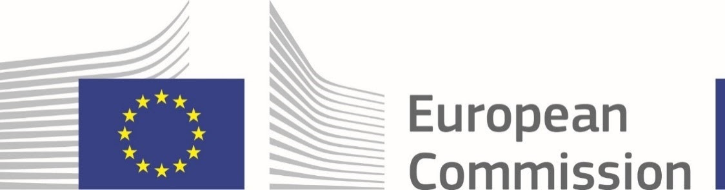February 13: DESTINATION EUROPE - Research and funding opportunities in the European Union from leading recruiters, experts, and the E.U. Delegation to the U.S.﻿
University of Washington - HUB Lyceum (Room 160)
Destination Europe features presentations by recruiters and experts on opportunities for all areas of research, including the hard sciences, engineering, humanities, social sciences, government, business, etc. ﻿﻿The opportunities to be presented at Destination Europe are open to all nationalities, not just Europeans. Simone Poetscher, Program Director of OSTA (Office of Science and Technology Austria) from the Embassy of Austria will present information on research opportunities in Austria.
For more information and registration:
https://jsis.washington.edu/euwesteurope/destination-europe-research-and-innovation-opportunities-in-the-european-union/

February 27 to March 8: Children's Film Festival Seattle at Northwest Film Forum, including a fantastic German feature film as well as an entire program of German-language short films. The director of the feature film, Rocca Changes the World, in attendance! https://nwfilmforum.org/festivals/childrens-film-festival-seattle-2020/

and finally…..
February 29, 2020: 20th Viennese Ball in Seattle!!
This cherished tradition from Vienna to let music be a tool of diplomacy, to bring people together, and to forget the problems surrounding us for a couple of hours, dates back over 200 years.
The annual social highlight held at the Nile Country Club in Mountlake Terrace and organized by the Austria Club of WA (www.austriaclubwa.com), offers an elegant evening including delicious dinner, dance and artistic performances, polonaise, quadrille, and of course dancing to live music until midnight! Do you want to brush up on your dance steps? A complimentary dance lesson is included, led by the USA Dance Team, from 4-5 pm just before the event.
Again this year, the City of Vienna is sponsoring the event and provides traditional “Damenspenden” (gift for the ladies) with a special greeting from Vienna’s Major Michael Ludwig:
"The Viennese Ball in Seattle is a special salute from the City of Vienna to a vibrant city of culture we entertain close friendly relations with. I wish the organizers of the ball every success and I hope the guests will enjoy an unforgettable evening dancing to the music of Viennese Waltz!"
Michael Ludwig, Mayor of Vienna
For more information see attached flyer. Tickets are available at: https://vienneseball2020.brownpapertickets.com/.

Mit herzlichen Grüßen

Eva Kammel
Honorary Consul of Austria in Seattle
office@austrianconsulateseattle.org

attachment Ball Invitation, Program preview

