2023 September Newsletter - HK Seattle
Dear Friends of Austria!
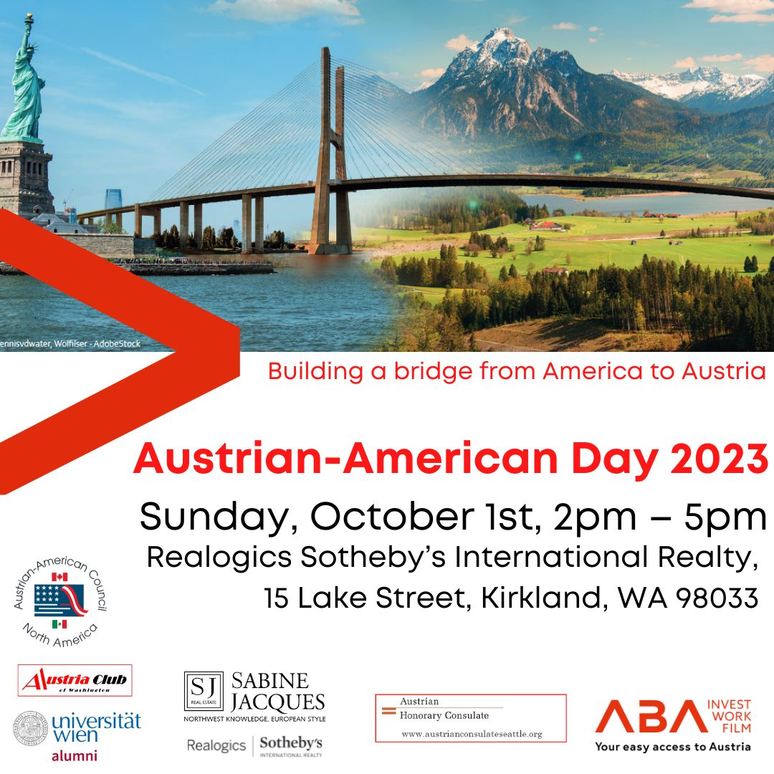
There are exciting news regarding the upcoming celebration of the Austrian American Day on Sunday, October 1, 2023:
It turned out that Austria’s Consul General from Los Angeles, Dr. Michael Postl, could clear his schedule and can join our celebration on Sunday! We are very honored by CG Postl’s commitment to serve and engage with the Austrian community. This time his wife Fariba can join him. We are happy to welcome them both to Seattle!
Attached is the invitation with more details. Please RSVP to Eva Kammel office@austrianconsualteseattle.org or to Christina Calio christina@caliomusic.com within the next couple of days (if you have not done so yet), so that we have enough “Strudels” and wine!
Looking forward seeing many of you then.

TRAVEL TO/FROM Austria: no further Covid related restrictions are currently in place. Please check the latest updates for traveling to and from Austria at the website of the Austrian Consulate General in Los Angeles: https://www.bmeia.gv.at/en/austrian-consulate-general-los-angeles/travels-to-austria/coronavirus-covid-19-and-travel-information/

NEWS FROM AND ABOUT AUSTRIA
Hallstatt tourist overflow:
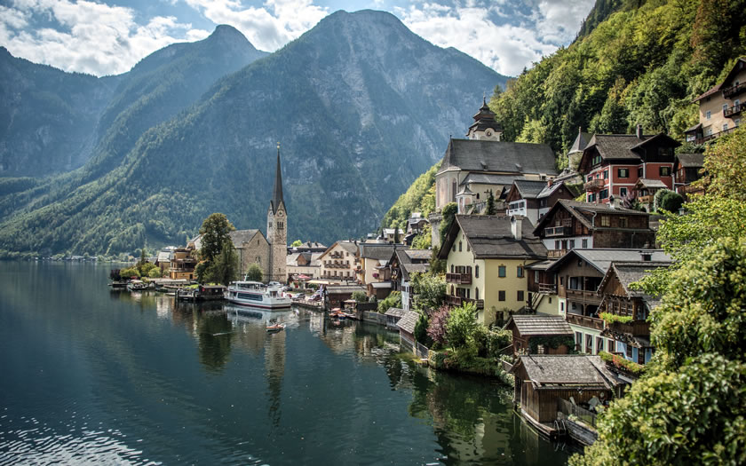
The picturesque village and UNESCO World Heritage Site in the heart of Austria, Hallstatt, has about 800 residents but hosts over 10,000 tourist per day, almost 1 million per year. The dilemma of being a famous tourist attraction because of the thousands of years long history, idyllic beauty, and stunning location, and the disturbance of the normal daily life of the residents is obvious. Regulations like reservations for busses, helped a bit but are far too little. So local residents went on strike to highlight the problems they are facing and to ask for further regulations and solutions. These are not easy to find because of the remote location, narrow streets, and very limited space available between the rocks and the bodies of water.

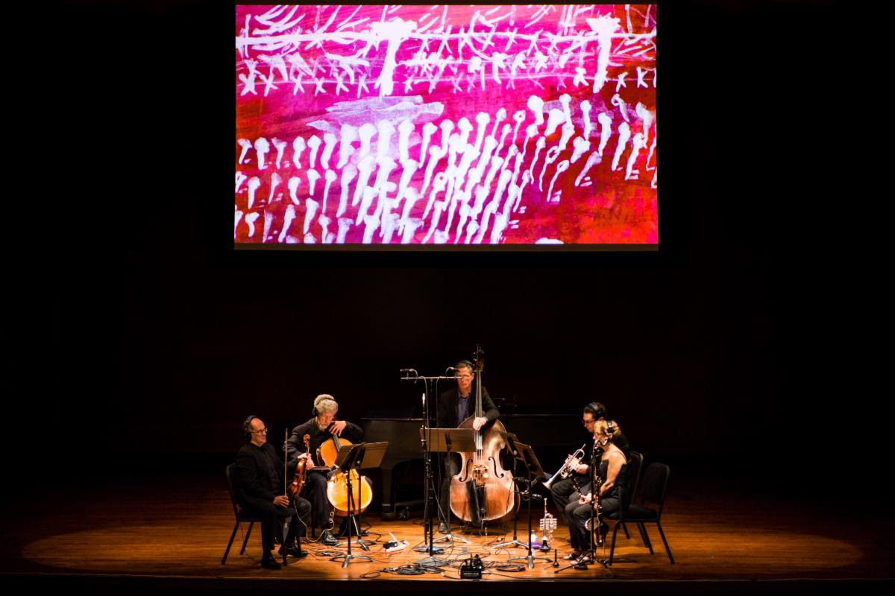
In 2017, Seattle based MOR (Music of Remembrance (mucisofremembrance.org), commissioned and premiered composer Mary Kouyoumdjian’s “to open myself, to scream”, exploring the fate of Europe’s Roma under Nazi rule. The work was inspired by the life and work of Austrian Romani artist Ceija Stojka, who survived three concentration camps to become a noted painter and writer. To conclude its major exhibition of Stojka’s work, the Austrian Cultural Center in New York has invited MOR’s Mina Miller to speak on Tuesday, September 19 as part of the closing ceremony and introduce a performance of “to open myself, to scream” by a quintet led by Austrian artist Maximilian Schweiger.
Now through September 30, MOR is offering a free streaming of its world premiere of the work. It weaves Kouyoumdjian’s powerful musical score together with piercing imagery by visual artist Kevork Mourad, derived from Stojka’s own paintings. It is an intense performance you won't soon forget. https://www.youtube.com/watch?v=4XCijqpc5bg
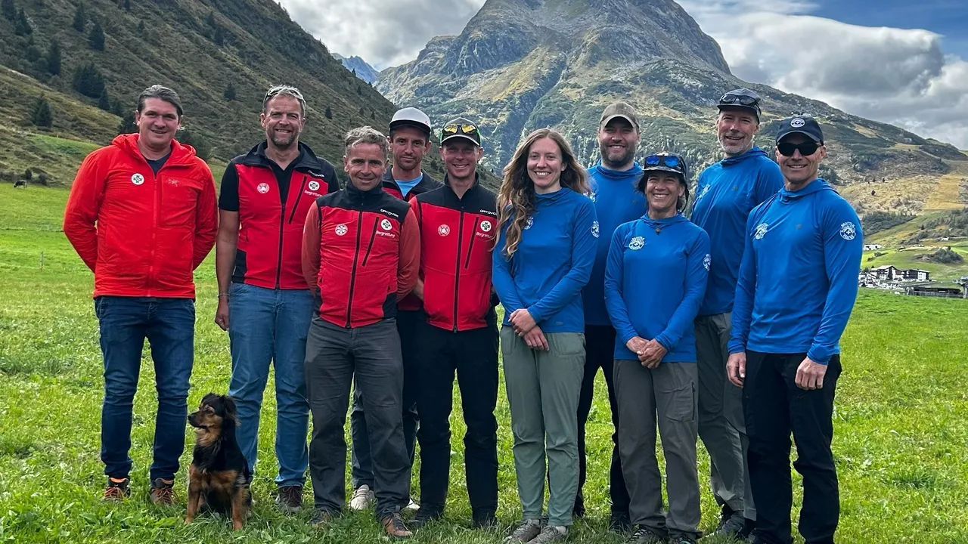
Tiroler Bergrettung -Seattle Mountain Rescue
https://tvthek.orf.at/profile/Tirol-heute/70023/Tirol-heute/14194655/Spezielle-Bergretter-Beziehung/15472996?fbclid=IwAR3yV8Rl20_TJ5dD5f-k9Dfbiqn67cKyNNPwdzr8sPa0r6Xy2DSy62Re44M
In September, 5 members of the Seattle Mountain Rescue organization visited the Tiroler Bergrettung in Jamtal. Background is the historical interesting story that shortly after WWII the foundation of the oldest US Mountain Rescue Organization was built upon the book of the Tiroler Bergrettung, “Neuzeitliche Bergrettungstechnik” by Wastl Marinier. A documentary by Mark Weiner of this fascinating exchange is in the making and should be released in 2024.
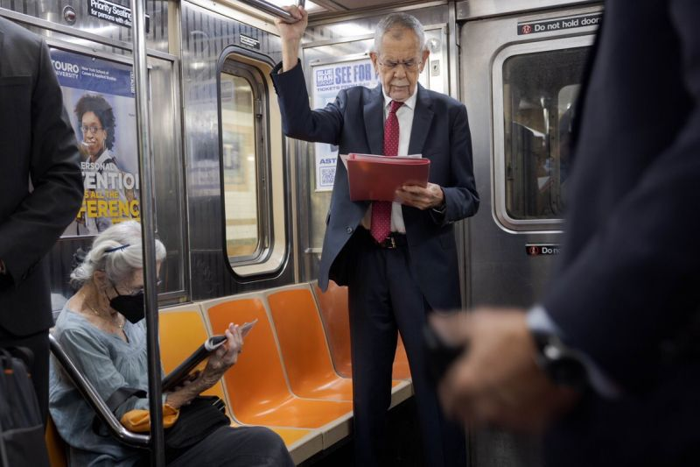
While to many world leaders were clogging up New York Midtown traffic to join the US General Assembly, Austria’s President Alexander VanDerBellen, a forceful advocate for actions against climate change, took another route…..

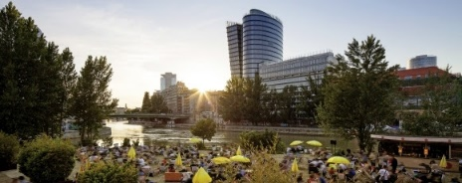 Vienna once again rated the World’s most livable City and top Conference destination according to the renowned magazines Monocle and Economist Intelligence Unit, and according to the Union of International Associations (UIA).
Vienna also makes Democracy an ongoing Habit: The coalition agreement between the two governing parties that formed the City of Vienna government in 2020, the SPÖ and NEOS (Vienna Progressive Coalition), included the goal of establishing Vienna as a model of democracy in Europe. With Vienna's application to become the European Capital of Democracy, Vienna is making a further push in this direction.
UPCOMING EVENTS
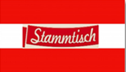 Monthly Stammtisch – 1st Thursday of the month: Mark your calendar!!
Next one: Thursday, October 5th, 7pm; at Epulo Bistro, 190 Sunset Ave, Suite B, Edmonds. Please contact Jürgen Schatzer juergenschhatzer@gmail.com for details for the upcoming one. The location is rotating throughout the greater Seattle Area. There is so much to talk and chat about!
Virtual Stammtisch for German Learners: once a month via zoom: Next meeting: on Friday, October 13, 2023 at 6:30pm. The virtual Stammtisch for German learners is an opportunity to get together, speak German, and have fun. Sabine Sullivan is a native speaker and will host the Online-Stammtisch. If you would like to attend or have any questions, please contact Sabine Sullivan: sabine.sullivan@zoho.com
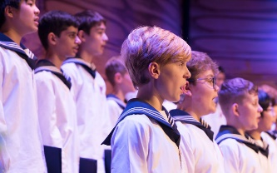 October 18: Performance of the Vienna Boys Choir at the Edmond's Center for the Arts. For tickets: https://www.edmondscenterforthearts.org/events/detail/593/vienna-boys-choir/4247

Check out the regular online film and music events organized by the Austrian Cultural Forum: https://acfdc.org/?mc_cid=487b48d54a&mc_eid=1321923619
ABC School https://www.abcgermanschool.com/ offers German Classes for infants to adult, offers preschool and after-school programs.
Please cotnact Nadja Helmer-Perry for more information: nadja@abcgermanschool.com
Please mark your calendar for following upcoming events:
Sunday, October 29, 2023; 1-4pm at the German House
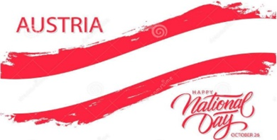
Austrian National Holiday Celebration
Welcome of newly recognized Austrians; Information about how to participate in elections in Austria (next one in 2024). Details TBD! Please contact Eva Kammel for more informaiton.
Sunday, December 3, 2023: 3-5pm/4-7pm: at the Kenmore Community Hall
Christmasmarket/Weihnachtsfeier
Christmas Market (outdoors at parking lot) from 3-5pm / Holiday Party (indoors) from 4-7pm. Please contact Michael Brandstetter michael.brandstetter@gmail.com if you can help out and contribute!

Saturday, March 2, 2023: at the Renaissance Hotel
22nd Viennese Ball
Stay tuned for more information about this very special event! Please contact Eva Donahoo, ewdcpa@comcast.net, if you have ideas and/or are interested to help!
All events are run by volunteers, many of them organized by the Austria Club of Washington. Please contact the Club’s President, Michael Brandstetter michael.brandstetter@gmail.com if you are interested in volunteering!
If I can be of assistance in any consular matters please do not hesitate to contact me at office@austrianconsulateseattle.org
Wishing you a smooth transition from the beaming summer to the darker days of the year. Enjoy the colorful outburst of nature!

Mit herzlichen Grüβen
Eva Kammel
Honorary Consul of Austria in Seattle
office@austrianconsulateseattle.org | www.austrianconsulateseattle.org

