September 2022 Newsletter - HK Seattle
Dear Friends of Austria!
Fall is here! With some nostalgia we had to say good-bye to the beautiful summer months and get back to fall routine. We still have time to enjoy the spectacle of nature presenting the changing of the colors before the wet and grey season really starts, either on a hiking trip in the mountains 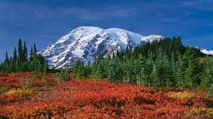 or on a walk in Seattle .
TRAVEL TO/FROM Austria:
Entering Austria: currently no Covid-19 related entry restrictions in effect.
Entering the USA: proof of full Covid-19 vaccination is required.
For detailed information: https://cms.bmeia.gv.at/index.php?id=93561&L=1&no_cache=1
For the Covid related situation within Austria: https://www.austria.info/en/service-and-facts/coronavirus-information
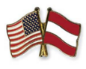Happy Austrian American Day – September 26!
The Austrian American Council West-WA Chapter, the Honorary Consulate of Austria in Seattle, and the Austria Club gathered with over 80 guests at the Holocaust Center for Humanity in Seattle, to commemorate Austrian-American Day. Austrian-American Day was established by President Bill Clinton on September 26th, 1997, to commemorate the many contributions of Americans of Austrian descent and to highlight the productive and friendly relationship between the two nations.
At this occasion we welcomed newly recognized Austrian citizens in the PNW who have received dual citizenship as a result of an ongoing effort by the Republic of Austria for reconciliation with those who suffered under the totalitarian Nazi regime, and their descendants.
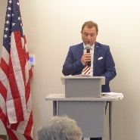 We want to especially thank Dr. Michael Postl, Consul General of the Republic of Austria who flew in from Los Angeles especially for this occasion, Lt. Governor Denny Heck for his video message, Dee Simon, CEO of the Holocaust Center for opening their doors, and for King County’s Proclamation of the Austrian American Day. Highlights were the stories we heard from survivors and their descendants; they moved us to tears but encouraged us even more to show our new fellow Austrians that we care, respect, and will never forget. Musical contributions from the Ann Rackl Quartet and Fred Mitterndorfer on his zither, champagne, coffee and all kinds of Strudels from The Little Prague Bakery comforted us. Special thanks go out to Christina Calio, Elana Sabajon, and Michael Brandstetter and to everyone who participated!
NEWS FROM AND ABOUT AUSTRIA
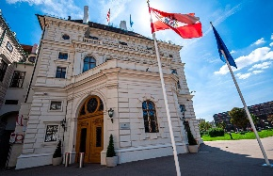 Election of Federal President, October 9, 2022:
Important: If you are registered to vote and ordered an absentee ballot (either by the 10 year Abo or for this election only) you already received the absentee ballot (white, with a list of 7 candidates) or should receive it within the next few days. Once you receive the absentee ballot, please mail it back IMMEDIATELY as the ballot must be received by your election office by October 9, 2022. The time span is very short, so an expedited mailing might become necessary.
With your absentee ballot you also received the (yellow) ballot for a potential 2nd round. If necessary, you need to fill in yourself the name of your favorite candidate for the 2nd round and mail back the second ballot immediately after October 18. The 2nd ballot must be received by your election office latest by November 6, 2022.
The mailing for both envelopes is already paid for.
The candidates:
A record number of 7 candidates, including the incumbent Prof. Alexander VanDerBellen will be on the ballot. The candidates will be listed on the ballot according to the alphabet.
In recent polls the advantage of Austria’s current President (he supports green and social liberal policies, the EU, and advocates European federalism; he appeals to the political center). His advantage to his closest competitor, the candidate of the far right party FPÖ, was over 40%. The major political parties (ÖVP, SPÖ, Die Grüne, NEOS) decided not to nominate their own candidate. Only the right wing party FPÖ and smaller independent or other far right groups put their own candidate on the ballot. 6,000 signatures and € 3,600 are required for the nomination of a candidate.
The President of Austria is elected for 6 years under the 2 round system, this means that if no candidate receives an absolute majority (i.e. more than 50%) of valid votes cast in the first round, then a second round occurs in which only those two candidates who received the greatest number of votes in the first round may stand.
Austria’s constitution grants the president the power to appoint the Chancellor and, by extension, federal cabinet ministers, Supreme Court justices, military officers, and most major bureaucrats. The president may dissolve the National Council. In practice, however, the president acts as a figurehead. During his tenure the past 6 years however, President VanDerBellen inaugurated a record number of 5 Chancellors, 67 minister, instituted 3 different administrations (Kurz 1: 2017 -2019 with the right wing FPÖ as coalision party until he had to dismiss them due to the scandals uncovered by the “Ibiza videos”. An “Expertenregierung” followed in the months until new elections made the way for Kurz 2 administration with the Green Party as coalition partner. 2021 Kurz resigned amidst corruption alligations and VanDerBellen inaugurated Karl Nehammer as new Chancellor).
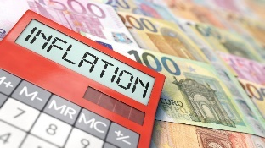 The inflation rate in Austria is about 9.3% and experts are forcasting a rise to almost 10%. Prices are rising mostly for energy, groceries and gastronomy. Prices for gas have slightly decreased but are still about 44% highter than a year ago. These increases in prices are typical for most EU countries right now. To compensate these hugh increases, the government will be subsidizing electricity costs up to a limit that should guarantee that everyone can get through the winter even with soaring energy prices to be expected. In addition, Euro 250 (Climate bonus) + Euro 250 (price increase bonus, tax free for incomes less than Euro 90,000/year) will be paid to each individual who fullfils the requirement (= registered in Austria as main residence for longer than ½ year) to help to offset the expected CO₂ taxes. Financially vulnerable groups can expect to receive additional Euro 300 from an emergency fund later this fall to offset the rising costs. With 2023, the amount of the climate bonus will be adjusted according to the public transportation availability of each region.
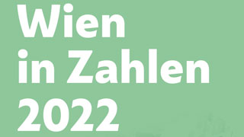 Wien in Zahlen (Vienna in numbers) 2022: Do you want to know it precisely? The annual collection of updated facts and numbers is out! Population: 1.9 Mio; an increase by 13% compared to 2021. How many international companies are registered? 225. How many dogs live in Vienna? 56,701 to be precise! And guess – how many sheep???? – 236!! For more fun and interesting facts: https://www.wien.gv.at/statistik/pdf/viennainfigures-2022.pdf
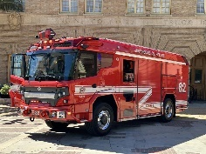 The first all electric fire truck running in the city of Los Angeles is also the first electric fire truck in North America and is – made in Austria! Austira’s company Rosenbauer Group, with HQ in Leonding in Upper Austria, was founded in 1866 and is by now one of the leading manufecturers of fire service vehicles and fire fighting equipments. The outside of the truck is still red but everything else is “green”.
UPCOMING EVENTS
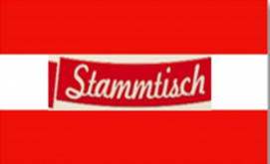 Monthly Stammtisch – Mark your calendar!!
STAMMTISCH: October 6, 2022; 7pm: Location: Tavern Hall, 505 Bellevue Square, Bellevue, WA. Join the monthly get-together with Friends of Austria. The location is rotating throughout the greater Seattle Area. There is so much to talk and chat about! Questions: please contact Jürgen Schatzer juergenschatzer@gmail.com
Virtual Stammtisch for German Learners: once a month via zoom: Next meeting: Wednesday, October 12, 2022, 7-8pm. The virtual Stammtisch for German learners is an opportunity to get together, speak German, and have fun. Sabine Sullivan is a native speaker and will host the Online-Stammtisch. If you would like to attend or have any questions, please contact Sabine Sullivan: sabine.sullivan@zoho.com .
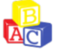ABC School in Bellevue Bilingual Kindergarten Class of 2023/24 – Open House: October 15; 10-12 noon
Offering this fall: Mini-me German Class for children 6-24 months; afterschool German classes for ages 5-14; evening Germen classes for adults; new preschool class Tues/Th ages 2-4 years.
For mor info: www.ABCGermanSchool.com or principal Nadja Perry: Nadja@abcgermanschool.com

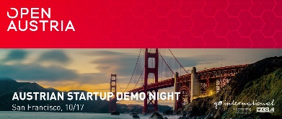 Open Austria – Austrian Start-up Demo Night, San Francisco October 17, 2022.
For more information: https://mailchi.mp/open-austria/open-austria-october-2019-newsletter-9280487?e=ff9eed866c

Saturday, October 29, 2022: 6 – 11pm: Kenmore Community Center
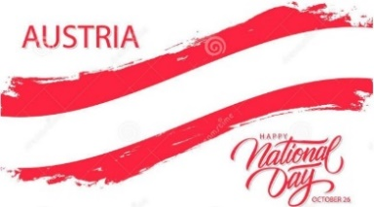 & 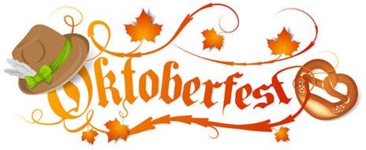
By combining the celebration of Austria’s National Holiday with the tradition of thanking for the harvest we aim for a social gathering filled with music, food, dancing, and making new and connecting with old friends! We hope you can join! For more information, please see attached invitation or contact Michael Brandstetter (President of the Austria Club of WA): michael.brandstetter@gmail.com

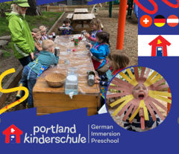 Portland Kinderschule: www.portlandkinderschule.com, a co-operative preschool offering a complete German language immersion for children 3-5 years of age. A few remaining spots are still open! For more info please contact directly: info@portlandkinder.com
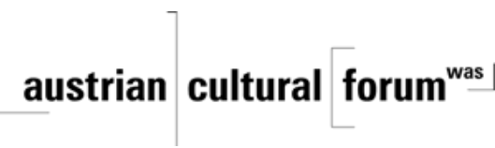 Check out the regular online film and music events organized by the Austrian Cultural Forum: https://acfdc.org/?mc_cid=487b48d54a&mc_eid=1321923619
Looking forward to seeing many of you at the next event on Saturday, October 29, 2022.
As always, if I can be of assistance in any consular matters please contact me at office@austrianconsualteseattle.org.

Liebe Gruesse und auf ein baldiges Wiedersehen
Eva Kammel
Honorary Consul of Austria in Seattle
office@austrianconsulateseattle.org | www.austrianconsulateseattle.org

