2023 November Newsletter - HK Seattle
Dear Friends of Austria!
Happy Thanksgiving!!
The Holiday Season continues with the start of Advent in just a couple of days. And the best way to celebrate the Season is getting together with friends:
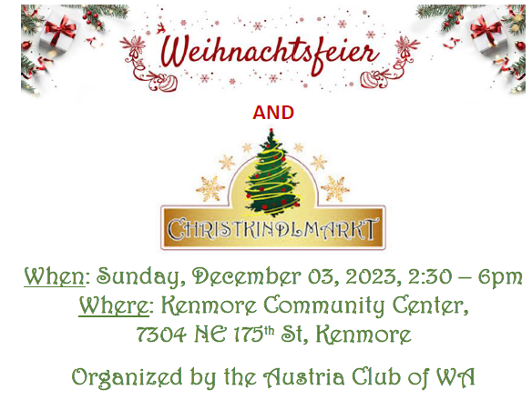
For more information, please see attached Invitation!
TRAVEL TO/FROM Austria: no further Covid related restrictions are currently in place
Please check the latest updates for traveling to and from Austria at the website of the Austrian Consulate General in Los Angeles: https://www.bmeia.gv.at/en/austrian-consulate-general-los-angeles/travels-to-austria/coronavirus-covid-19-and-travel-information/
For Austrian citizens living abroad: Please register - if you have not done so already:
- register as an Austrian living abroad
- register to vote
You can do this ANYTIME! Forms, fill-in help etc are posted on the Website of the HC Seattle: www.austrianconsulateseattle.org and on the website of the Consulate General of Austria in Los Angeles: www.austria-la.org

NEWS FROM AND ABOUT AUSTRIA
Novmeber 1: 31 Austrian citizens could leave the Gaza Strip togther with about 500 other foreign citizens and 80 severely wounded Palestinians.
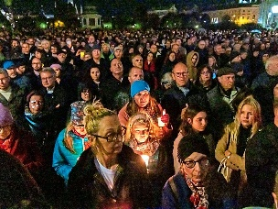 November 2: peaceful Candlelight Demonstration in Vienna, Heldenplatz; about 20,000 participants, demonstrating for the release of all hostages and setting a sign against antisemitism, terror, brutality, and hate, but for freedom, democracy and protecting human rights. Speakers were among others were president of the “Isralelitische Kultusgemeinde”, designated ambassador of Israel to Austria, 3 relatives of hostages, and representatives of the government.
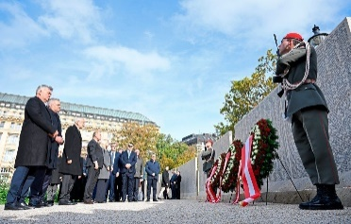November 9: Highest level of government representatives together with Austria’s President participated in a commemoration of the fateful “Kristallnacht” (November pogrom) 85 years ago.

November 18: The opening of the 23/24 ski season with a World Cup Slalom in Gurgl, Tyrol, turned into a triple success of Austrian skiers Manuel Fellner, Marco Schwarz and Michael Matt. The event was also used by activists to highlight the unsolved and dangerous climate change related problems facing our planet.
November 23: 14 Christkindlmarkets with 777 booths are opening for the advent season in Vienna, the most in any European city. Besides “Glűhwein” and punsch, cotton candy and gingerbread cookies, arts and crafts, candles and ornaments are offered in a festive holiday spirit.
Austria is gearing up for the 200th anniversary celebrations in 2024 for Anton Bruckner, the Music Virtuoso of the 19th Century. Anton Bruckner (1824 – 1896) is widely regarded as one of the most influential composers of his time. Yet, during his lifetime, his musical works were rather ambivalently received. His talent as an organist was recognized early on. His symphonies, however, initially received an unenthusiastic reception, especially from Vienna's cultural elites. Anton Bruckner's reputation was a stubborn, eccentric loner from the countryside who didn't fit into high society. Only in old age did he finally receive the respect and admiration of his contemporaries. In a prelude to the upcoming festivities, “The New Yorker” took a look at his life and musical legacy: https://www.newyorker.com/sponsored/story/learning-to-hear-the-sound-of-bruckners-austria
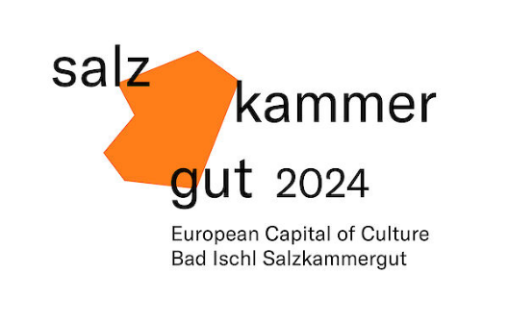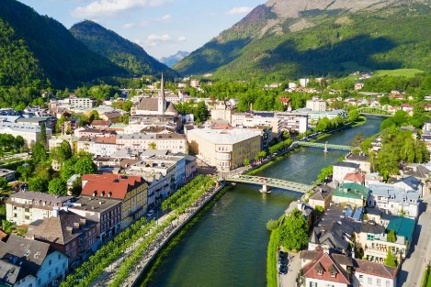 Bad Ischl and Salzkammergut: European Capital of Culture 2024 : Bad Ischl is a town that is lovable as it is livable. Imperial City, spa city and now also banner city for the Capital of Culture 2024! For the first time in the history of the program, the title was awarded to an inner Alpine region and a rural area. The city is now busy organizing events and getting ready to showcase its beautful setting and long tradition and history: https://www.salzkammergut-2024.at/
Book recommendation:
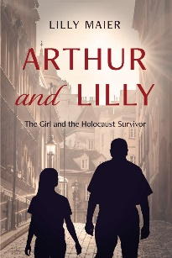 Author and historian Lilly Maier is currently on a US book tour to present her book, Arthur and Lilly. The Girl and the Holocaust Survivor. Arthur and Lilly – The Girl and the Holocaust Survivor. The book details the impact one encounter had on the lives of two people, shaping their outlooks on the past and their paths into the future. The story is based on the author’s real-life meeting and friendship with Arthur Kern, a survivor. Arthur managed to flee from Austria in 1939 and settled in the USA. 65 years later, Arthur knocks on the door of the apartment he used to live in as a boy in Vienna and meets eleven-year-old Lilly. It is a moving tale of two lives that fatefully cross paths, and an immensely knowledgeable insight into the Kindertransporte that rescued hundreds of Jewish children.
UPCOMING EVENTS
German Language School Seattle: https://www.germanlanguageschool.org/
Christmas Indoor Nikolaus Market: December 9, 2023; 2pm – 5pm. For more Information: Brigitte Zischke: info@germanlanguageschool.org
Check out the regular online film and music events organized by the Austrian Cultural Forum: https://acfdc.org/?mc_cid=487b48d54a&mc_eid=1321923619
Virtual Stammtisch for German Learners: once a month via zoom: Next meeting: Friday, December 8 at 6:30 pm. The virtual Stammtisch for German learners is an opportunity to get together, speak German, and have fun. Sabine Sullivan is a native speaker and will host the Online-Stammtisch. If you would like to attend or have any questions, please contact Sabine Sullivan: sabine.sullivan@zoho.com
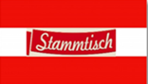Monthly Stammtisch – 1st Thursday of the month: Mark your calendar!!
Next one: Thursday, December 7, 2023; 7pm at Cactus, 121 Park Ln, Kirkland. Please contact Jürgen Schatzer juergenschhatzer@gmail.com for details for the upcoming one. The location is rotating throughout the greater Seattle Area. There is so much to talk and chat about!
Save the Date! More information about this very special event will come soon!
Mit herzlichen Grüβen und Wűnschen for a peaceful Advent time
Eva Kammel
Honorary Consul of Austria in Seattle
office@austrianconsulateseattle.org | www.austrianconsulateseattle.org

Attachment: Invitation Xmas Feier. Save the Date Viennese Ball

