2022 May Newsletter - HK Seattle

Dear Friends of Austria!
Summer is almost here! The beautiful flowering rhododendrons, azaleas, and many other colorful blossoms are brightening up our days.
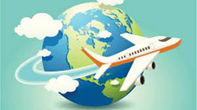 TRAVEL TO/FROM Austria:
Good news for traveling to Austria in the summer: the testing requirement for the flight to Europe got lifted, so proof of vaccination is sufficient. The testing requirement returning to the US though is NOT yet lifted, that means as of now you still need to provide a negative PCR test (max 1 day before departure) for your return flight. Beginning June, masks are no longer required in most settings in Austria. Only in the city of Vienna and in sensitive settings, like health care or with senior citizens, stricter rules are staying in place. For the newest updates please check the website of the Consulate General of Austria in Los Angeles: www.austria-la.org -> travels to Austria: https://www.bmeia.gv.at/en/austrian-consulate-general-los-angeles/travels-to-austria/coronavirus-covid-19-and-travel-information/
For the Covid related situation within Austria: https://www.austria.info/en/service-and-facts/coronavirus-information
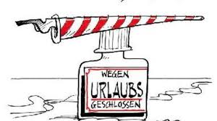The Honorary Consulate of Austria in Seattle will be temporarily closed for vactation from June 27 – Aug. 1, 2022. Please let me know ASAP if I can be of assistance in consular matters before my travels. In any case, you always can contact the Consulate General of Austria in Los Angeles for any questions or in case of emergency: www.austria-la.org.

NEWS FROM AND ABOUT AUSTRIA
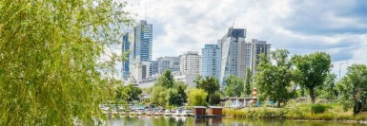 The City of Vienna is preparing fo the summer: Offering swimming lessons for children, reduced and subsidised vacation for low income families, and preparations for upcoming heat waves, including citywide “cool” spots.
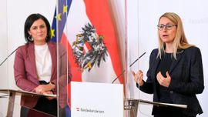 May 9: tworesignations in the government: Minister for Economy, Margarete Schramböck, who has been widely criticized, and Minister for Agriculture, Tourism and Telecommunication, Elisabeth Koestinger, who served over 12 years in politics and plans to transfer to privte business. Both politicians were recruited by and loyal to former chancellor Sebastian Kurz. They were also criticized for not using their chance to demonstrate what empowered women can achieve.
This change in government gives Chancellor Nehammer the chance to further restructure the responsibilities and build the government according to his vision. New Minister for Economy and Labor is Martin Kocher and the new Minister for Agriculture is Norbert Totschnig.
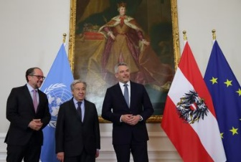 May 11: UN Secretary General Antonio Guterres visits Vienna to lead the highest meeting of the UN system. For this occasion negotiations about assistance to Ukraine and efforts to end this brutal war were the main focus. Guterres emphasized that assistance must also be provided to neighboring states like Moldova. The global community must also use this crisis to wean off from fossil fuel. During his time in Vienna, the Secretary General had meetings with Austria’s President, Chancellor, and other Austrian leaders.
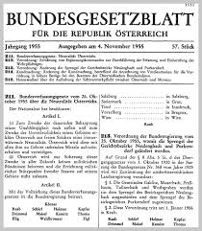After Sweden’s and Finland's move to apply for Nato’s membership and dropped their neutrality clause, Austria’s Neutrality is again in discussion. Now besides Austria, only Switzerland and Ireland remain neutral countries in Europe. As documented in the Bundesgesetz Oct. 26, 1955 about Neutrality in Austria, Austria is bound to neutrality by the 1955 Austrian State Treaty and its constitution, which prohibits entry into military alliances and the establishment of foreign military bases on Austrian territory. Austrian neutrality is actually an enforced neutrality. The territory of Austria was occupied by allied forces until 1955. In 1955 the Soviet Union, in the Moscow memorandum, demanded Austria's neutrality on the model of Switzerland and expressed acceptance for pledges by the four powers to the integrity and inviolability of Austrian territory. All of the countries with which Austria had diplomatic relations ratified the Austrian State Treaty. The question remains, is it enough to commit that Austria's military neutrality does not mean moral neutrality? For further readings on this topic: https://www.derstandard.at/story/2000135919854/neutralitaet-der-lange-weg-zum-kurzen-abschied or
https://www.dw.com/en/will-austria-abandon-neutrality-to-join-nato/a-61880804.

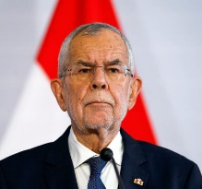 May 22: Austria’s President Alexander VanDerBellen declares his candidacy for a 2nd term for the Presidency. During his tenure he could guide the Republic also in turbulent times with calm and well thought through actions. His approval ratings are high and he is expected to win easily at the election in late fall 2022. More information about participating in these elections will be provided soon.
UPCOMING EVENTS
and 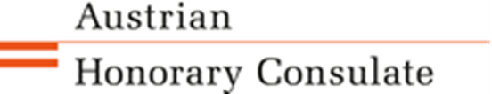 invite to an informal Austrian Businesses/Professionals Networking Evening : Wednesday, June 15, 6pm, at the Rheinhaus - Bocce Den; 912 12th Ave, Seattle: On the occasion of the visit of Ute Stadlbauer, regional director of the Vienna Business Agency https://viennabusinessagency.at/ we invite you to join, meet fellow Austrians, exchange your business and professional experiences, and learn how the VBA can support your professional efforts. Playing Bocce is included! Please RSVP to office@austrianconsulateseattle.org.
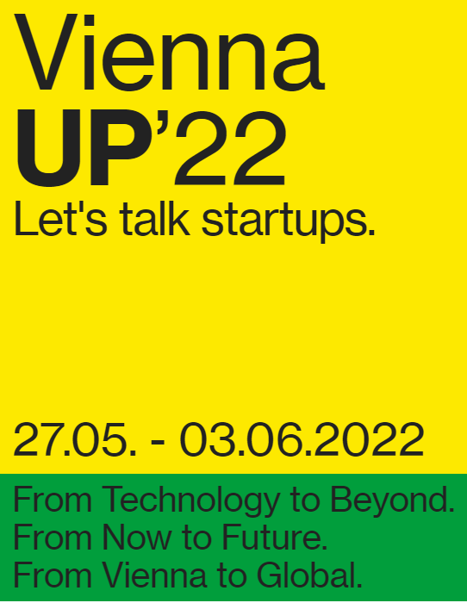ViennaUP’22: May 27 – June 3, 2022: Let’s talk startups! https://viennaup.com/ Business festival ViennaUP’22 places Vienna firmly at the center of the international startup world, connecting thousands of people from over forty different countries to discuss issues of the future in a spirit of cooperation, in person in Vienna or online from around the world.
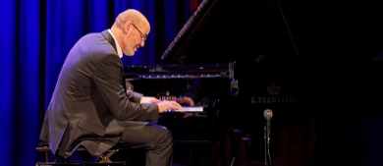 Monday, June 6: 7pm at the German House: Piano concert with Boogie Woogie pianist Frank Muschalle from Berlin, hosted by the Honorary German Consulate and the Goethe Pop Up.
More info and the free ticket reservation link on the Goethe Pop Up website: https://www.goethe.de/ins/us/en/sta/gps/ver.cfm?event_id=22949112
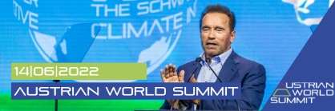 June 14, 2022: Austrian World Summit 2022 Climate Action: "Creating Hope - Inspiring Action" - is this year's theme of the Austrian World Summit, an hybrid event. Host Arnold Schwarzenegger will once again bring inspiring climate action heroes from all around the world on stage for exciting panels on topics like digitalization, climate communication and many more. Visit the Austrian World Summit event homepage. You have the possibility to watch the livestream, join in on the discussions and arrange targeted 1:1 meetings to generate new business contacts. Be part of our international community and register now! Participation is free of charge!

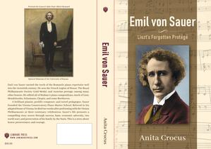 Anita Crocus, one of our friends of Austria, finished writing an intriguing biography of the German pianist “Emil von Sauer, Liszt’s Forgotten Protégé”. https://www.kirkusreviews.com/book-reviews/anita-crocus/emil-von-sauer-liszts-forgotten-protege/. He was one of the most distinguished pianists of his generation and was also the founder of the Vienna Conservatory Master Piano School. He lived in Vienna from 1901 until his death in 1942. For more information about this publication please contact Anita directly: acrocus@comcast.net
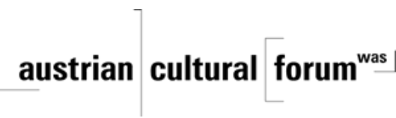 Check out the regular online film and music events organized by the Austrian Cultural Forum: https://acfdc.org/?mc_cid=487b48d54a&mc_eid=1321923619

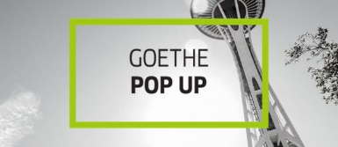 Regular events are offered by the Goethe Pop Up Seattle, ranging from book club, Summer camps, movies, and literature presentations: https://www.goethe.de/ins/us/en/sta/gps.html
https://www.goethe.de/ins/us/en/new/sea/mai.html

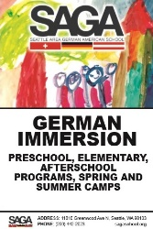 SAGA German Immersion School in Seattle: for more information about their summer camps, enrollment, and program, please check their website: http://sagaschool.org/
Weltbund Tagung – Auslandsösterreicher Treffen: 1.-4. September 2022 in Vienna: Information and registration: https://www.weltbund.at/veranstaltungen/austria/weltbund-tagung-2022/ Registration Deadline: August 3, 2022. This annual event brings together Austrians living abroad and offers an opportunity to engage in concerns and wishes common to those living abroad, independent where in the world! After 2 years of being forced to go virtual, it can take place again in person.
Monthly Stammtisch – 1st Thursday of the month: Mark your calendar!!
Virtual STAMMTISCH: June 2, 2022, 7pm: Join a casual get-together with friends of Austria via zoom. There is so much to talk and chat about! Zoom link: https://us02web.zoom.us/j/5845087371 . Questions: please contact Juergen Schatzer juergenschatzer@gmail.com or Elana Sabajon: youcan@askelana.com
Wishing you a refreshing break surrounded by beautiful nature, seen here at the Japanese Garden in Seattle.
Mit herzlichen Grüβen
Eva Kammel
Honorary Consul of Austria in Seattle
office@austrianconsulateseattle.org | www.austrianconsulateseattle.org

