HC Newsletter May 2020
Dear Friends of Austria!
Dear Austria Club Members!
Time flies … or not? It becomes sometimes hard to remember the days when life was still “normal”! We all long for that normality but we still need to be patient, time will come when we can gather again, waltz through the night and dine out with friends. Most important though, bleibt gesund!
GENERAL INFORMATION
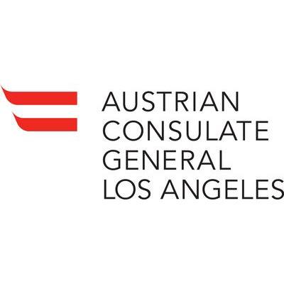Re-Start of limited Public Hours at the Consulate General of Austria in Los Angeles:
As of now the Consulate General is open again for limited services. Reservation of an appointment is absolutely necessary. If you need a new passport urgently, please reserve your spot ASAP as the demand is high. The link for the reservation, list of required documents, forms to download, etc. can be found at the website of the Consulate General: https://cms.bmeia.gv.at/gk-los-angeles/service-fuer-buergerinnen/ausweise-dokumente/reisepass/
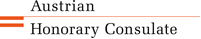 Re-Start of limited Public Hours at the Honorary Consulate of Austria in Seattle:
June 8: pending on King County’s move to next re-opening phase) : Meetings for those types of requests that were handled by the HC so far (certifications, citizenship applications, passports for minors < 12years, etc.) can be arranged. For additional precautions and modifications, please go to the HC Seattle website: www.austrianconsulateseattle.org or contact Eva Kammel (office@austrianconsulateseatle.org) for scheduling an appointment.
Limited Passport Service for Adult Passport applications will start about 2 weeks after the general re-start of the HC Seattle. A separate notification and information about this new service will go out to all once the date is confirmed.
Notification will go out once the date is confirmed.

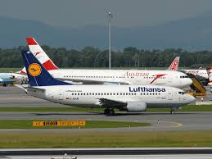 Traveling to/from Austria
For the latest updated travel information please see the website of the Consulate General in Los Angeles: https://cms.bmeia.gv.at/en/austrian-consulate-general-los-angeles/news/. Please check this website and with the airline as restrictions change frequently.
If you are an Austrian citizen, you can travel to Austria (Lufthansa is planning on flying out of Seattle June 30). But you need either a negative Covid-19 test (not older than 4 days) or get tested at the Airport Vienna – Schwechat (€ 190) or stay 2 weeks in Quarantine.
US citizens are not allowed to travel to Austria with a few exemptions, among those: If you are the spouse of an Austrian citizen: you need to verify that you are married and live in the same residence. So, bring with you your marriage certificate and some document that states your common residence.
Currently there are no visa application for Austria accepted.
Traveling to US:
You need to be an US citizen or Green Card or valid Visa holder to be able to enter the USA. Upon return you need to stay in 2 weeks quarantine. Please check the latest information as the restriction change frequently.
International Achievement Award:
The Intercultural Achievement Award (IAA) is a key project for intercultural dialogue of the Austrian Federal Ministry for European and International Affairs. The award honors successful and innovative projects in the field of intercultural dialogue, both in Austria and on a global scale. The award is open to all those who identify and make use of opportunities which positively shape intercultural coexistence. It also rewards those who successfully break new ground in intercultural dialogue, who have mastered a specific challenge through intercultural action, and who promote the dialogue of cultures and religions through their media presence. The categories are: Sustainability, Recent Events, Innovation, and Media, prizes range from $5 – 10,000; deadline for submission: June 15; For more information see attached flyers, link, or contact Simone Bliss at the Consulate General in Los Angeles: Simone.Bliss@bmeia.gv.at
https://www.bmeia.gv.at/europa-aussenpolitik/auslandskultur/dialog-der-kulturen-und-religionen/intercultural-achievement-award/

NEWS FROM AND ABOUT AUSTRIA

May 1: “United Across Nations and Generations”, Austria joins 170 other signatories in support of the appeal by UN Secretary-General Antonio Guterres on protecting our children amid Covid19. (USA did not participate).
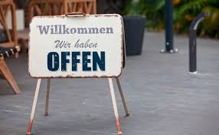 May 1: Austria is reopening: The numbers point in the right direction: only 24 new cases/day, contamination factor: 0.63, in Vienna: 0.9. Most people are following the requirement of wearing masks in shops and public transportation. Otherwise wearing of masks is recommended but not required. All shops and service providers can open following guidelines of precaution, restaurants open on May 15, hotels on May 29. Schools open in stages depending on the age with the high school seniors (Maturaklassen) first.
May 4: Initiated by the EU, United against Coronavirus, the global collection to fund research toward Covid research for a vaccine and cure, raised $8 billion from countries all over the world (USA did not participate): Austria contributes $34 mill.
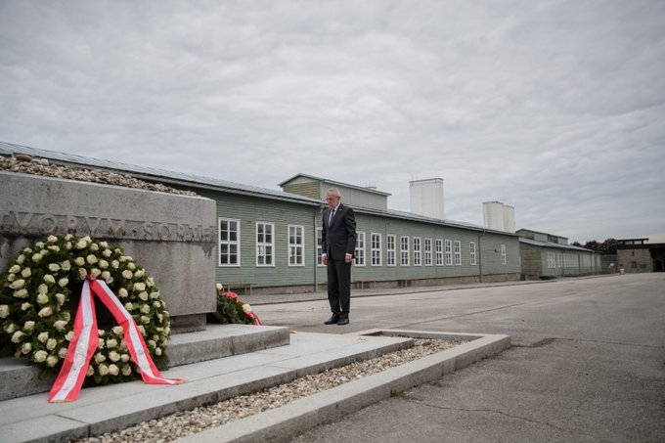 May 5: 75 ago soldiers of the US army liberated Mauthausen Concentration Camp in Austria. We remember the victims of Nazi terror and honor those who fought and sacrificed to liberate Europe. We recommit ourselves to Never Forget and reaffirm Never Again. President VanDerBellen laid a wreath en lieu of a traditional commemoration ceremony and reminded of the “open wound” in Austria’s history.
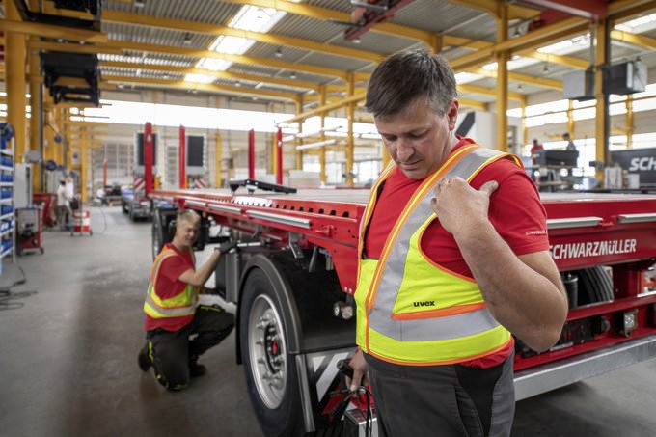 May 6: Austrians workers can go back to work putting social distancing in practice. One help to support these measures is the “smart vest” which alerts if workers are coming too close.
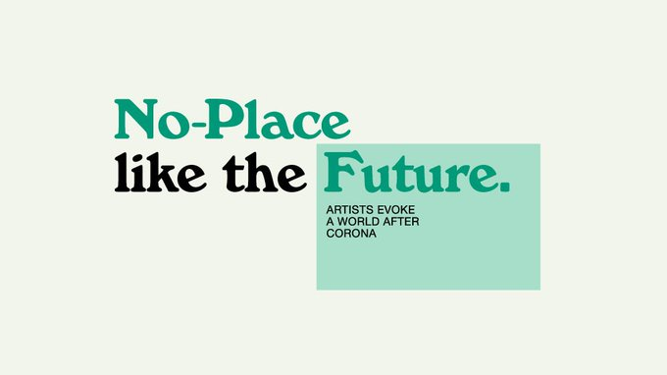 May 7: Launch of NPLF: Artists evoke a world after Corona - The Austrian Embassy and the Austrian Cultural Forum in Washington DC, the Austrian Cultural Forum in New York, the Austrian Consulate General in Los Angeles and Open Austria, Austria’s innovation office in Silicon Valley, have created this project “No-Place Like The Future” https://www.noplacelikethefuture.org/ with the aim to bring Austrian and American artists (back) together, invite them to jointly work on a new piece of art – and thereby create a brighter future for all of us.
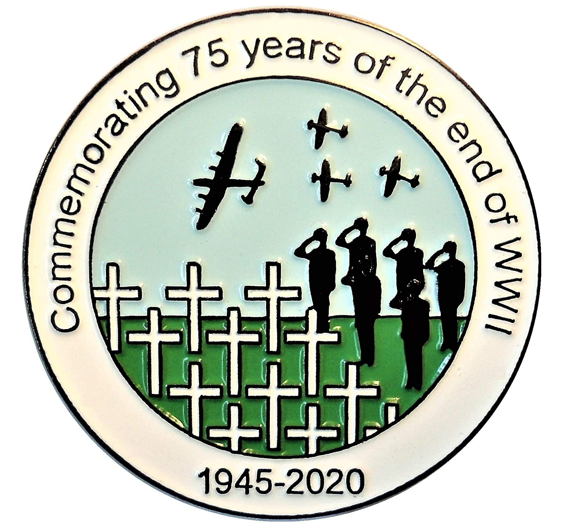 May 8: Fest der Freude (Fest of Joy): commemoration of 75 years end if WWII: President Alexander Van derBellen addressed in a video greeting the commitment to basic rights for freedom, rule of law, democracy, and solidarity. “These are the fundamental pillars of Our Austria”. Due to the Corona Crisis the festivities were moved to a virtual space.
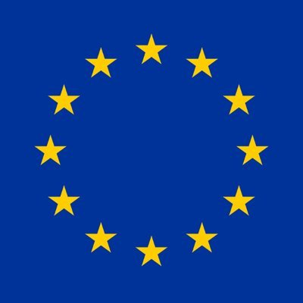 May 9: Europe Day – 70 years of the Schengen Declaration. It carries even more significance this year as we face the pandemic crisis together.
.
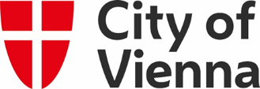 Starting May 15: Under strict regulations restaurants can open in Vienna and around the country. The City of Vienna also issues gift certificate for restaurants (€ 25-50) to spur the interest in dining out again (valid after June 15).
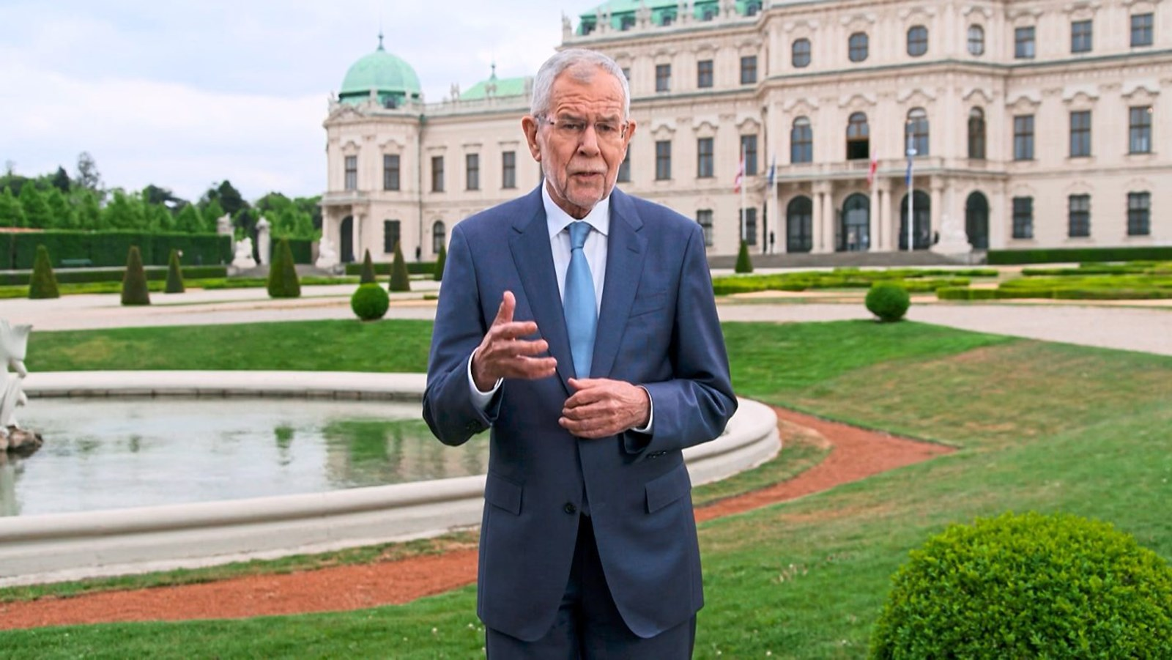 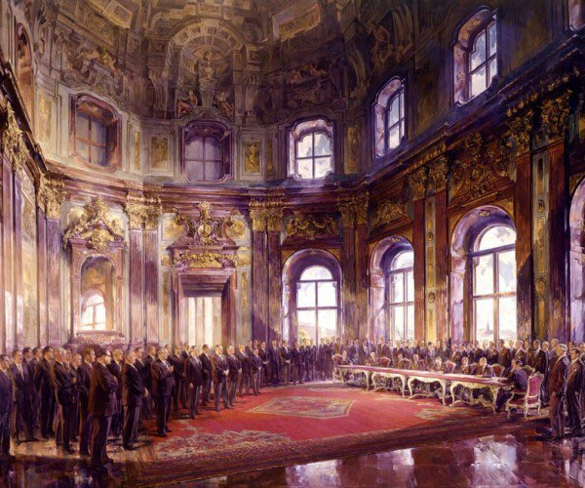 May 15: commemoration of 65 years of Declaration Austria’s Independence (Staatsvertrag) signed at the Schloss Belvedere in 1955. Austria’s President Alexander VanDerBellen remided that "Mit diesem Leben in Freiheit, in einer liberalen Demokratie, müssen wir verantwortungsvoll umgehen." (we have to protect carefully our lives in freedom in a liberal democracy)

UPCOMING EVENTS
Kabarettabend: Lachen ist die beste Medizin: Humor is the best medicine:
Thanks to the Austrian American Society of OR, we in WA can also enjoy an evening of humor. Get acquainted or reacquainted with Michael Niavarani, Viktor Gernot, Monika Gruber, Alfred Dorfer, Die Hektiker, Wir sind Kaiser and much more. The whole playlist is about 1.5h long and you can watch at your preferred time, several times or take a break in between, or watch it together with friends at the “Virtual Stammtisch” (see below).
Link: https://www.youtube.com/playlist?list=PLvk2Ir11cyldmb9yiQOu6dDuokJ7qqGmV
Thanks AAS Oregon! Great cooperation! Have fun watching!
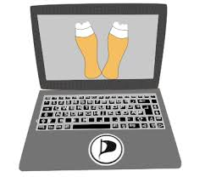June 12, 7pm: come and join the Österreicher -Austrian Gruppe – virtual Stammtisch: let’s talk about the Kabarett playlist, watch together, and have fun. Get Info and zoom link for the Stammtisch meeting from Elana Sabajon: youcan@askelana.com, or from Jürgen Schatzer: Juergen.schatzer@gmail.com . Hope to “see” many of you there!
Something to look forward to:
The 20th Viennese Ball, which was the last social gathering we could enjoy in February, seems like it happened a century ago! Even more so we cherish the fact that we had the opportunity to celebrate this joyful evening together. And that feeling inspired the Ball committee under Eva Donahoo to already start planning for the 21st Viennese Ball, in 2021. As soon as the date is confirmed, “Save the Date” - let us think positively!
Herzlichst,
Eva Kammel
Attachments: Intercultural Achievement Award flyer and info

