June 023 Newsletter - HK Seattle
Dear Friends of Austria!
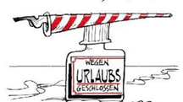Wegen Urlaubs geschlossen: Closed for vacation from June 18 - July 6, 2023, and then again from August 1 – August 28, 2023. Please contact the Honorary Consulate of Austria in Seattle for July appointments! office@austrianconsulateseattle.org.

TRAVEL TO/FROM Austria: no further Covid related restrictions are currently in place.
Please check the latest updates for traveling to and from Austria at the website of the Austrian Consulate General in Los Angeles: https://www.bmeia.gv.at/en/austrian-consulate-general-los-angeles/travels-to-austria/coronavirus-covid-19-and-travel-information/
For the Covid related situation within Austria: https://www.austria.info/en/service-and-facts/coronavirus-information
NEWS FROM AND ABOUT AUSTRIA
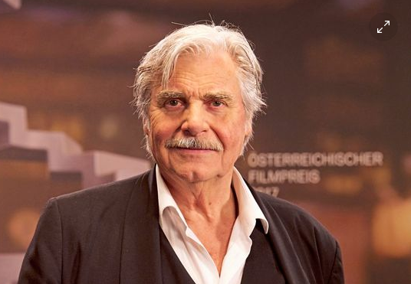 May 30: Well known actor at the Vienna Burgtheater, Peter Simonischek, 76, native of Graz, passed away after a severe illness. He starred in the movie “Toni Erdmann” (“European Actor 2016 Award), played the “Jedermann” at the Salzburg Festival, and toured with his wife Brigitte Karner, who was named “Actress of the Year”. He also played in several successful movies and TV series, e.g. “Herrenjahre”, Fürchten und Liebe”, “Gebürtig”, and many others. For his performance as Afzal in “The Who and the What” he earned the “Best Actor” award.
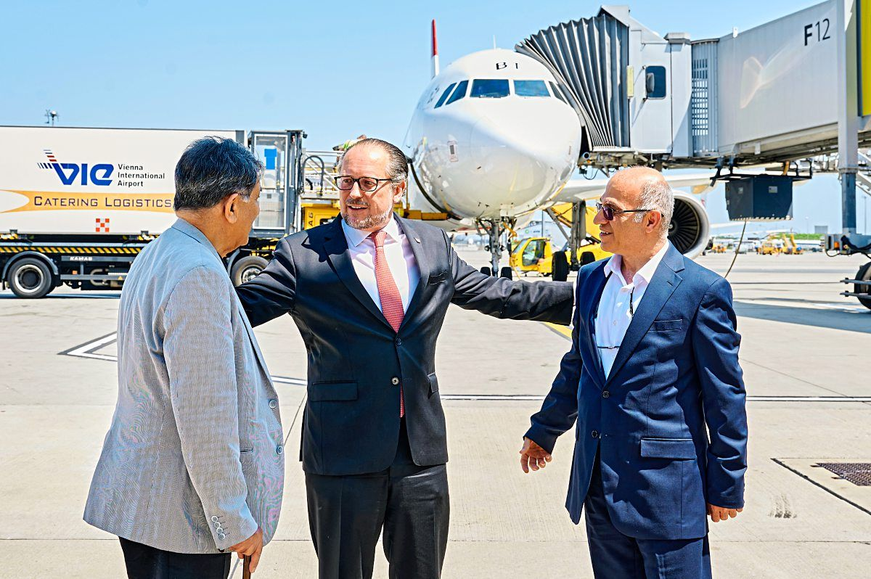 June 2: Two Austrian-Iranian and a Danish citizen who where unjustified held in Iranian detention for many years on accusations of espionage, were finally freed after long, secret and intense negotiations of Austrian negotiators and other EU officials. Foreign Minister Schallenberg welcomed them at the Vienna airport.
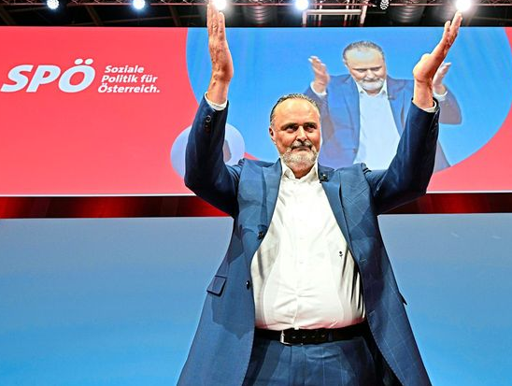 on June 3 and 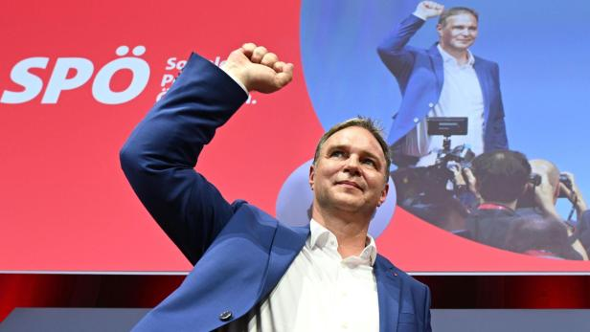 on June 5: the socialdemocratic party in Austria SPÖ has a new leader after a chaotic period of confusion: at the party convention on June 3, the rather centrist and pragmatic Governor of Burgenland, Hans Peter Doskozil, got elected by 53% as chair against the more idealistic and passionate Andreas Babler. But after the final check on the counted votes a severe mistake was detected and the results were just the opposite: now Andreas Barbler is the confirmed new chair of the social democratic party. His task, especially after this chaotic nomination process, will be an especially difficult one, not only to unify the party but also to convince the electorate about the party’s policy program and leadership capabilities. At his first TV and news conference appearances, Andreas Barbler appeared passionate, well informed, and polite in his conversations.
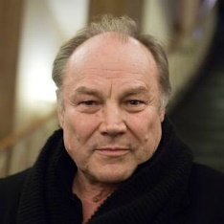 June 22: Klaus Maria Brandauer from Altaussee celebrates his 80th Birthday. This famous and very well known actor, director, professor at the Max Reinhardt Seminar, is still performing on the stage of the Burgtheater since 50 years, played leading roles in many movies (e.g. “Jenseits in Afrika”, “Mephisto”, “Never say never again”, “The Russia House”).
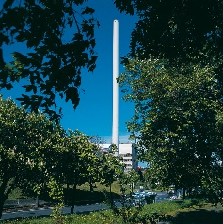 The first “Müllverbrennungsanlage” (garbage burning facility) in Vienna, Flötzersteig, was built 60 years ago and after regular updates still burning annually about 200,000 tons of garbage while providing heat and electricity for 55,000 households. The area around the facility is surrounded by trees and beehives producing honey passing the”Bio quality” test. Today, there are 3 of such facilities working burning about 820,000 tons of garbage annually.
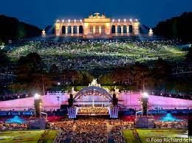June 8: Vienna Philharmonic Summer night Concert at the Schoenbrunn Palace in Vineea 8:30pm local time. Your local PBS station will broadcast the concert for US audiences as part of their Great Performances collection.
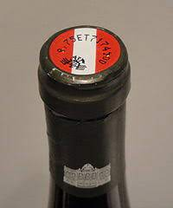 Austrian winemakers switching grapes to account for climate change. Due to rising temperatures, the taste of wine is changing, the harvest has moved forward by 6 (!) weeks compared a generation ago. The new wine varieties “Furmint” and “Petit Manseng” are late-ripening and therefore safe from the August heat. Austria’s wine is increasingly seen as environmentally conscious and of high quality. https://www.euronews.com/2023/06/05/the-austrian-winemakers-switching-grapes-to-account-for-climate-change

June 11: The play ”Leopoldstadt” by Tom Stoppard wins “Best Play” at the 76th Tony Awards. Set in Vienna, the play takes its title from the Jewish Quarter. Full of customary wit and beauty, Stoppard’s late work spans fifty years of time. The passionate drama of love and endurance begins in the last days of 1899 and extends to 1955. The play follows the rise and fall of Vienna's Jewish community through the lens of one family. They face the grief of losing a son and nephew in the First World War, navigating the family business through the depression and the rise of Bolshevism, and the onslaught of Nazi invasion.
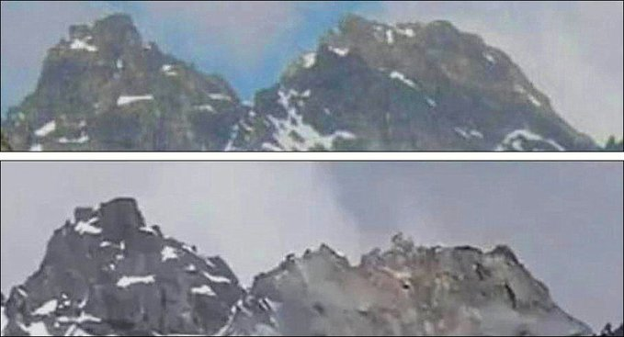 June 11: Before and after a massive rock slide of the “Fluchthorn” (3,400m ~ 10,000ft) in the Silvretta mountain range that broke away the South summit including the summit cross, lowering the summit by about 100m (~ 300ft). Over 100,000 m3 material became loose and raged towards the Jamtal Hütte. Fortunately nobody got hurt and the Jamtalhütte got spared. A probable cause is climate change as glaciers retreat and the underlying permafrost gets thawed by the increasing temperatures and so loosens the rock formations. More of these rock slides in altutudes above 2,500 m ( ~ 8,000ft) must be expected to come. https://tirol.orf.at/stories/3211320/
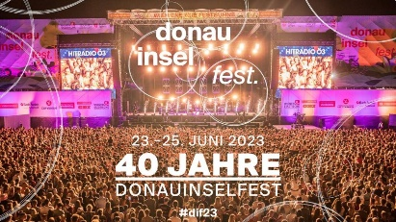 June 23-25: The largest Open Air Festival in Europe, the “Donauinselfest” in Vienna celebrates its 40th anniversary this year! The “Donauinsel” changes into an enormous stage for music, art and entertainment. This year, again over 100,000 visitors are expected.
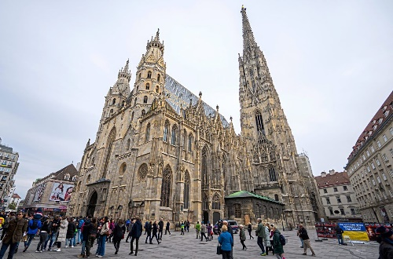 June 22: according to “Ecconomist”: Vienna is again the most livable city worldwide, ranked before Kopenhagen and Melbourne. Public services and transportation, high security and plentiful cultural offerings were among the top ratings. The categories were stability, health , education culture, environment and infrastructure.
Thinking of moving to Austria? To Vienna? A summary of relevant information can be found in the “Expat Gude”: https://viennabusinessagency.at/fileadmin/user_upload/International/Expat-Guide-Vienna.pdf Adjusting to life in a new city can be daunting. The purpose of this guide is thus to give you an idea of the procedures you will have to follow and the vocabulary you will be encountering – all part of the settling-in process. And – mark your calendar for October 1: Katja Otter from the Vienna Business Agency will be in town and ready to answer all your questions! More info about this event TBD
UPCOMING and PAST EVENTS
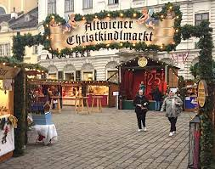 Christmas in June??!?!? We are already planning ahead for the upcoming events, in particular for the annual Christkindlmarket. Are you interested in joining these efforts? Elana Sabajon did a wonderful job as the ‘project manager’ of last year’s Christkindlmarkt/Weihnachtsmarkt and really enjoyed doing it. For this year, we (the core team that organizes the event) already have the date (2nd of December) and the anticipated location. We are reaching out to you because Elana will be out of the country for 6 months starting in September. Therefore, we are looking for someone who would enjoy either co-coordinating the event or taking on the whole ‘management' themselves. Elana is happy to share her documentation with you. Our next zoom meeting is scheduled for the 17th of July at 19.30. Elana would love to hand over the baton at that meeting.
Request: Please email Elana, youcan@askelana.com, if you have any questions about what the ‘job’ entails and/or if you are interested in taking it on.
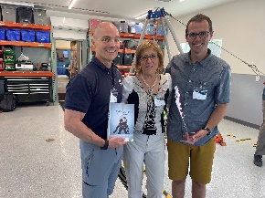 June 3: At the party celebrating 75th anniversary of the Seattle Mountain Rescue SMR https://www.seattlemountainrescue.org/ and ribbon cutting of their new building in North Bend, I had the honor to represent Austria, especially highlighting the connection between the Österreichische Bergrettung Tirol and SMR. During 2nd WW and in years thereafter, immigrants from Austria who were leaders of the Tyrolean Bergrettung settled in the Seattle area and became co-founders and experts advising on the bylaws and the then newest mountain rescue techniques. I could also pass on books about the Tiroler Bergrettung and a table flag as a gift from the Tiroler Bergrettung. SMR, a group of dedicated volunteers, as is their counterpart “Tiroler Bergrettung”, is an organization dedicated to saving lives in all seasons through search, rescue, and mountain safety education under their motto: “Everybody Comes Home from the Backcountry”. Have you heard about the dramatic rescue of a 10-year-old girl lost in the woods near Snoqualmie Pass for over 24h? This was one of the latest wonderful missions SMR carried out! Well worth supporting!
Check out the regular online film and music events organized by the Austrian Cultural Forum: https://acfdc.org/?mc_cid=487b48d54a&mc_eid=1321923619
Virtual Stammtisch for German Learners: once a month via zoom: Next meeting: Friday, July 21, 2023; 6:30pm. The virtual Stammtisch for German learners is an opportunity to get together, speak German, and have fun. Sabine Sullivan is a native speaker and will host the Online-Stammtisch. If you would like to attend or have any questions, please contact Sabine Sullivan: sabine.sullivan@zoho.com
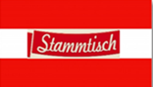Monthly Stammtisch – 1st Thursday of the month: Mark your calendar!!
Please contact Jürgen Schatzer juergenschhatzer@gmail.com for details for the upcoming one. The location is rotating throughout the greater Seattle Area. There is so much to talk and chat about!
Mit herzlichen Grüβen
Eva Kammel
Honorary Consul of Austria in Seattle
office@austrianconsulateseattle.org | www.austrianconsulateseattle.org

