June 2022 Newsletter - HK Seattle

Dear Friends of Austria!
Summer is here! ….although there is still room for improvement in the weather. But better rain and cooler temperatures than heat wave and wildfires!
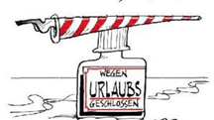 The Honorary Consulate of Austria in Seattle will be temporarily closed for vacation from June 27 – Aug. 1, 2022. If you need consular assistance, please contact the Consulate General of Austria in Los Angeles for any questions or in case of emergency: www.austria-la.org.

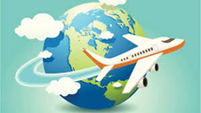 TRAVEL TO/FROM Austria:
June 12: International travelers returning to the USA will no longer be required to provide a negative Covid test before boarding. Noncitizen nonimmigrants are still required to show proof of vaccination before boarding a flight to the United States. As of now, there are no Covid related restrictions going to Europa and returning to the USA (for US citizens and green card holders). Please check the latest updates for traveling to and from Austria at the website of the Austrian Consulate General in Los Angeles: https://www.bmeia.gv.at/en/austrian-consulate-general-los-angeles/travels-to-austria/coronavirus-covid-19-and-travel-information/
For the Covid related situation within Austria: https://www.austria.info/en/service-and-facts/coronavirus-information
NEWS FROM AND ABOUT AUSTRIA
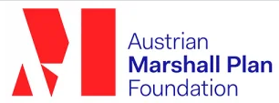 June 8, 2022: 75 years of Marshallplan: a peace project with future vision. It was the cornerstone for democracy, economic prosperity and cooperation in Europe. Also important is the fact that the Marshall Plan is very much alive in Austria.The Austrian Marshall Plan Foundation continues a longstanding transatlantic relations and created a strong culturall, economic, and scientific networt between Europe and the USA. The ceremony was held with Austria’s Foreign minister Alexander Schallenberg and US Ambassador to Austria , Victoria Kennedy, in attendance.

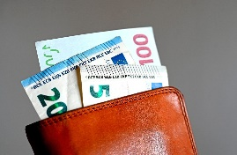 June 14: The Austrian government decides on a massive support package geared to dampen the increase of cost of living, especially for the vulnerable segment of the population. Costs of this package are estimated 28 billion until 2026. Most of this amount wil be recovered through increased tax income due to inflation.
The City of Vienna is trying to offset the massive increase in energy costs with a onetime bonus of Euro 200 for lower and middle income households.
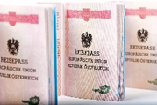 MA 35, the government office in Vienna dealing with citizenship applications, seems to be overwhlemed by the number of applications for citizenship. The next available appointments for submitting applications are in 2023…. The office got reformed in 2021, that brought some improvements but it is far from enough. Comparison: In Tyrol, the next available appointment is in 3 weeks.

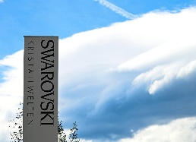 For the first time in its 127 year long existance, the famous crystal company Swarovski will have a CEO who does not belong to the owner family. The choice fell to the international renowned manager Alexis Nasard. The majority ownership of the company remains still within the Swarovski family.
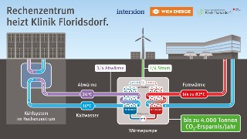 In a further, innovative step toward climate neutrality and fossil fuel independence, the City of Vienna is installing a heat pump connecting to Interxion’s data center with the Hospital Floridsdorf located in immediate vincinity by using the excess heat from the server rooms. It is expecteed that this innovative plan to use thermal energy will cover up to 70% of the hospital’s energy needs. https://www.wien.gv.at/english/politics/international/newsletter/03-2022-thermal-energy.html
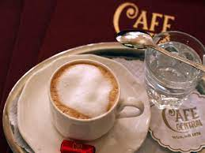Lovestory about Wiener Kaffeehauskultur (Viennese Coffehouse culture): What is that special thing that has made Viennese coffee house culture such a lasting and treasured experience? From a typical Viennese breakfast to mushrooms grown in grounds. From coffee beans left behind by the Ottomans, to local specialties enjoyed by all but with names understood by few. Vienna’s coffee houses aren’t just for coffee. Find out about the experience that is Vienna’s coffee house culture. https://www.youtube.com/watch?v=XvpkFlzgiL0&t=42s
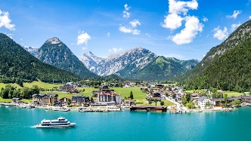 The European Environment Agency (EEA) is monitoring inland and coastal swimming spots across EU member states. Europe’s cleanest bathing waters are in the landlocked country of Austria, known for its many beautiful lakes including the Alpine waters of Achensee in Tyrol (photo) and the emerald-hued Weissensee in Carinthia, with 97.7% of its waters declared excellent. Come for a dip in the lake…..!
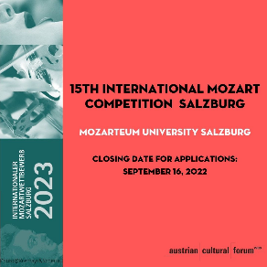 15th biannual International Mozart Competition Salzburg: February 3-16, 2023; String Quartet and Voice applicants only at this time. Music by Mozart is the center of this great music competitions. Application deadline: September 16, 2022. For more information:
https://www.uni-mozarteum.at/en/kunst/mowe/index.php?mc_cid=a410704cb4&mc_eid=1321923619

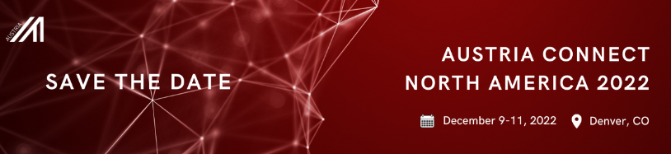 Save the Date: Dec. 9- 11, 2022 – Denver, CO:
Austria Connect North Ameica 2022 – It is on! The most important event for Austrian Business representatives in the US: https://www.advantageaustria.org/us/news/Austria_Connect_NA_2022_STD.en.html
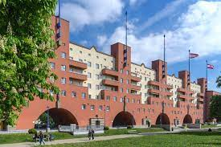 Vienna’s successful social housing progam, now almost 100 years in existance, is one of the best worldwide and contributes to Vienna’s standing as most livable city for the tenth year in the row. The City of Seattle is taking interst in how Vienna achieves this amazing goal of having (almost) no homeless population and affordability for all: https://www.youtube.com/watch?v=69mIwvdPTkQ . In a meeting with Austria’s Consul Gerenal Dr. Postl and Seattle City Council member Tammy Morales ideas got exchanged and was a startingpoint for futher cooperation betweeen the two cities.
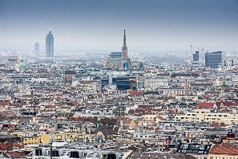 June 22: The City of Vienna again ranks as most livable city among 140 cities, according to the “Economist”. Criteria were health system, education, culture and infrastructure. Only in the last 2 years the city lost its first place due to Covid restrictions.

UPCOMING EVENTS
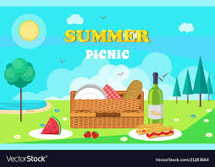 July 23, 2022; 1-5pm in Woodinville Summer Picnic organized by the Austria Club. There will also be an auction: “Trachten Exchange/ Kleidertausch “ fundraiser that should help to offset some of the costs for the exciting events planned for the fall.
For more information please contact Michael Brandstetter : michael.brandstetter@gmail.org. and for the “Kleidertausch: Christina Calio: christina@caliomusic.com
Please mark your calendar for following events in the fall:
Sunday, September 25: Austrian American Day – Welcome of new Austrian Citizens at the Holocaust Museum in Seattle
Saturday, October 29: National Holiday – Erntedankfest at the Kenmore Community Hall
More details will be provided later in the summer. Please stay tuned!
July 1, 2022, 5pm: Colorado native and resident of Salzburg, Katie Mahon, http://katiemahan.de/, will perform a piano concert on top of the Hafelekar near Innsbruck at 2,000m altitude, a once in a lifetime concert experience. So, if you are nearby, don’t miss it!
More information: https://www.innsbruck.info/brauchtum-und-events/veranstaltungskalender/detail/event/katie-mahan-piano-passion-on-the-top-of-innsbruck.html

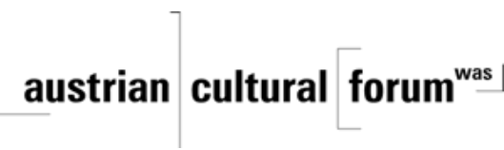 Check out the regular online film and music events organized by the Austrian Cultural Forum: https://acfdc.org/?mc_cid=487b48d54a&mc_eid=1321923619

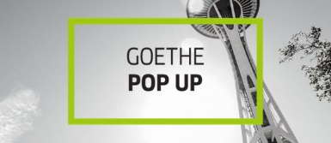 Regular events are offered by the Goethe Pop Up Seattle, ranging from book club, Summer camps, movies, and literature presentations: https://www.goethe.de/ins/us/en/sta/gps.html

Monthly Stammtisch – 1st Thursday of the month: Mark your calendar!!
Virtual STAMMTISCH: July 7, 2022, 7pm: Join a get-together with friends of Austria: There is so much to talk and chat about! Zoom link: https://us02web.zoom.us/j/5845087371 . Questions: please contact Elana Sabajon: youcan@askelana.com or Juergen Schatzer: juergenschatzer@gmail.com
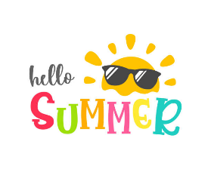 Wishing you all a wonderful summertime, that you can enjoy the beautiful nature around us, gatherings with friends and family. Looking forward seeing you again after my return from Austria in August.
Mit herzlichen Grüβen
Eva Kammel
Honorary Consul of Austria in Seattle
office@austrianconsulateseattle.org | www.austrianconsulateseattle.org

