HC Newsletter June 2021
Dear Friends of Austria!
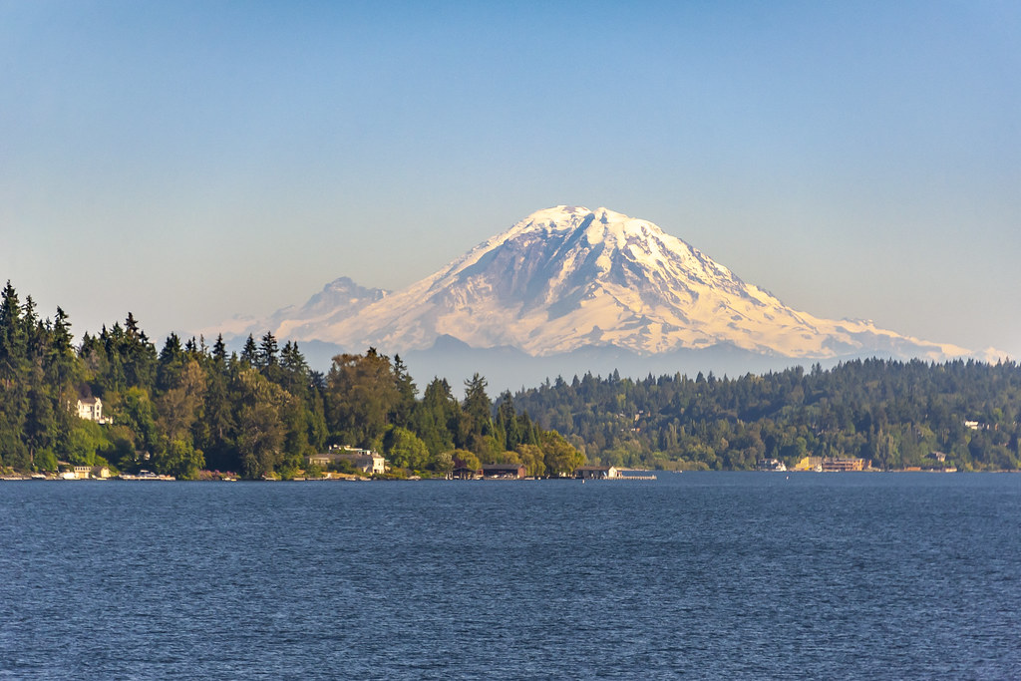 Summer is here! The heat is on – even in “cool” Seattle we can enjoy balm evenings and record high daytime temperatures. But there are Lake Washington and other beautiful mountain lakes waiting, tempting for a swim to cool off.
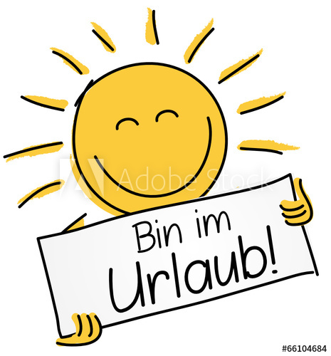 The Honorary Consulate of Austria in Seattle will be closed for vacation from June 30 – July 13, 2021.
Please contact the Consulate General of Austria in Los Angeles for any questions or in case of emergency: www.austria-la.org.
Are you an Austrian Citizen and registered as “Auslandsoesterreich/in” (Austrian living abroad)? If so, then you have recently received an email from the Foreign Ministry about the newest update of the services for all Austrian citizens living abroad. Check out the newly designed website https://auslandsregistrierung.bmeia.gv.at/#/ and/or the Auslandsservice-App where you can update your profile and your preferences what types of emails/information you want to receive.
If you are not yet registered as “Auslandsoesterreicher/in” then please use this reminder to do so: https://auslandsregistrierung.bmeia.gv.at/#/. Only then the Austrian Foreign Ministry can help you in case of emergency or provide you with important information. Thank you!
New travel guidelines: effective with TODAY
Austria has lifted the entry restrictions for travelers arriving from the United States, effective Thursday, June 24, 2021. Travel to Austria for all purposes is now possible for US citizens. Please note that either proof of vaccination, proof of recovery from COVID-19 or a negative covid-19 test result must be presented upon entry into Austria. Also, only certificates and test results issued in English or German by a medical professional or public authority will be accepted.
Austrians are still not allowed to travel to the USA unless they have a green card, a valid visa, certain family members and some other exemptions.
For more details, please check the website of the Consulate General of Austria in Los Angeles www.austria-la.org and
https://www.austria.info/en/service-and-facts/coronavirus-information.

June 3: Norbert Hertl, one of the most beloved and active members of the Austrian community in WA has gone from us peacefully. His humor, his love for dancing, the mountains, skiing, and above all, his longing for harmony and justice will stay with us. He is with God now. Our prayer and thoughts are with Norbert’s amazing family who was with him and cared for him in the most loving way possible.

NEWS FROM AND ABOUT AUSTRIA
June 2: The party leader of the right-wing Party FPÖ, Norbert Hofer, stepped down unexpectedly after months long internal power struggles with the ultra-right Herbert Kickl, who is now succeeding him in this position.
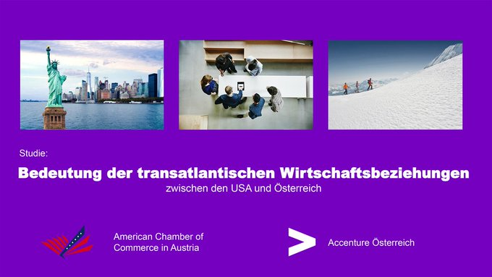 June 7: A new American Chamber of Commerce in Austria Study about the importance of transatlantic economic relations produced interesting results: http://amcham.at/studie/
USA are the 2nd most important trading market for Austria
Exchange of goods: + 150% in the last 10 years
USA is the 3rd most important capital provider for Austria
USA-companies provide 120,000 jobs in Austria

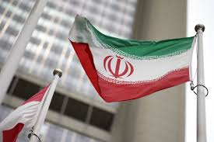June 12: Nuclear talks between the USA and Iran resumed in Vienna. The previous USA administration withdrew in 2018 from the agreement negotiated under the Obama administration.

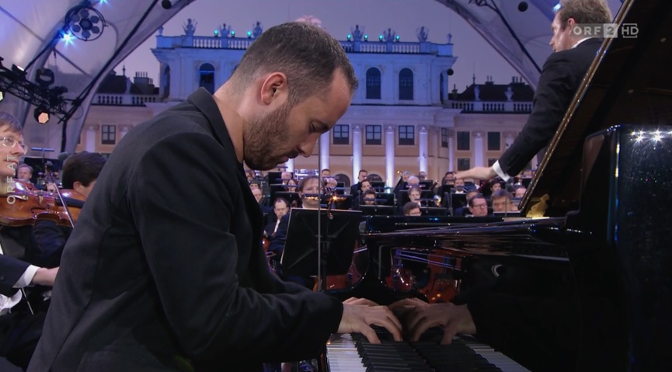 June 18: The Vienna Philharmonic Orchestra could finally perform again the traditional Sommer Night Concert in front of the Schönbrunn Castle, under the direction of guest conductor Daniel Harding, and Igor Levit was the featured pianist.
This concert will be broadcasted on PBS on Aug. 27, 2021
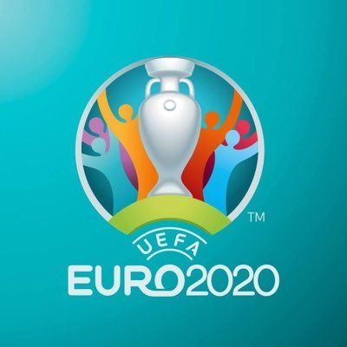 Men’s Soccer UEFA EURO CUP: The Austrian Team ended up on second place in its group and is therefore advancing to the sweet 16 - play off at the EURO Soccer Tournament, for the first time ever! Team captain David Alaba impressed with his play and led the team to a forceful and dynamic performance. Saturday, June 26, 2021, is the playoff game: Austria: Italy. Daumen halten!! This 60th anniversary tournament, originally planned for 2020, got postponed because of the pandemic, and is held in 11 cities in 11 UEFA countries.

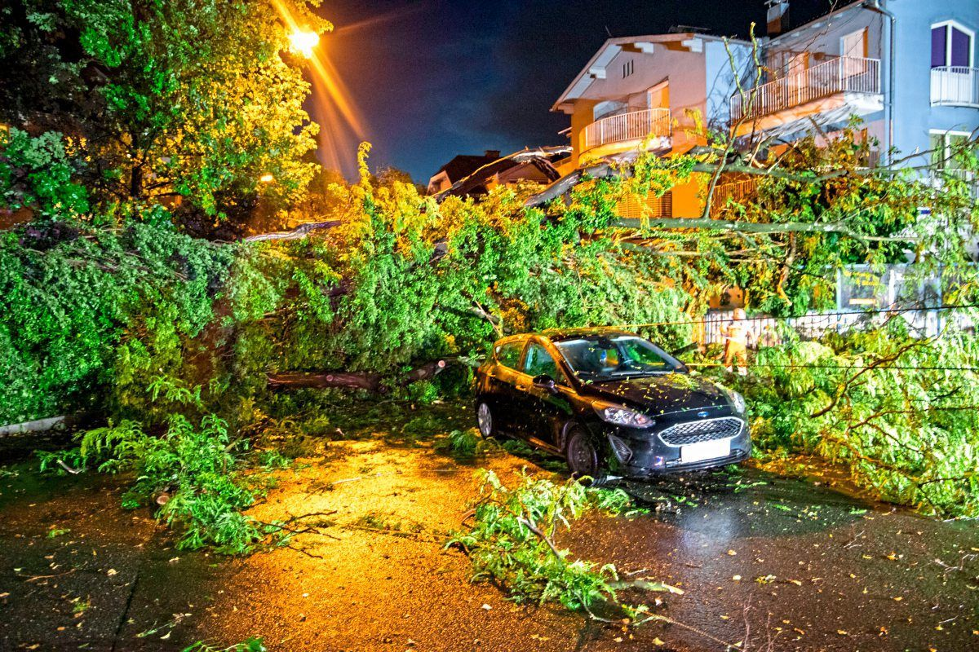 June 24: after days of record heat massive thunderstorm, hail, and strong winds swept through the country causing massive damage, power outages, and disruptions in transportation.

UPCOMING EVENTS
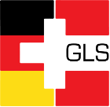The German Language School Seattle (GLS) is currently enrolling students for next school year. Early Registration for 2021-2022 will last through July 31. Please visit the website for more information: https://germanlanguageschool.org
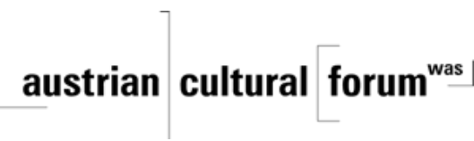 Check out the regular online film and music events organized by the Austrian Cultural Forum: https://acfdc.org/?mc_cid=487b48d54a&mc_eid=1321923619

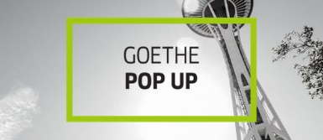 Check out the regular events offered by the Goethe Pop Up Seattle, ranging from book club, Summer camps, movies, and literature presentations: https://www.goethe.de/ins/us/en/sta/gps.html

Monthly Stammtisch – 1st Thursday of the month: Mark your calendar!!
Virtual STAMMTISCH: Thursday, July 1, 2021: 7 – 9pm:
Hope many of you can join, bring your favorite drink and let’s enjoy time together! There is so much we can talk and chat and laugh about! For any questions, please contact Jürgen Schatzer: juergen.schatzer@gmail.com
zoom link: https://us02web.zoom.us/j/5845087371

MARK YOUR CALENDAR:
Saturday, August 21, 2021: Garden Party at Peter Rueckert’s Estate in Arlington: The Austria Club of WA is organizing the first get-together after the long time of necessary hiatus. Please contact Austria Club President Rosie Mulholland (mulho@comcast.net) or 206 351 1198 for more details!

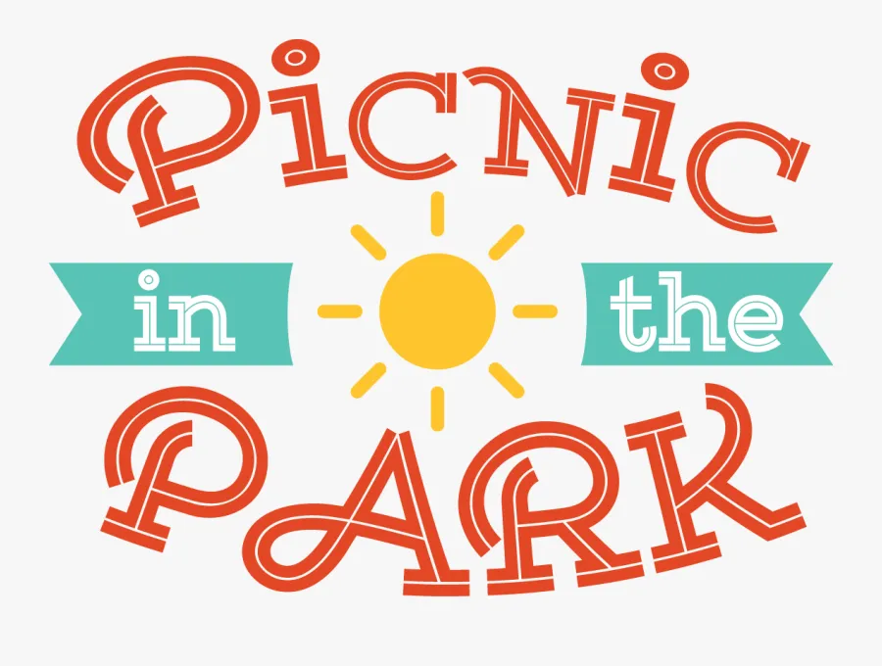 Saturday, September 11, 2021, 2-6pm Seward Park, Seattle, Picnic Shelter # 5!
!!!!! Friends of Austria Gathering!!!!
Reserve the date and plan on bringing your family and friends along. More details are coming!
Wishing you a wonderful summertime!
Mit herzlichen Grüssen
Eva Kammel
Honorary Consul of Austria in Seattle
office@austrianconsulateseattle.org | www.austrianconsulateseattle.org

