**2023 July Newsletter - HK Seattle**

Dear Friends of Austria!

Summer at its best is here! Wishing you a wonderful time enjoying the best months of the year!

We are already looking ahead and planning exciting events to come in the fall. **Please scroll down for more information and to mark your calendar!**

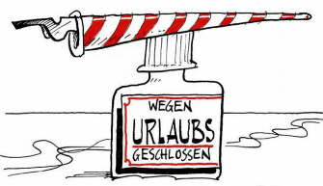 The **Honorary Consulate of Austria in Seattle will be closed for vacation from July 31 – August 28, 2023**. Please contact the HC Seattle to schedule appointments for September. For immediate assistance, please contact the Consulate General of Austria in Los Angeles: <www.austria-la.org>

**TRAVEL TO/FROM Austria:** no further Covid related restrictions are currently in place.

Please check the latest updates for traveling to and from Austria at the website of the Austrian Consulate General in Los Angeles:<https://www.bmeia.gv.at/en/austrian-consulate-general-los-angeles/travels-to-austria/coronavirus-covid-19-and-travel-information/>

**NEWS FROM AND ABOUT AUSTRIA**

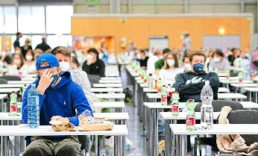 **July 7**: admission **exam for medical school** in Austria: about 12,000 applicants tested for 1,850 spots. 75% of the spots go to the highest ranked students with the best final Austrian high school grades. The remaining slots are distributed among EU citizens and then non EU citizens. Would you pass the test? Find out: <https://www.derstandard.at/story/3000000177280/wuerden-sie-den-medizin-aufnahmetest-bestehen>

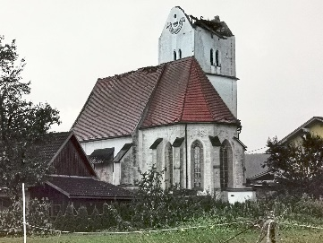 **July 15**: **Extreme weather** including hail, severe thunderstorms, strong winds and heavy rain devastated southern and Western parts of Austria: from destroyed roofs (here a church near Kühnsdorf) to flooding and broken trees caused damages in the Millions of Euros and interruptions. Even Federal President VanDerBellen got stranded for several hours while on the train ride to the opening ceremony of the Bregenzer Festival.

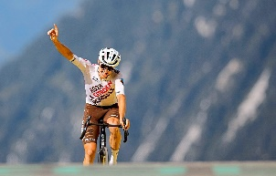 **July 19:** **Tour de France** “King’s” stage 17: The Austrian **Felix Gall**, 25, wins this most difficult and strenuous section of the prestigious Tour de France, where the athletes had to overcome over 5,000 m (16,400 ft) altitude and 166km (100 mi) in under 4h49min.

** July 20 – Aug 31,2023 2023: Salzburger Festspiele**: <https://www.salzburgerfestspiele.at/en/> again this year we can expect outstanding opera, concert and theater performances by world renowned artists and musicians. The whole city becomes a stage offering an unmatched plethora of world class productions. On the program are the staple of “Jedermann”, Figaro, Falstaff, “Die griechische Passion”, and Macbeth among many other productions.

Some protests against the coalition of the Salzburg State government with the far right party are expected.

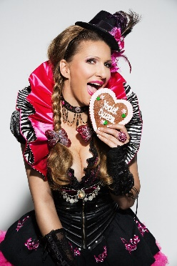 Interesting interview of Austrian Voices, the podcast for Austrians living abroad, with **Manuela Horn, our Austrian Yodel Queen,** about her life, life in Seattle, dual citizenship, longing for her *Heimat,* and her career: <https://austrian-voices.podigee.io/22-austrian-voice-manuela-horn> . Have fun listening!

**Austrian Fulbright Foreign Language Teaching Assistant Program (2024–25 program year): Live and teach English abroad in Austria:** Are you graduating from college and are looking for an exciting opportunity that allows you to explore a new culture while simultaneously gaining valuable first-hand classroom experience? For decades, Fulbright Austria has worked with the Austrian Federal Ministry of Education, Science, and Research (BMBWF) to bring qualified, motivated university graduates from the United States to teach English in Austria in secondary schools all across the country. <https://www.fulbright.at/programs/in-austria/teaching-assistants/grant-details/us-teaching-assistant-program>  
Application period for school year 2024-25: 15 October–15 November 2023.

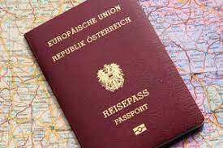 Did you know that the **Austrian passport** is one of the most powerful passports in the world? Austria holds 3rd position (together with Finland, France, Luxenbourg, South Korea and Japan) and offers 189 visa free destinations out of 227 worldwide. 2nd is Germany, Italy and Spain, and 1st Signapore with 192 travel destination without a visa, according to the Henley Passport Index 2023.

**“The Year of Noise And Silence” by Valentina Azizova**: Eager to read a beautiful, gripping book describing the struggles of a 16 year old Russian girl who immigrated to Vienna, all by herself, to attend the Modeschule Hetzendorf? Immersed into authentic Viennese atmosphere, from the smell of the Anker Filiale to the crowded UBahn to the beauty of historic buildings, this story of a year long difficult journey lets you not put down the book. Available at Amazon: <https://a.co/d/hHIC4ps>  
In the meantime, Valentina Azizova became "Artist in Residence" at the Vienna Museumsquartier, Designer by Palmers, and now chef designer at Nike in Portland. Herzliche Gratulation, Valentina!

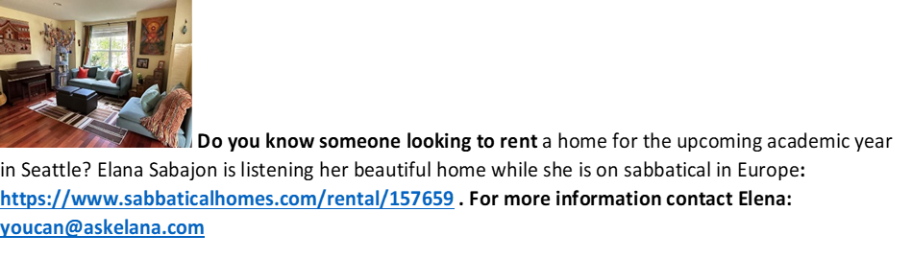

**UPCOMING EVENTS**

**Friday, August 18, 2023: Seattle Opera: Das Rheingold – German Day:** There will be pre-show talk at 6:30pm with General Director Christina Scheppelmann and a post-show with a cast member. The German/Austrian community receives a 20% discount for that show: use promo code **HARMONY2324** for ticket order online, over the phone or in person.

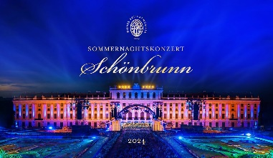 **Friday, August 25, 9pm**, at Great Performances on your public TV Station (in Seattle Area: KCTS9); **Vienna Philharmonic Summer Night Concert 2023,** open air concert from the magnificent gardens of Vienna’s Imperial Schönbrunn Palace. Conducted for the first time by Yannick Nézet-Séguin, music director for both the Metropolitan Opera and the Philadelphia Orchestra.



**Monthly Stammtisch – 1st Thursday of the month: Mark your calendar!!**

**Thursday, August 3, 2023; 7pm; location: Epulo Bistro**, 190 Sunset Ave Suite B, **Edmonds**. Please contact **Jürgen Schatzer** [juergenschhatzer@gmail.com](mailto:juergenschhatzer@gmail.com) for more details. The location is rotating throughout the greater Seattle Area. There is so much to talk and chat about!

**Oktoberfest**: **Saturday, September 23; 2023**; at the Kenmore Community Hall, organized by the Austria Club of Washington. Please contact Michael Brandstetter for more info: <michael.brandstetter@gmail.com>

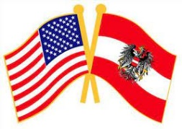**Austrian-American Day: October 1, 2023 (actual AADay: September 24): location:** Realogics Sotheby’s International Realty, Kirkland **,** with special guests:

**Katja Otter from the Austrian Business Agency and Hannelore Weiss from the University of Vienna, Alumni organization**. Katja will report about her services supporting Austrians and their families when relocating or moving to Austria. Hannelore will explore the possibility of opening an Alumni Chapter here in Seattle. Mark your calendar for this very special event filled with important information for all Austrians and Friends of Austria. For more information: Christina Calio: <christina@caliomusic.com>

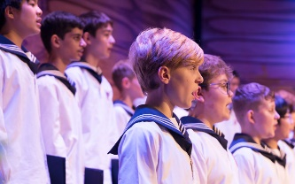 **October 18**: Performance of the **Vienna Boys Choir** at the Edmonds Center for the Arts. Tickets go on sale on June 26: <https://www.edmondscenterforthearts.org/events/detail/593/vienna-boys-choir/4247>

**Sunday, October 29**: location TBD: celebration of the Austrian National Holiday (actual day: October 26), welcome of new Austrian citizens

Check out the regular **online film and music events** organized by the **Austrian Cultural Forum**: <https://acfdc.org/?mc_cid=487b48d54a&mc_eid=1321923619>

 **Virtual Stammtisch for German Learners**: once a month via zoom: Next meeting: **in September.** The virtual Stammtisch for German learners is an opportunity to get together, speak German, and have fun. **Sabine Sullivan** is a native speaker and will host the Online-Stammtisch. If you would like to attend or have any questions, please contact Sabine Sullivan: [sabine.sullivan@zoho.com](mailto:sabine.sullivan@zoho.com)

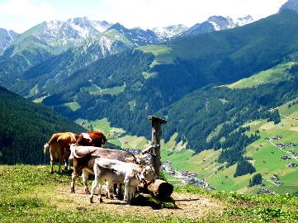 Wishing you a wonderful summer filled with family time, nature, sunshine, and happy hours!

Mit herzlichen Grüβen

Eva Kammel

Honorary Consul of Austria in Seattle

[office@austrianconsulateseattle.org](mailto:office@austrianconsulateseattle.org) | [www.austrianconsulateseattle.org](http://www.austrianconsulateseattle.org)