July 2021 Newsletter - HK Seattle

Dear Friends of Austria!
After we survived the extreme and for Seattle very unusual heat end of June, we now can enjoy a beautiful summer with sunny skies, cool nights, and moderate temperatures, at least in Western WA. But reports of record wildfires close by, flooding in Austria, and other extreme weather-related events all over the globe make us aware that climate change is already happening. Drastic actions to combat cannot come soon enough!
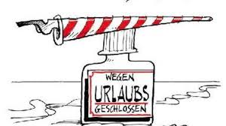The Honorary Consulate of Austria in Seattle will be closed from Aug. 6 – Aug. 30, 2021. Please contact the Consulate General of Austria in Los Angeles for any questions or in case of emergency: www.austria-la.org.

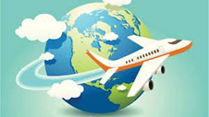 TRAVEL TO/FROM Austria:
For newest updates please check the website of the Austrian Consulate General in Los Angeles: https://cms.bmeia.gv.at/en/austrian-consulate-general-los-angeles/news/
Travel To Austria:
NEW: With July 1, 2021, Austria (and the EU Schengen area) has lifted the entry restrictions for travelers arriving from the United States or other countries/territories with low epidemiological risk. Travelers coming from these countries may enter Austria without quarantine or pre-travel-registration if they provide upon entry a certificate of vaccination, a certificate of recovery or a negative Covid-19 test result. (“3 G rule”: Geimpft-Genesen-Getestet)
Please note that only certificates and test results issued in English or German by a medical professional or public authority will be accepted.
Vaccination Certificate (e.g. “CDC COVID-19 Vaccination Card”):
- Inoculation with BioNtech/Pfizer, Moderna, Johnson&Johnson/Janssen, AstraZeneca, Sinopharm, or Sinovac COVID-19 vaccines.
- Start of validity: 21 days after the first inoculation.
- End of validity: 90 days after the first inoculation if partially vaccinated (received 1 of 2 prescribed doses) or 270 days after the second/only inoculation if fully vaccinated (received all prescribed doses)
NOTE: beginning with August 15, 2021, proof of vaccination is only recognized with full immunization
Following website gives a clear overview about the Covid related requirements (e.g. mask wearing) within Austria: https://www.austria.info/en/service-and-facts/coronavirus-information
Travel To the United States:
Travel ban for EU citizens is still in effect. Only US citizens, green card/Visa holders and certain exemptions are allowed to enter the USA. Upon entry all travelers (also transit travelers) must provide a negative Covid-19 (PCR or Antigen) test no older than 3 days. Children under 2 years are exempt from this rule.

News from: 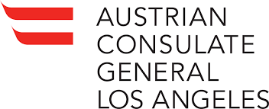
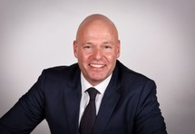 A herzliches Auf Wiedersehen und Danke to Consul General of Austria in Los Angeles, Andreas Launer. After 4 years representing Austria and working for all Austrians living in 16 states on the West Coast, he moves on to becoming Ambassador for Austria in Kuala Lumpur, Malaysia.
GK Launer’s time in Los Angeles was dominated by the increasing needs and adjustments caused by the pandemic, and he and his team worked hard to provide as much support as needed.
We are thankful that he could visit us in Seattle, still in the times “before”, so that he could see not only the beauty but also the tremendous potential this region has to offer for further exchange with Austria for business, innovation, culture, and tourism. His attendance at the Austrian National Holiday zoom event October 2020 organized by the Austrian community in WA, was greatly appreciated and made this event very special.
We are wishing GK Launer and his family a good transition and success at his new post!
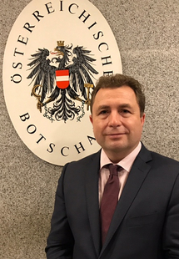 Dr. Michael Postl, serving the last 4 years as Ambassador of Austria to Malaysia, is succeeding GK Launer as Consul General of Austria in Los Angeles. Among many other posts within the Austrian Foreign Ministry, Dr. Postl has previously served as Austria’s ambassador for Armenia, Georgia, Uzbekistan, and Iran.
Welcome Dr. Postl to the West Coast! We are looking forward to a strong collaboration with the Austrians living in the Pacific Northwest!

NEWS FROM AND ABOUT AUSTRIA
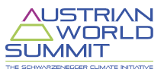 July 1, 2021: Austrian Climate World Summit at the Spanish Riding School in Vienna, host: Arnold Schwarzenegger; https://www.austrianworldsummit.com/. The list of speakers is impressive - let's hope for the same of a positive impact on Climate Change!
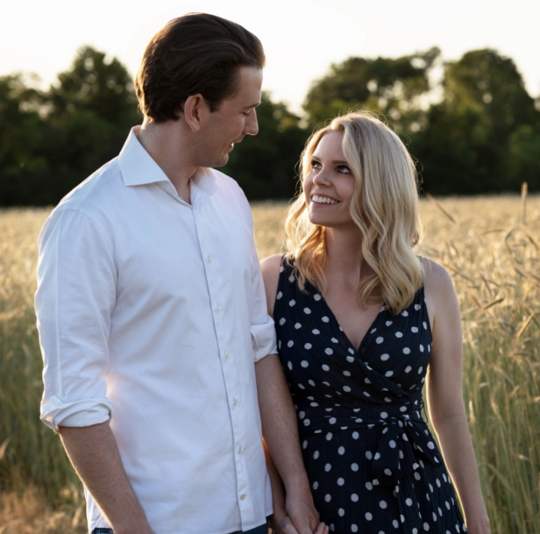 July 10, 2021: Austria’s Chancellor Sebastian Kurz, 35, announces that his longtime partner Susanne Thier is expecting their first child beginning of December. No words about a planned wedding yet. He will be one of several high ranked Austrian politicians entering parenthood (after Minister Elisabeth Köstinger (Tourism), Alma Zadic (Justice) , Susanne Raab (Integration), and Gernot Blümel (Finance). Best wishes

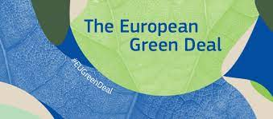 July 14, 2021: The European Green Deal: https://ec.europa.eu/info/strategy/priorities-2019-2024/european-green-deal_en.
The European commission adopted a set of rules to make the EU’s climate, energy, transport, and taxation policies fit for reducing net greenhouse gas emissions by at least 55% by 2030, compared to 1990 levels. Achieving these emission reductions in the next decade is crucial to Europe becoming the world's first climate-neutral continent by 2050 and making the European Green Deal a reality. Everything that produces energy from fossil fuels will become more expensive, what reduces the CO₂ emission will become cheaper. Poorer EU countries and areas will get subsidies. No more combustion motors after 2035.
For Austria this would mean: reductions of greenhouse gas emission by 2030 by 48% compared to 2005. This would require a steep change compared to the past: While between 1990 and 2019 the EU as a whole could achieve a reduction by 26%, Austria increased the emission by 1% during the same time frame. Sweden must reduce most (by 50%), whereas Bulgaria the least: by 10%. Radical steps need to be implemented, e.g. to reduce the emission caused by transportation, reaching further than just switching to e-cars will be necessary, including e.g more home office, car sharing; away from private cars to common mobility. If a country does not fulfil its quota by 2030 then the country must buy surplus from more ambitious countries.

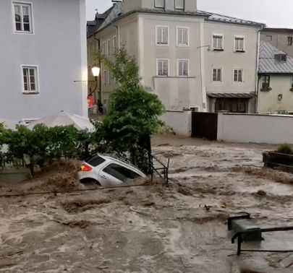 July 14: Deluge like record rainfalls in parts of Germany caused huge damage by flooding and uncontrollable rivers. Many residents lost their homes, describing the situation like after a bomb attack.
A few days later also in parts of Austria, especially in Upper Austria and Salzburg region, extreme rainfall, hail and thunderstorms caused catastrophic flooding and damages. Here is a dramatic footage of the catastrophe in Hallein, where within minutes the town got devastated. https://twitter.com/i/status/1416505105063555079. Luckily, no casualties were reported. Within a few hours more rain poured down than normally within a month.
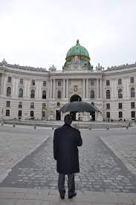Over 2 dozen US Diplomats in Vienna suffer from mysterious Havana syndrome (headache, dizziness, and sleep disorders). The Viennese office of the CIA is one of the worlds largest. The Austrian foreign ministry is cooperating fully with the US agency to secure the health of foreign diplomats. The syndrome is unexplained but US scientists say it is most likely caused by directed microwave radiation. It was first found in Cuba 2016-2017. This story was first reported in the New Yorker: https://www.newyorker.com/news/news-desk/vienna-is-the-new-havana-syndrome-hotspot
Note: Espionage is de facto permitted in Austria as long as it is not directed towards the country itself. Maybe it is time to watch again the classic Orson Welles movie: “The Third Man”?! Enjoy!

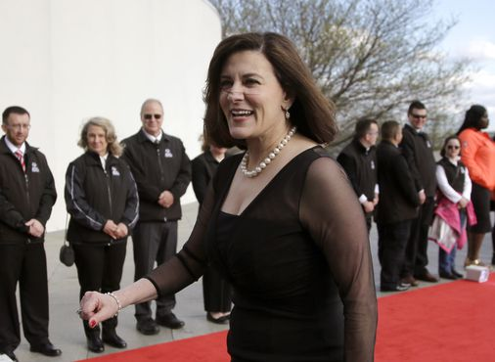 July 21, 2021: Victoria Kennedy, widow of the late senator Edward Kennedy, got nominated by President Joe Biden as next US Ambassador to Austria. “I am humbled by the confidence the president has placed in me, and if confirmed, I look forward to being able to serve my country as ambassador to Austria.” Until her arrival in Vienna, Chargé d'Affaires Mario Mesquita, has assumed his duties at the U.S. Embassy Vienna.

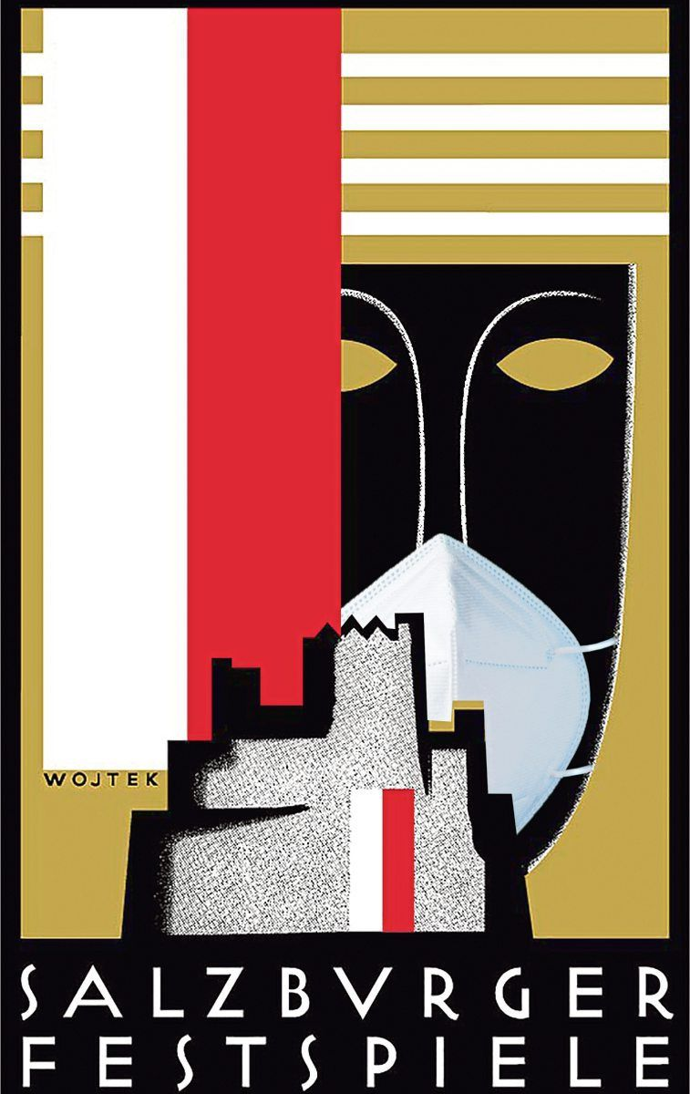 Salzburger Festspiele 2021: July 21 – Aug 31, 2021: https://www.salzburgerfestspiele.at/en/ . Exciting premieres as well as longstanding popular masterpieces of literature and music are again on the program of the 101st Salzburg Festival. Stunning performances by world renowned artists are awaiting the audiences. With tight Covid restrictions the Salzburg Festival could be carried out even last year at the height of the Covid crisis. Also, this summer Covid precautions are fully implemented and even got increased: after the 1st Covid infection case already at the premiere of “Jedermann”, wearing of FFP2 masks are from now on required although the mask mandate in Austria got lifted. It will also be the last festival for Helga Rabl-Stadler who successfully led this prestigious event for many years.

News from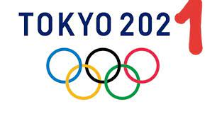 (as of 7/28/2021)
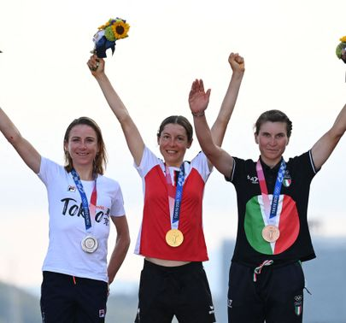 Dr. Anna Kieshofer, 30, holding a PhD in Mathematics, amateur in her sport and traveling to Tokyo with only a minimal team, calculated her race perfectly and wins the Gold medal for Austria in the women’s bicycle road competition. Out of the 137km she mastered the last 41km in an impressive solo, escaping the attention of her competitors. The Dutch favorite of the race, Annemiek van Vleuten, did not realize that Anna was in front of her and thought she won when crossing the finish line. Congratulations Anna to this extraordinary accomplishment! What a thrilling race!
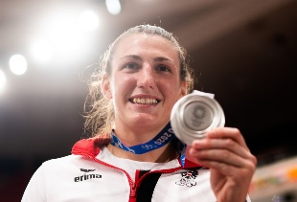 Judoka Michaela Polleres, 24, wins Olympic Silver medal for Austria. This is the most important victory so far for her, placed 8th in the world ranks. She impressed with her strong, confident, and composed performance. Congratulations, Michaela!
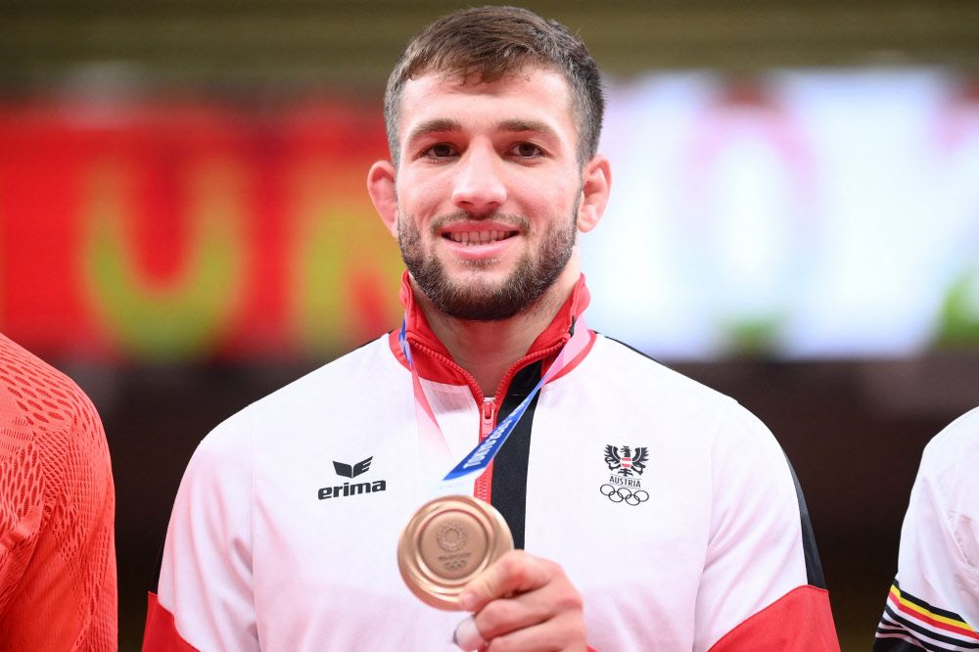 Judo fighter Shamil Borchashvili, 26, won the Olympic Bronze medal for Austria. Only 28th in the world ranks, he clearly astonished with his performance as an outsider. Shamil came as a refugee from Chechnya to Austria as a young child and lives now in Wels. Congratulations Shamil!

UPCOMING EVENTS
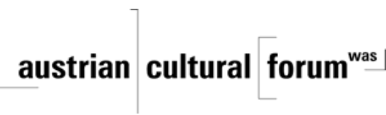 Check out the regular online film and music events organized by the Austrian Cultural Forum: https://acfdc.org/?mc_cid=487b48d54a&mc_eid=1321923619

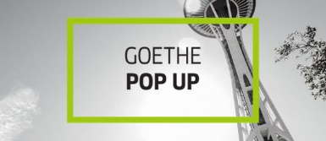 Regular events are offered by the Goethe Pop Up Seattle, ranging from book club, Summer camps, movies, and literature presentations: https://www.goethe.de/ins/us/en/sta/gps.html

Monthly Stammtisch – 1st Thursday of the month: Mark your calendar!!
Virtual STAMMTISCH: Thursday, August 1, 2021: suspended – “Sommerpause” - on vacation – see you in September!

Saturday, August 21, 2021: Garden Party at Peter Rueckert’s Estate in Arlington: The Austria Club of WA is organizing the first get-together after the long time of necessary hiatus. Please contact Austria Club President Rosie Mulholland (mulho@comcast.net) or 206 351 1198 for more details!

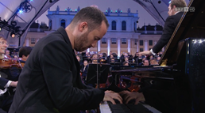 Friday, Aug. 27; 9pm at your local PBS station: Great performances: Vienna Philharmonic Summer Night Concert 2021: Enjoy the Vienna Philharmonic’s annual summer night concert with pianist Igor Levit under the direction of guest conductor Daniel Harding at Vienna’s Schönbrunn Palace.

MARK YOUR CALENDAR:
!!!!! Friends of Austria Gathering!!!!
Saturday, September 11, 2021, 2-6pm Seward Park, Seattle, Picnic Shelter # 5!
Reserve the date and plan on bringing your family along. For more details, Covid-19 precautions, contact etc. please see attached invitation.
Wishing you a wonderful summertime!
Mit herzlichen Grüβen
Eva Kammel
Honorary Consul of Austria in Seattle
office@austrianconsulateseattle.org | www.austrianconsulateseattle.org

