2024 January Newsletter - HK Seattle
Dear Friends of Austria!
Don’t we all need a bit of cheering-up breaking through the constant rain?
Well, just one more month to go to a beautiful night in Viennese tradition – here in Seattle, in the stunning Madison Ballroom at the Renaissance Hotel!
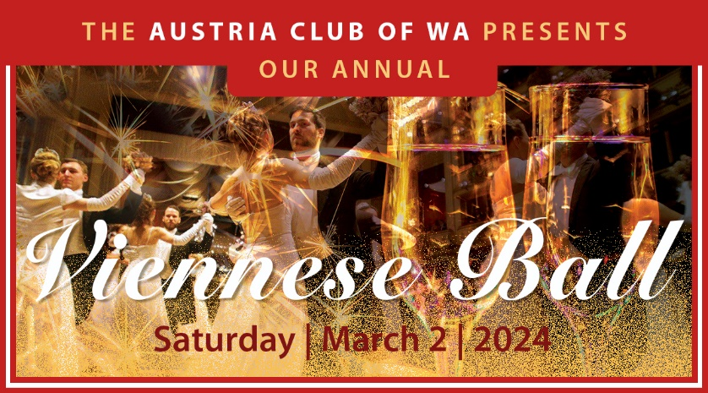
All guests will enjoy a delicious dinner, music and dance performances, and live dance music. All ladies will be greeted with a present from the City of Vienna including well wishes from the mayor of the city of Vienna for an enjoyable evening. For preview of the program, dinner selection, ticket order, and general information including complimentary dance lesson: http://www.austriaclubwa.com/activities_upcoming.html and attached invitation.
You don’t want to miss this very special evening – hope to see you at the Ball!
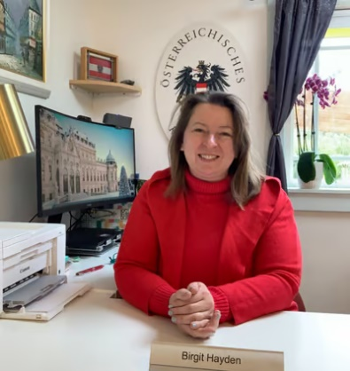 Congratulations to Birgit Hayden on her appointment as Honorary Consul of Austria for OR in Portland! Wonderful that Oregon has now again an official point person for all matters “Austria”. Birgit has great connections to the Austrian community in OR, and her warm and welcoming personality makes her the perfect representative of Austria. If you live in OR and need notarizations, passport applications for children under 12, or other consular matters (excluding passport with fingerprints - here a trip to Seattle is still necessary), are interested in business liaison for companies wanting to do business with Austria, or looking for contact with Austrians in Oregon and SW Washington, please contact Birgit at:
mailto:https://austrianconsulateportland.org/, Tel: (503) 298-6949; https://austrianconsulateportland.org/
TRAVEL TO/FROM Austria: no further Covid related restrictions are currently in place
Please check the latest updates for traveling to and from Austria at the website of the Austrian Consulate General in Los Angeles: https://www.bmeia.gv.at/en/austrian-consulate-general-los-angeles/travels-to-austria/coronavirus-covid-19-and-travel-information/

NEWS FROM AND ABOUT AUSTRIA
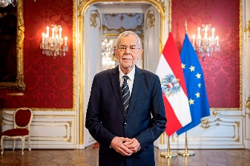 January 1: In his New Year’s speech Austria’s president Alexander Van Der Bellen appealed to everyone to make efforts to talk to each other and not about each other. He also encouraged to investigate the missions of the different political parties to better understand what they are actually standing for. Eying the upcoming elections for the National Assembly and several other local and state and EU wide elections, VanDerBellen also appealed to the leaders of the political parties to formulate the ideas and arguments instead of throwing accusations at each other. He also explicitly addressed the problems associated with climate change and demanded that we use all energy to solve the problems instead of questioning scientific facts where there is nothing to question about. He concluded that Austria has all skills, resources, and characteristics needed to make 2024 a year better than we are expecting.
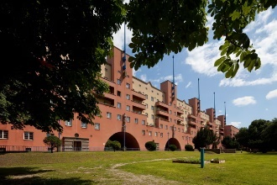 January 10: The social housing secret: how Vienna became the world’s most livable city:
https://www.theguardian.com/lifeandstyle/2024/jan/10/the-social-housing-secret-how-vienna-became-the-worlds-most-livable-city .This Guardian article describes the main reasons why Vienna is able to keep rents regulated and also create a healthy mix of social economic background and incomes living together in the same apartment complexes.
January 15-21: 84. Streiff- Hahnenkamm Downhill Race in Kitzbűhel; Although no Austrian racer placed for the podium this year (the double winner was Cyprien Sarrazin from France), everyone who reaches the finish line must get applauded. This race is one of the most feared of, with a record speed of 153km/h (=96mi/h), with maximal grade of 85% (an extremely steep road has 10-15% grade!), with the record time of less than 2 min for the 3.3km (~ 2mi)!!! No wonder that some skiers talk about how they try to overcome fear in the start booth….
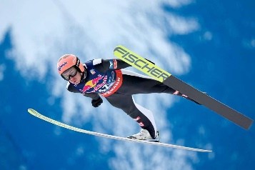 January 27: Austrian Stefan Kraft won gold at the Ski Flying World Championship in Kulm, Austria. It was way back in 2008 since an Austrian occupied this position! Stefan Kraft, 31, born in Schwarzach, is one of the most successful ski jumpers of all time, having won the Ski Jumping World Cup and Ski Flying World Cup overall titles two and three times respectively, the Four Hills Tournament once and Raw Air Tournament twice, and three individual gold medals at the World Championships. Since March 2017, he has held the ski flying world record of 253.5 metres (832 ft).
From Jan. 19 – March 3: A continuous open air ice rink near the City Hall in Vienna, winding through the park and even with a second floor, will make Vienna’s ice dreams come true.
January 27: International Holocaust Remembrance Day marks the anniversary of the liberation of the Auschwitz-Birkenau death camp by the Soviet Army in 1945. This somber reminder of the Holocaust’s horrors demands our commitment to ensure that a repeat will never happen.
The passionate performance of “Farewell, Auschwitz” by composer Jake Heggie was organized by “Music of Remembrance” at the Seattle Benaroya Hall on January 22, 2024: https://www.youtube.com/watch?v=txByJzhn4Ks
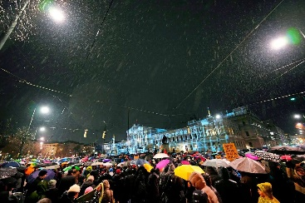 January 27: pouring rain did not deter up to 80,000 protesters who gathered in front of the Parliament in Vienna and in several Austrian cities to defend democracy and raise awareness for the mounting danger of extreme right parties. Several representatives from the Social Democratic party, the Green party, nonprofit organizations like Caritas, religious communities and from arts and culture joined the demonstration. Just for this occasion, Nobel prize winner Elfriede Jelinek wrote a chilling and moving essay that was presented by actress Mavie Hörbiger : “Ich höre ein Ungeheuer atmen” (I hear a monster breathing): https://www.derstandard.at/story/3000000204864/ich-h246re-ein-ungeheuer-atmen
2024 will mark the anniversaries of famous Austrian musicians, here is some pre-information about Anton Bruckner und Arnold Schönberg. Please look out for more information on upcoming special events honoring those giants of the music world in upcoming editions of the HC Newsletter!
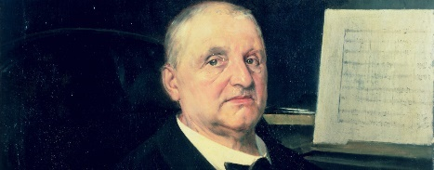 200th birthday Anton Bruckner: https://www.anton-bruckner-2024.at/en/?mc_cid=5f2d31bf94&mc_eid=1321923619
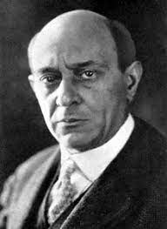150th Birthday Arnold Schönberg: https://www.schoenberg150.at/index.php/en/?mc_cid=5f2d31bf94&mc_eid=1321923619
2024 is also a big and important election year in Austria with upcoming EU elections (June), some state-wide elections, and the most important election to the National Assembly in September which will determine the Austrian government for the next 5 years.
Every Austrian citizen older than 16 years is eligible to vote!
Please register to vote if you have not yet done so! You can submit the registration ANYTIME – once you are registered, the absentee ballots for all elections you are eligible to vote will be mailed to your address for the next 10 years without any further action needed.
For more information about how to register, elections in Austria in general, etc., please see the website of the Honorary Consulate of Austria in Seattle (www.austrianconsulateseattle.org) and the website of the Consulate General of Austria in Los Angeles: https://www.bmeia.gv.at/en/austrian-consulate-general-los-angeles/service-for-citizens/elections-and-direct-democracy-general-information
It is our civil duty and privilege to participate in elections, a beacon of democracy.

UPCOMING and PAST EVENTS
Visit of a group of Austrian’s CEOs and IT consultants visited Seattle January 15-18, 2024, and got briefed on latest information while visiting Microsoft (generative AI, cybersecurity), Boeing (Everett factory tour), UW (Prof. Bender), Esper (mobile device management), Forma vision (holographic meeting platform), Alitheon (digital fingerprint software). Many thanks go to Tony Emsenhuber and the Advantage Austria Team in Los Angeles for organizing this great visit! Hope Tony can come up to Seattle soon again, for sure before he plans his retirement!

January 23, 6:30-8pm; SAGA Open House: https://www.sagaschool.org/ . This is an informal event allowing prospective parents and children to learn about SAGA’s program and meet some teachers and staff. For further information please contact SAGA at: admissios@sagachool.org
Virtual Stammtisch for German Learners: once a month via zoom:
Next meeting: Friday, February 23, 2024; 6pm.
The virtual Stammtisch for German learners is an opportunity to get together, speak German, and have fun. Sabine Sullivan is a native speaker and will host the Online-Stammtisch. If you would like to attend or have any questions, please contact Sabine Sullivan: sabine.sullivan@zoho.com

Monthly Stammtisch – 1st Thursday of the month: Mark your calendar!!
Next one: Thursday, February 1, 2024; 7pm; at the Epulo Bistro, 190 Sunset Ave Suite B, in Edmonds, WA
Please contact Jürgen Schatzer juergenschhatzer@gmail.com for details for the upcoming one. The location is rotating throughout the greater Seattle Area. There is so much to talk and chat about!
And in addition:
This time a special additional meeting: Deutsch-Österreichisches Treffen:
Friday, February 16, 2024; 6pm; Spada Farmhouse Brewery, Snohomish, WA;
If you have any questions about this gathering, please contact Adrianna Kostersitz: adikos@live.com

Check out the regular online film and music events organized by the Austrian Cultural Forum: https://acfdc.org/?mc_cid=487b48d54a&mc_eid=1321923619
Hope you stay dry and in good spirit through this rainy season

Mit herzlichen Grüβen
Eva Kammel
Honorary Consul of Austria in Seattle
office@austrianconsulateseattle.org | www.austrianconsulateseattle.org

