2022 Newsletter February 2022- HK Seattle

Dear Friends of Austria!

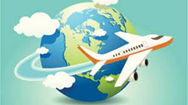 TRAVEL TO/FROM Austria:
February 19: Entering Austria traveling from USA: possible following the 3G rule: vaccinated, recovered or (PRC) tested
As the restrictions change frequently, please check the latest updates for traveling to and from Austria at the website of the Austrian Consulate General in Los Angeles: https://www.bmeia.gv.at/en/austrian-consulate-general-los-angeles/travels-to-austria/coronavirus-covid-19-and-travel-information/
For the Covid related situation within Austria: https://www.austria.info/en/service-and-facts/coronavirus-information
NEWS FROM AND ABOUT AUSTRIA
February 19: a new timetable for easing Covid restrictions was announced, under the requirement that no new variants or other Covid related challenges will emerge:
February 19 to March 5: 3G instead of 2G (i.e. a negative test is sufficient) for most of public life, exempt vulnerable situations like hospitals, nursing homes etc.
After March 5: 3G will be dropped for most of public life; masks only mandatory for specific publi situations (public transportation, groceries, hospitals etc); no restricting closing hours.

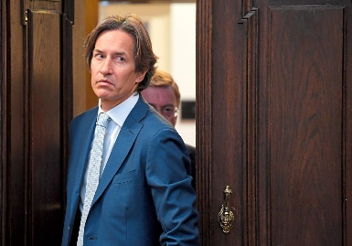 Former Finance Minister Karl-Heinz Grasser got sentenced to 8 years in porison finalizing the largest corruption process in the 2nd republic, after 3 years of deliberations. He immediately appealed to the verdict and the assumption of innocence must be uphjeld until the fial verdct is spoken. The main accusation is the enrichment through corruption of alomost 10 mio Euro during the privatisation of federal appartments BUWOG.

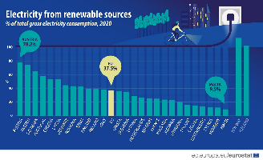 In Austria, about 78% of electricity consumed in 2020 was generate3d from renewable sources, the highest in the EU! Decarbonizing Europe’s energy grid is critical for affordable utilities, erengy sovereignity, and the green transition. For more information: Eurostat: https://ec.europa.eu/eurostat/en/web/products-eurostat-news/-/ddn-20220126-1
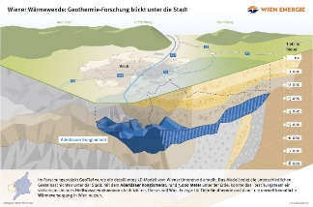 A major source of geothermally heated groundwater has been discovered about 3,000 m = yards beneath the city of Vienna, which could be utilized for district heating of about 125,000 households and help to meeting its goal of entirely decarbonizing its heat supply by 2040. Further research neds to be done to ensure the feasibility. Vienna's Fernwärme (district heating) network is an essential part of its plan to switch to sustainable heating. Fueled by waste incineration and waste-heat recovery, the city is committed to meeting about 56 percent of its heating needs through Fernwärme by 2040, with the remainder largely covered by heat pumps. By then, the Fernwärme network should operate in an entirely carbon neutral fashion, with geothermal heat playing a major role.
https://www.wien.gv.at/english/politics/international/newsletter/01-2022-geothermal-heat-source.html
Vienna top travel destination in 2022
Where to travel in 2022? Good news for all travel-hungry: two leading international media, the US news portal Bloomberg and the British daily newspaper The Independent, have named Vienna the top travel destination in 2022.
Vienna in first place worldwide for quality of life
According to the Expat City Ranking 2021 by Internations, a network for people living and working abroad, Vienna ranks first worldwide in its Quality of Urban Living Index. The city also achieves high scores in the subcategories transport and health and environment. Overall, the Austrian capital ranks 14th out of 57. https://www.internations.org/expat-insider/2021/quality-of-urban-living-index-40190
Nationality Rooms in Pittsburg displkayiing 31 Nationality Rooms, among them the “Austira Room”
https://www.nationalityrooms.pitt.edu/rooms/austrian-room

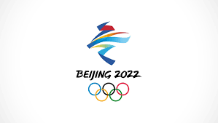 Austria’s Athletes delivered a woderful perfomance at the Olympic Games:
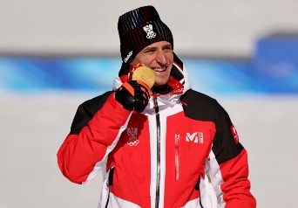 Matthias Mayer is Austria’s Alpine Skiing super athlet of the Games! He won Gold in Mesn’s Super -G and Bronce in Downhill race. This is Mayer’s 3rd Gold medal at Olympic games after Downhill Gold in Sotschi 2014 and Super-G Gold in Pyeongchang 2018). Coming from a Farm Family in Carithia he impresses with his modest and quiet personality.
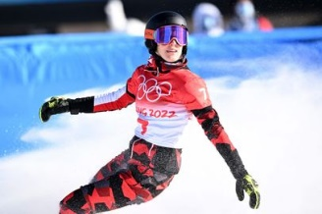 Danilela Ulbing won Silver in Snowboard Parallel Giant Slalom
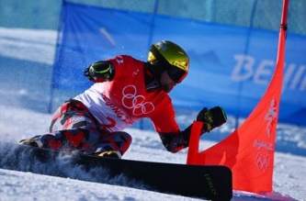 Benjamin Karl won Gold in Sonwboard Parallel Giant Slalom
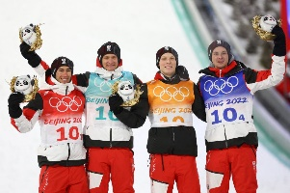 Gold in Team Ski Jumping goes to the Austrian team Stefan Kraft, Daniel Huber, Jan Hoerl, Manuel Fettner.
Anna Gasser won Olympic Gold twice in different snowboarding competitions.
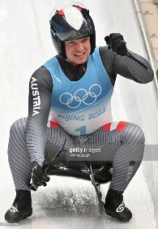 Wolfgang Kindl won Silver in Men’s Singles Luge
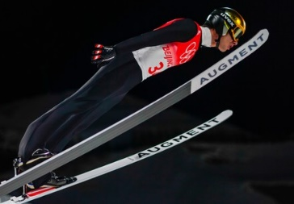 Manuel Fettner Silver Ski Jumping
Several other athletes placed also among the best 10, sometimes only a fraction of a second behind.
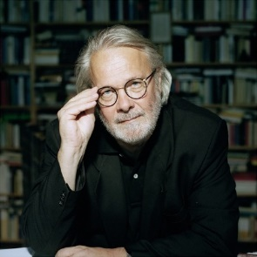 February 8: Austrian Author Gerhard Roth died in Graz 79 year old. He won many literary prizes and also the Golden Romy for the screenplay “Schnellschuss”. His vast writings list “Stiller Ozean”, “Landlaeufiger Tod”, serveral cycles of novels, as his main opus „Das Archive des Schweigens”, the re-appraisal of Austrian history in today’s political and social systems.
UPCOMING EVENTS
Check out the regular online film and music events organized by the Austrian Cultural Forum: https://acfdc.org/?mc_cid=487b48d54a&mc_eid=1321923619

Regular events are offered by the Goethe Pop Up Seattle, ranging from book club, Summer camps, movies, and literature presentations: https://www.goethe.de/ins/us/en/sta/gps.html

Monthly Stammtisch – 1st Thursday of the month: Mark your calendar!!
Virtual STAMMTISCH: September 2, 2021: Join the first get-together with friends of Austria after the summer break, even when only via zoom. There is so much to talk and chat about! Zoom link: https://us02web.zoom.us/j/5845087371 . Questions: please contact Elana Sabajon: youcan@askelana.com

Mit herzlichen Grüβen
Eva Kammel
Honorary Consul of Austria in Seattle
office@austrianconsulateseattle.org | www.austrianconsulateseattle.org

