2023 December 2023 Newsletter - HK Seattle
Dear Friends of Austria!
Wishing you all peaceful last days of 2023, enjoying some rest and slower pace together with family!
Thinking about a New Year’s Resolution that brings so much fun?
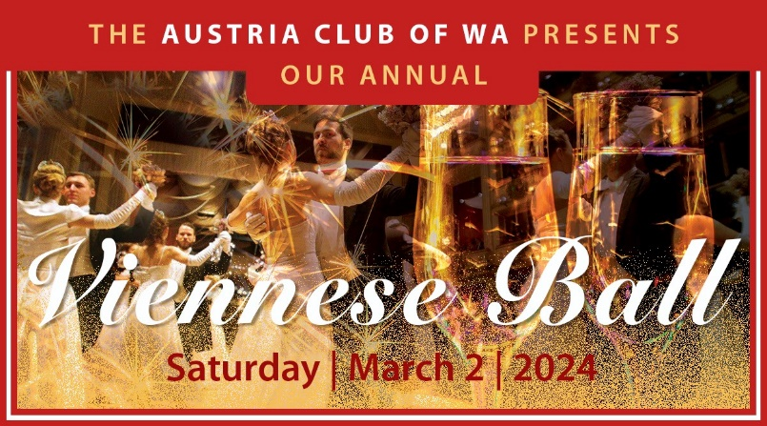
Watch out for the announcement of the start of the ticket sale at the beginning of the New Year! Stunning new location, new live band, elegant dinner and so much more – all in Viennese Ball tradition … you don’t want to miss it… !
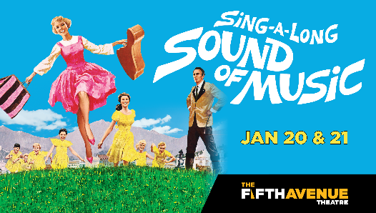 In January 2024 there will be a Sing Along Performance of “The Sound of Music” at the 5th Ave Theater in Seattle! https://www.5thavenue.org/shows/2023-2024/sing-a-long-a-sound-of-music/ . If we can get a group of 10+ (we aim for the performance on Sunday, Jan 21 at 1:30pm), we will get a discount of 25% and the transaction fee will be reduced from $10 to $2. We can dress up in our traditional Dirndl and Lederhosen if we want! If you are interested in participating, please contact Michael Brandstetter michael.brandstetter@gmail.com or Eva Kammel office@austrianconsulateseattle.org
TRAVEL TO/FROM Austria: no further Covid related restrictions are currently in place
Please check the latest updates for traveling to and from Austria at the website of the Austrian Consulate General in Los Angeles: https://www.bmeia.gv.at/en/austrian-consulate-general-los-angeles/travels-to-austria/coronavirus-covid-19-and-travel-information/

NEWS FROM AND ABOUT AUSTRIA
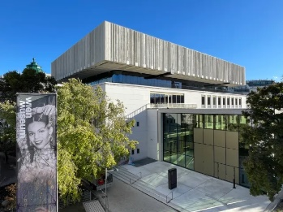 December 6: Opening of refurbished Wien Museum: Vienna is the EU’s fastest growing capital and is regularly named the world’s most liveable city. The story of its origins from the earliest settlement (Bronze Age) to the present day is told by the Wien Museum, originally built in the 1050s, which reopens to the public today after a €108m refurbishment. In a radical departure from Austria’s national museum strategy, entry is free aiming that the museum becomes a meeting place, a living room for everyone”. The Nazi era is covered in some detail under the heading "Laboratory of Cruelty" showing the citizens of Vienna joyfully welcoming the Nazis into their city in March 1938 until Austria’s public reckoning with its wartime past that only began in the 1990s.
https://www.theartnewspaper.com/2023/12/06/austria-confronts-its-nazi-past-in-multi-million-euro-wien-museum-refurbishment
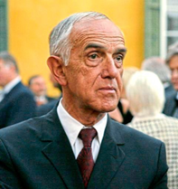 December 26: Gaston Glock, Austrian engineer and inventor of the gun that bears his name, died at age 94. 65% of the market share of these hand guns are sold in the USA. Born in Vienna into a modest home, he got trained as an engineer and designed his first weapon for the Austrian Military in 1982. It was lighter, more precise and reliable and cheaper. Soon after he became a phenomenal seller, especially in the United States. Up to 80% of the US police force are using this product. He entertained right wing politicians but avoided publicity and valued his privacy at his estate on the shores of the Wöthersee in Velden. He was a reclusive billionaire. At the age of 82 he divorced his wife and married a 31-year-old woman.

Fulbright Teaching Assistance Program: https://www.usta-austria.at/?mc_cid=94b306d2cc&mc_eid=1321923619
Are you looking for an exciting opportunity that allows you to explore a new culture while simultaneously gaining valuable first-hand classroom experience? For decades, Fulbright Austria has worked with the Austrian Federal Ministry of Education, Science, and Research (BMBWF) to bring qualified, motivated university graduates from the United States to teach English in Austria in secondary schools all across the country.
As a teaching assistant, you help Austrian students develop the linguistic skills that will help them succeed as they grow up. You also serve as an informal cultural ambassador and promote mutual understanding between the peoples of the United States of America and the Republic of Austria—making your job as an English teaching assistant in Austria just as rewarding for you as it is for your students.
Application deadline: January 15, 2024
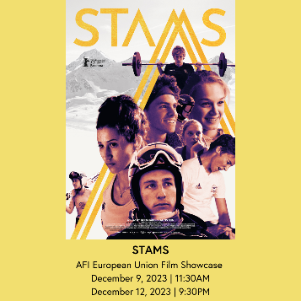 Austria’s contribution to the European Film Festival in Washington, DC, is “STAMS” by Bernhard Braunstein, a documentary about the world famous skiing high school in Tyrol. https://silver.afi.com/Browsing/Movies/Details/f-0100004293?mc_cid=94b306d2cc&mc_eid=1321923619.. The documentary takes viewers inside Stams, one of the most prestigious skiing high schools in the world, to show one year in the life of the students. It reveals the institutional mechanisms used to develop elite athletic talent, while leaving plenty of room to question what physical and mental costs might accrue along the way. In German with English subtitles.
On 20 September 2023, the Austrian Federal Government resolved to provide additional support to all living victims of National Socialism from Austria. With this step, Austria is reaffirming its special responsibility towards those persecuted by the Nazi regime. The resolution provides for a one-time extraordinary gesture payment of 5,087.10 Euros to all living victims of National Socialism from Austria under National Fund criteria.
All persons who qualify were notified by the Austrian government. If you think you qualify but did not get the notification, please contact the National Fund https://www.nationalfonds.org/gesture-payment or the Honorary Consulate of Austria in Seattle for further information.
To receive the payment you must submit a Proof of Life. Please contact the Honorary Consulate of Austria in Seattle to schedule an appointment.
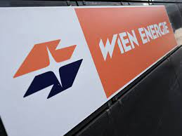 The City of Vienna is opening the largest heat pump in Europe that produces 100% renewable energy for now about 56,00, with an endgoal of 110,000 households. The energy gets extracted from the heat produced by the cleaning process of sewage water. Vienna has the goal to achieve CO₂ neutrality by 2040.
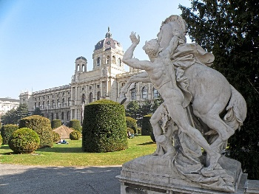 For the 11th time, Vienna again got ranked as the most livable city in the world according to Mercer. Vienna, Austria, tops the quality of living ranking for 2023. Known for its rich history, stunning architecture, and vibrant cultural scene, Vienna offers its residents a high standard of living in various aspects (health care, public transportation, housing, education etc) . It is followed by Zurich, Switzerland and Aukland, New Zealand in second and third place, respectively. https://www.mercer.com/insights/total-rewards/talent-mobility-insights/quality-of-living-city-ranking/?size=n_20_n . FYE: Seattle ranks 52nd.
Vienna got also voted the ”European Capital of Democracy” 2024/2025 by 4,000 European experts and citizens from 47 different countries. The jury was particularly impressed by the city’s clear focus on a future based on climate change and how to advance democracy to boost social cohesion based on active citizen participation.
2023 Vienna got ranked as one of the best Christmas Markets by the “Financial Times”.

Something special started in the world famous Skiresort town Lech am Arlberg: Champagne - Gondola: for an exclusive break, apres-ski or for a special occasion you can get Champaigne and snacks served during the gondola ride! https://www.moet-champagner-gondel.at/

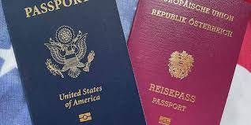Doppelstaatsbűrgerschaft: This very pressing and contentious topic is relevant for so many Austrians living abroad, wherever in the world (about 600,000!): If an Austrian citizen applies for another citizenship, he/she will lose the Austrian citizenship unless a special “Beibehaltung” is granted before the application process got started. Unfortunately, currently this “Beibehaltung” gets granted only in rare circumstances. Within the EU, Austria is one of the strictest countries in this regard.
There are different groups working on this issue and trying to raise awareness and to put pressure on politicians and officials.
https://www.weltbund.at/
https://www.beibehaltung.at/
https://www.doppelstaatsbuerger.at/
UPCOMING EVENTS
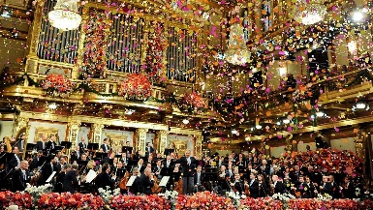 January 1: New Year’s Concert with the Vienna Philharmonic Orchestra: broadcasted on January 1. Celebrate the New Year with waltzes by Strauss and more, performed at Vienna’s Musikverein by the Vienna Philharmonic, led by guest conductor Christian Thielemann. PBS favorite Hugh Bonneville returns as host. Tune in on January 1 to your local PBS Station at 9pm (in Seattle Area: KCTS9)

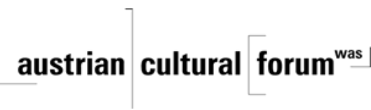 Check out the regular online film and music events organized by the Austrian Cultural Forum: https://acfdc.org/?mc_cid=487b48d54a&mc_eid=1321923619
Virtual Stammtisch for German Learners: every other month via zoom: Next meeting: in February 2024. The virtual Stammtisch for German learners is an opportunity to get together, speak German, and have fun. Sabine Sullivan is a native speaker and will host the Online-Stammtisch. If you would like to attend or have any questions regarding German lessons, please contact Sabine Sullivan: sabine.sullivan@zoho.com.
Sabine is also organizing the “Austria Cultural Table” for the ICFF (international Children’s Friendship Festival, http://www.icffseattle.org/), coming up April 20-21, 2024. If you are interested in volunteering or with ideas, please contact Sabine.
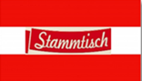Monthly Stammtisch – 1st Thursday of the month: Mark your calendar!!
The next one is on Thursday, January 4, 2024, 7pm, at Chianti Kirkland, 7 Lakeshore Plaza, Kirkland, WA. The location is rotating throughout the greater Seattle Area. There is so much to talk and chat about! For more information please contact Jürgen Schatzer juergenschhatzer@gmail.com.
Mit herzlichen Grüβen and best wishes for a healthy, happy
…. and peace for all
Eva Kammel
Honorary Consul of Austria in Seattle
office@austrianconsulateseattle.org | www.austrianconsulateseattle.org

