April 2023 Newsletter - HK Seattle
Dear Friends of Austria!
The last few weeks were busy at the Honorary Consulate.
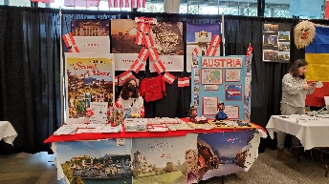 First, we hosted an Austria Table at the International Children’s Friendship Festival April 22-23, 2023. It was fun to see many children (and their parents/grandparents) “traveling” from country to country and learn about each other’s culture and specifics. We had wonderful volunteers at our Austria Table, being excellent ambassadors of Austria! Thank you, Sabine Sullivan, for organizing and all volunteers who contributed. Please make sure you don’t miss it next year!
Apropos Ambassador:
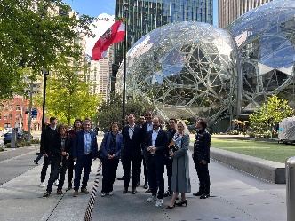 It was a great honor and privilege that Austria’s newly accredited Ambassador to the US, DDr. Petra Schneebauer, together with Consul General Dr. Michael Postl, came to Seattle on her first official visit to the West Coast! They were accompanied by a delegation headed by State Secretary for Digitalization, Florian Tursky, and Austrian journalists. In a whirlwind of activities, meetings with SpaceX, Amazon, representatives of the Governor’s office and Greater Seattle Region as well as sightseeing were packed into the 2-day visit.
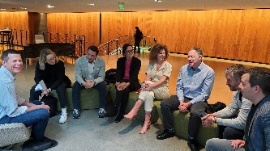 In addition, the Austrian journalists held a round table discussion with some of our professional Austrians sharing their insight in AI, work, life, and job opportunities here in the Seattle area in comparison to Austria. Thank you to all who participated and especially Bernhard Klee, for providing the space and keeping the journalists happy by touring them afterwards through the Amazon Spheres.
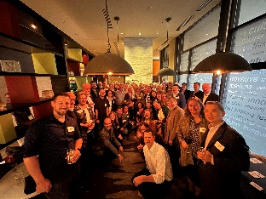Highlight was a wonderful reception honoring our special guests at the Renaissance Hotel, where the delegation also stayed overnight. Many thanks to fellow Austrian Jürgen Oswald, general manager of the hotel, for the hospitality! Over 70 guests joined a relaxed and gemütlich get-together, mingling and chatting with new and well-known friends, and listening to a hilarious impromptu performance by Manuela Horn, our Yodelqueen! Both, Ambassador Schneebauer and Consul General Postl, were full of positive comments, and they really enjoyed and were impressed by such a crowd of accomplished, friendly, and engaged Austrians and their spouses. Thank you to everyone who contributed!
Enclosed is also the Welcome Letter of Ambassador Schneebauer. She is reminding all Austrians living abroad to please – if you have not done so yet - register through the online-portal: https://auslandsregistrierung.bmeia.gv.at/ to make sure your data are correct and up-to-date, so that you can be reached in case of emergency and stay informed about important official developments. For further service beyond the local and Consulate General’s office, please check the information portal of the Ministry for Foreign Affairs: https://www.bmeia.gv.at/reise-services/auslandsservice/
One more item: please check the validity of your passport! If you need to apply for a new passport (everyone gets a new passport, there are no “extensions” anymore), please contact me ASAP, so that we can get the application in before the travel season starts.
The Next Delegation from Austria is coming May 14-16, 2023. They are companies from Tyrol and Vorarlberg (Blum, Gebrüder Weiss, Liti-Link, RedHat, Sola, and other consulting, medical and educational institutions, interested in logistics, IT - infrastructure. Please let me know if you are interested in joining a get-together on Monday, May 15, 2023.

TRAVEL TO/FROM Austria: no further Covid related restrictions are currently in place for traveling to Austria. The ban on unvaccinated travelers to the US may expire on May 11. Please stay tuned!
Please check the latest updates for traveling to and from Austria at the website of the Austrian Consulate General in Los Angeles: https://www.bmeia.gv.at/en/austrian-consulate-general-los-angeles/travels-to-austria/coronavirus-covid-19-and-travel-information/
For the Covid related situation within Austria: https://www.austria.info/en/service-and-facts/coronavirus-information
NEWS FROM AND ABOUT AUSTRIA
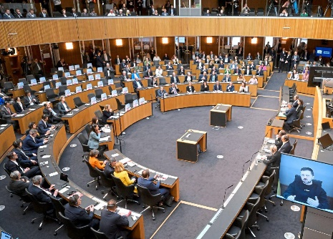 March 30: video speech by Ukraine President to the Austrian Parliament. Members of the governing parties and Austria’s Federal President were attending this important event and assured Austria’s commitment to continue to help Ukraine with humanitaren aid as much ssd [ossible. President Zelinsky especially thanked Asutria for the medical assistnace of several Austrian hospitals for some of the worst injured soldiers.
In an act of disrespect the far right party FPÖ (in opposition) did not attend and protested with the argument of adhering to Austria’s neutrality written in its constitution.
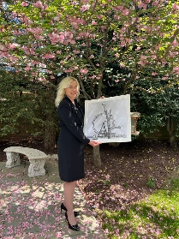 April 19: Ambassador Petra Schneebauer presented her letter of Credence to US President Joe Biden. As a present she brought a photo of the Vienna Ferris Wheel taken in 1946 by former White House Photographer Yoichi Okanmoto as a symbol of Austrian – American Friendship. Willkommenschreiben attached
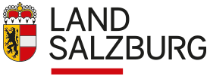April 22: elections in Province Salzburg: Losses of the traditional parties, wins of right wing FPÖ and left wing KPÖ, coalition formation is still under negotiations. Many voters switched their paries they voted for last elections.
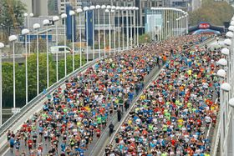 April 23: Vienna 40th City Marathon : about 40,000 runners were participating, about 9,000 of them aimed for the full length over 42 km (= 26mi), almost 40% were women. (As comparison, at the first Vienna Marathon there were only 2% of them women!). Julia Mayer improved the Austrian record by 1 sec to 2:30:42h. The men’s category won Samwel Mailu from Kenya with 2:05:08h, the women’s winner Magdalyne Masai, also from Kenya, needed 2:24:12h
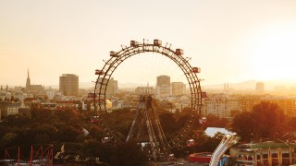 The City of Vienna ranked again at or near the top of numerous recent global rankings:
According to Boston Consulting Group: Most desirable “middleweight” (< 3Mio population) city: 2nd place just behind Copenhagen and ahead of Amsterdam; in category Quality of Life: on top,
In overall Global city ranking: ranks 7th (tied with Beijing) (BTW Seattle ranks 12, London and New York on top))
Newsweek’s “World’s best Hospitals 2023”: University Hospital Vienna: placed 30th out of 250; runs jointly with Medical University of Vienna and closely combines treatment with research and teaching. (BTW, UW Medical Center ranks 110)
TIME’s “World Greatest Places”: as a first for an Austrian city, Vienna ranked under the top 50 travel destinations.

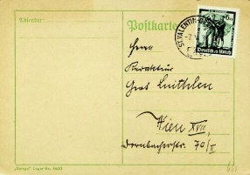 Postcards are an Austrian invention! Did you know that the first cards were issued by the post offices of Austria-Hungary in 1869? They became quickly very popular. The first version of the postcard had no images, and strict rules dictated where you could write on them. Serving as the instant messaging system of their time, postcards were supposed to simplify everyday communication. A year later, the British and German post services followed the Austrian example, and in 1873 the US. The concept of the postcard had taken root worldwide.
When was the last time you sent a postcard?
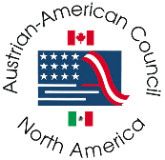 Austrian American Council West has launched a new website worth exploring! There you can also find information about the ambitious project of bringing the first SOS Children’s village to California: https://aacwest.com/ . Please contact Christina Calio, president of the AAC West – WA Chapter, for more information: christina@caliomusic.com

UPCOMING and PAST EVENTS
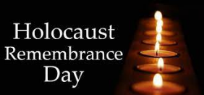 April 17 marked the Holocaust Remembrance Day and the 80th anniversary of the Warsaw Ghetto uprising. We should never forget the importance of remembering the horrors imposed in the past and make sure they will never be repeated, that we will never forget.
Seattle based Music of Remembrance https://www.musicofremembrance.org/ under the leadership of Mina Miller invites you to watch Lori Laitman’s powerful “Wertheim Park: https://www.youtube.com/watch?v=oh5NGxFsQO0
The Holocaust Center of Humanity in Seattle observed the Holocaust Remembrance Day with a presentation by survivor Agi Day, https://holocaustcenterseattle.org/programs-events/yom-hashoah-2023-online-program
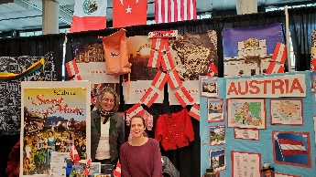 International Children’s Friendship Festival (April 22-23,2023): had many visitors of all ages. The children (and their parents/grandparents!) were busy “traveling” from country to country and to learn more about each other’s culture. Many visitors stopped by our Austria table. Thank you Sabine Sullivan for taking on the organisation and all the volunteers ready to talk about Austria!
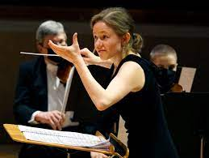 Katharina Wincor, 28, joined the Seattle Symphomy Orchestra to conduct the April 27-28 RachFest - a two-day festival featuring all four Rachmaninov Piano Concertos, in commemoration of the composer’s 150th anniversary. The Austrian conductor is a rising, charismatic talent. Wonderful to have her perform here in Seattle!
Check out the regular online film and music events organized by the Austrian Cultural Forum: https://acfdc.org/?mc_cid=487b48d54a&mc_eid=1321923619
Virtual Stammtisch for German Learners: once a month via zoom: Next meeting: at 7pm. The virtual Stammtisch for German learners is an opportunity to get together, speak German, and have fun. Sabine Sullivan is a native speaker and will host the Online-Stammtisch. If you would like to attend or have any questions, please contact Sabine Sullivan: sabine.sullivan@zoho.com
Eastside German Language School is hosting its Maifest and start of registration for next school year on Saturday, May 20, from 10-12pm. For mor information: https://wp.egls.us/
Flohmarkt! May 13, 11am-4pm; at the SAGA school grounds, 1105 Greenwood Ave N, 98133 Seattle; For more information, also if you want to host an booth, please contact SAGA directly: info@sagaschool.org
Monthly Stammtisch – 1 or 2nd^{st} Thursday of the month: Mark your calendar!!
Please contact Jürgen Schatzer juergenschhatzer@gmail.com for details for the upcoming one. The location is rotating throughout the greater Seattle Area. There is so much to talk and chat about!
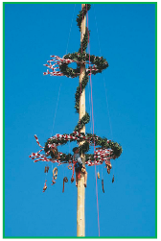 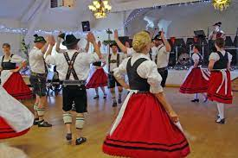 MAIFEST of the Austria Club: May 28, 2023, 3-7pm, at the Kenmore Community Center, 73rd NE and NE Bothell Way. Everyone is invited to join the Celebration of Spring!
Tickets: Austria Club Members: $25, Non-Members:$ #5; music, dance and Dinner included. For more information, please contact Michael Brandstetter: michael.brandstetter@gmail.com
The sun is out! Finally, we can leave winter behind us! Enjoy, recharge, and stay healthy. Looking forward seeing you at the next Austria event.
Mit herzlichen Grüβen
Eva Kammel
Honorary Consul of Austria in Seattle
office@austrianconsulateseattle.org | www.austrianconsulateseattle.org

Attached: Welcome Letter Schneebauer

