2022 April Newsletter - HK Seattle
Dear Friends of Austria!
What a busy April we had – from nature competing opening buds, Easter/Passover Holidays, last ski runs, to special guests visiting Seattle!
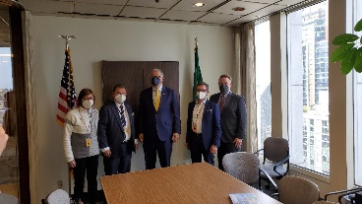 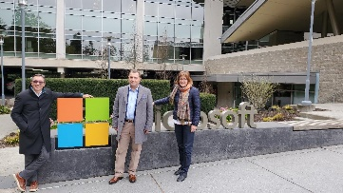After a long Covid forced pause of visits, it was a special honor to welcome from Los Angeles Austria’s Consul General Dr. Michael Postl and Trade Commissioner Volker Ammann in Seattle from April 11-14, 2022. We prepared a packed program including visits with Gov. Jay Inslee, with some of the Tech giants, and with companies of the region where Austrians could present their excellent contribution. Forward looking discussions about the Microsoft Cloud Center that is currently under construction in Austria and presentations by Austrian researchers at UW informed our guests about ongoing developments. At a working-breakfast with the president of the Austria Club, Michael Brandstetter, and the Austrian American Council West-WA Chapter president, Christina Calio, the president of the Austrian American Society of OR, Egbert Kunrath, and other board members, we could discuss with CG Postl concerns of Austrians living abroad, especially dual citizenship. At the social gathering at the Salmon House, it was especially nice to see so many former and present board members and presidents of the AC of WA but also of OR who visited for this occasion. Together with our guests of honor we enjoyed the happy atmosphere, beautiful view, buffet, and just being able to gather in person again.
TRAVEL TO/FROM Austria: Current as of April 1:
Travel to Austria: 3-G required for arrivals from all countries: either valid proof of vaccination (max of 270 days after administration of last dose), or negative Covid test, or proof of recovery.
Travel to United States: since April 19: Good news for travel in the summer: CDC has dropped all countries from the “high risk” list for Covid infection. All travelers must provide a negative Covid Test not older than 1 calendar day; all non-citizens/green card holders must provide in addition proof of full immunization.
As the restrictions change frequently, please check the latest updates for traveling to and from Austria at the website of the Austrian Consulate General in Los Angeles: https://www.bmeia.gv.at/en/austrian-consulate-general-los-angeles/travels-to-austria/coronavirus-covid-19-and-travel-information/
For the Covid related situation within Austria: https://www.austria.info/en/service-and-facts/coronavirus-information . Most restrictions are gone, only masks are required on public transportation and in public spaces.
NEWS FROM AND ABOUT AUSTRIA
April 5: Austria pledges extra 10 Mio Euro to Moldova. In 1991 Moldova gained independence from the USSR.
April 7: Austria is expelling 4 Russian diplomats, elaborating only: “the (four) people have acted in a way that is inconsistent with their diplomatic status”. This kind of phrase is usually used to refer to spying.
https://www.usnews.com/news/world/articles/2022-04-07/austria-says-it-is-expelling-four-russian-diplomats. Austria hosts an unusually large contingent of diplomats because several International Organisations are based in Vienna.
April 19: 4 Austrian diplomats got expelled from Russia.
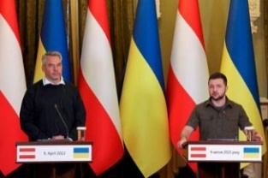 April 9: Austria’s Chancellor Karl Nehammer visited Ukraine’s President Volodymyr Zelensky in Kyiv and delivered emergency and other rescue vehicles. He traveled by train within Ukraine. His visit should deliver a clear symbol of respect of souverainity, independence and in support of the political leadership of Ukraine. Some critical questions came from reporters about the still flowing gas imports from Russia and if Raiffeisen Bank is adhering to the imposed sanctions. The Chancellor also reported that the Austrian Ambassador to Ukraine is returning to Kiew. After an emotioanl visit to the horrors of Butcha, Chancellor Nehammer promised continued help from Austria together with the EU, also for the time after the war had ended.
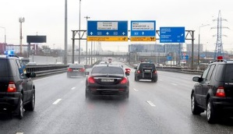 April 11: Chancellor Karl Nehammer visited Russia’s President Putin in Moscow. Nehammer said his motivation for this trip was that every chance to end this horrible war, even a small one, must be tried. He confessed after the talks though that there is no optimistic assessment and that the Russian offensive to the Eastern Ukraine is imminent. He reiterated that it is important to tell Putin in his face that he alone is responsible for this ongoing horror.
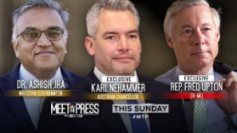 April 17: Austria’s Chancellor Karl Nehammer, who met with Ukraine President and the Russian president was guest at “Meet the Press”. https://www.nbcnews.com/meet-the-press/video/full-austrian-chancellor-putin-believes-he-is-winning-the-war-in-ukraine-137864261833. Austria’s Chancellor stressed that he saw the importance of confronting the Russian President with the reality of the horrors of the war after he saw himself the devastation his troops are inflicting on the Ukrainian people. He came out of the meeting with no real hope of an end in the near future.
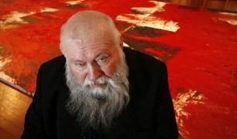April 18: Artist Hermann Nitsch, died at age 83. He was famous and triggered intense critique and uproar at the same time because of his extravagant, scurille, brutal exhibitions, where blood was prominent. We wanted to bring you out of your comfort zone to realize reality. He was one of the most prominent representative of the “Viennese Actionism”. https://www.nytimes.com/2022/04/23/arts/hermann-nitsch-dead.html
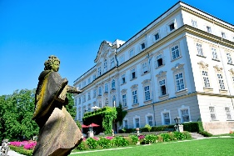April 21: Austria’s ambassador to the United States, Martin Weiss, will leave his post in the summer to accept the leadership position of “Salzburg Global Seminar”. This prestigious political thinktank is located in the Leopoldskron Castle and hosts programs on global topics, to challenge present and future leaders to solve issues of global concern. He will be the first non US leader of this organisation. His successor as ambassador has still to be determined.
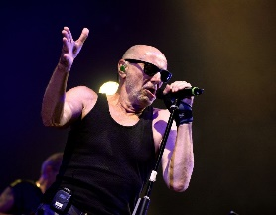 April 24: Willi Resetarits , aka “Ostbahn-Kurti” suffered a deadly accident at the age of 73. He was one of the most influential and original homegrown musicians, portraying “Schmaeh” ( typical Viennese humor) and social justice at the same time. He interpreted songs from the Rolling Stones with typical Viennese flair, offering comfort and advice, coziness and complaints.
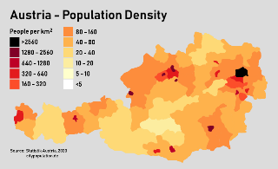 April 26: For the first time Austria surpassed 9 Million residents. The surge in residents this year is partly due to the influx of refugees from the Ukraine, about 50,000 so far. Out of these refugees were almost 40% childrens under 20 years, and about 70% women. In 2022, Vienna’s number of residents increased the most, almost by 1%. The country is prepared to welcome about 200,000 refugees to stay in Austria. So far, about 250,000 Ukrainian refugees have transited through Austria.
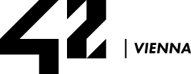 In its quest to develop into “Europe’s Digital Capital”, Vienna is opening a new institute for digital education (Programmierschule 42 Vienna, part of the global network Ecole 42) and is offering 150 spots at no cost, later to be increased to 450 students. For more information about applications: 42vienna.com
UPCOMING EVENTS
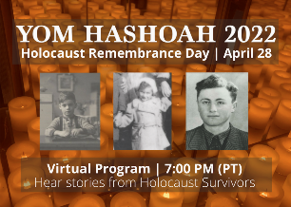 April 28: Holocaust Remembrance Day: Yom Hashoah 2022: The Holocaust Museum Seattle invites to a virtual program of remembrance and inspiration with a panel of local Holocaust survivors, a candle-light ceremony with descendants of survivors, and words of reflection from Rabbi Simon Benzaquen. https://holocaustcenterseattle.org/yom-hashoah-2022-holocaust-remembrance-day
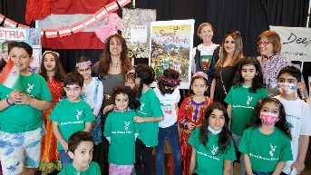 Saturday, April 23, we presented at the International Children’s Festival an Austria cultural table, emphasizing to children (and adults!) the beauty and cultural diversity of our home country. A heartwarming example of cultural exchange among children was an Iranian children’s group singing Do-Re-Mi in Farsi in front of our table: https://share.icloud.com/photos/0a2LaWNpDHSihMFpon9wC29dA .
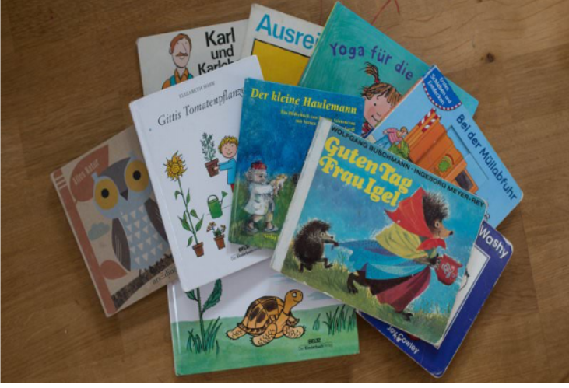 April 30: 9am – 12noon at GLS (German Language School Seattle) BOOK and BAKE Sale. c/o Villa Academy. For more information: germanlanguageschool.org
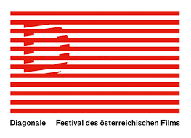Three Austrian films streaming for an international audience!
The annual Austrian film festival Diagonale has joined forces with the Austrian film platform WatchAUT to make the online screening of three Austrian films possible around the world. Streaming is available between April 5 and May 5, 2022 through WatchAUT.film for € 9,90. All films have English subtitles.
The films included in the package are:
“Notes from the Underworld” | "Johanna Dohnal – Visionary of Feminism" |"The Murder Case"
Tickets available from https://acfdc.org/events-2022

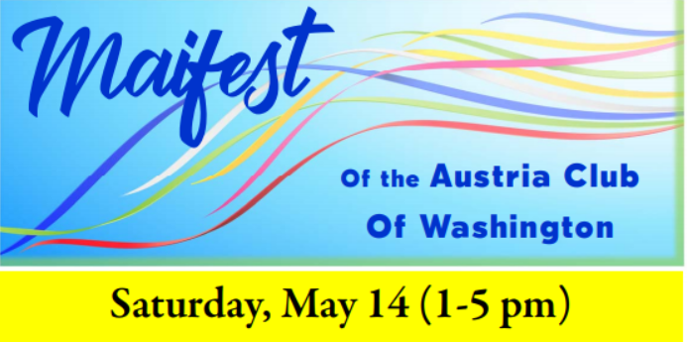
at the Scottish Rite Center; 1207 N 152nd Street, Shoreline. Live music by Bert Carlson Band, good food and drinks will cheer up this traditional celebration of spring, finally again in person! Bring your family and guests!
For more information, please see attached flyer or contact Michael Brandstetter michael.brandstetter@gmail.com.

Weltbund Tagung – Auslandsoesterreicher Treffen: 1.-4. September 2022 in Vienna: Information and registration: https://www.weltbund.at/veranstaltungen/austria/weltbund-tagung-2022/ Registration Deadline: August 3, 2022. This annual event brings together Austrians living abroad and offers an opportunity to engage in concerns and wishes common to those living abroad, independent where in the world! After 2 years of being forced to go virtual, it can take place again in person.
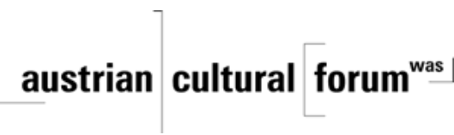 Check out the regular online film and music events organized by the Austrian Cultural Forum: https://acfdc.org/?mc_cid=487b48d54a&mc_eid=1321923619
Regular events are offered by the Goethe Pop Up Seattle, ranging from book club, Summer camps, movies, and literature presentations: https://www.goethe.de/ins/us/en/sta/gps.html
Monthly Stammtisch – 1st Thursday of the month: Mark your calendar!!
Virtual STAMMTISCH: May 5, 2022, 7pm: Join the first get-together with friends of Austria after the summer break, even when only via zoom. There is so much to talk and chat about! Zoom link: https://us02web.zoom.us/j/5845087371 . Questions: please contact Elana Sabajon: youcan@askelana.com or Jürgen Schatzer: juergenschatzer@gmail.com
As travel season is upon us and restrictions are easing on both sides of the Atlantic, please check your travel documents. If you need a new Austrian passport, please contact me at office@austrianconsulatesettle.org. Regular processing time for a new passport is about 6-8 weeks.
With hope and prayers for peace,
Mit herzlichen Grüβen
Eva Kammel
Honorary Consul of Austria in Seattle
office@austrianconsulateseattle.org | www.austrianconsulateseattle.org

