HC Newsletter April 2021
Dear Friends of Austria!
Today I am writing from Vienna. As for many of us, it was hard not being able to travel and visit family last summer.
The travel experience was very different, there were hardly any passengers on the plane (I think more personnel than passengers!) but the Covid checks (negative test not older than 48 hours) were very thorough, at SEA but also at Frankfurt and Vienna Airports. Wearing masks all the time during the flight and at the airports was mandatory, no difference if vaccinated or not (this might change soon),
After my arrival in Vienna, I could leave the quarantine at day 6 after a negative Covid-19 test. They checked very strictly; the police even came by the address I stayed at to check that I do not leave the house!
In addition, there is a strict lockdown in the Eastern part of Austria, with only groceries, pharmacies open and otherwise only limited visits allowed. These Covid related restrictions will change with May when they plan to open up gradually. Also, they are working on a “green” passport that shows your vaccination/test/recovery status and will open the doors to many more activities. The vaccination efforts are running on high speed after initial bumps in the roll out. And most important, the number of infections are falling steadily. Hope for a somewhat normal is out there – planning for an active summer in Vienna and other parts of the country is already under way!
I assume that traveling in summer or early fall should become much easier. Also, the EU is lifting the travel restrictions for US citizens because of the improved situation in the US. But all is guided by the success of reducing the number of infections. For the newest updates on the current travel restrictions, please check the website of the Consulate General of Austria in Los Angeles: https://cms.bmeia.gv.at/gk-los-angeles/aktuelles/
Although the timing for my travel to Austria showed me a different Austria than I am used to (no Heurigen Besuch, no Kaffeehaus, no visit at the Opera), it is all worth to finally being able to visit family!
I will resume regular in person appointments for the Honorary Consulate after May 10, 2020
NEWS FROM AND ABOUT AUSTRIA
March 25: the first part of a memorial wall - listing all 64,000 names of Austrian victims murdered in the Shoah - has been revealed in Vienna. All 64,000 names will be engraved, including the year of birth. An important day for Austria. We will not forget.
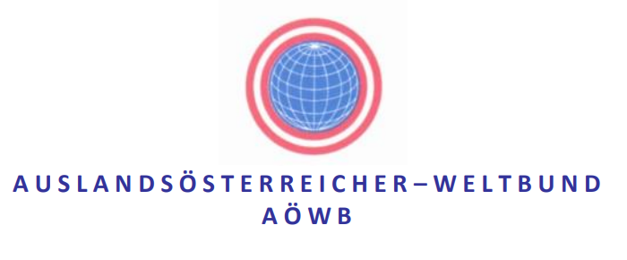2.-5. September: Annual meeting of Austrians Abroad (Weltbund) this year in Vienna: September; for more information please see attached invitation or the Weltbund website: https://www.weltbund.at/.
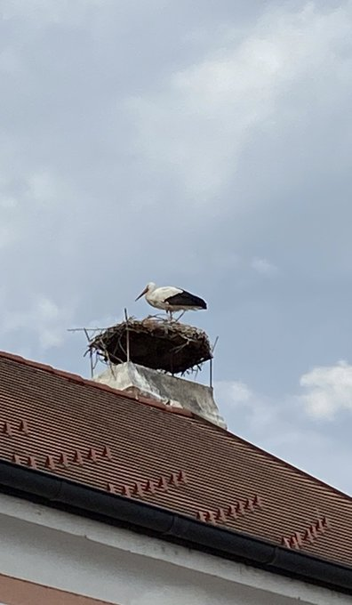 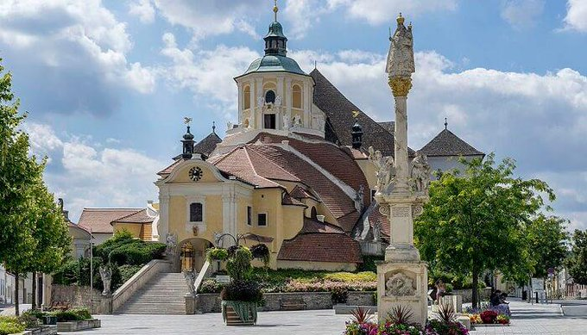 March 30: 100 anniversary of Austria’s province Burgenland (Haydn Kirche) beloging to the Republic of Austria

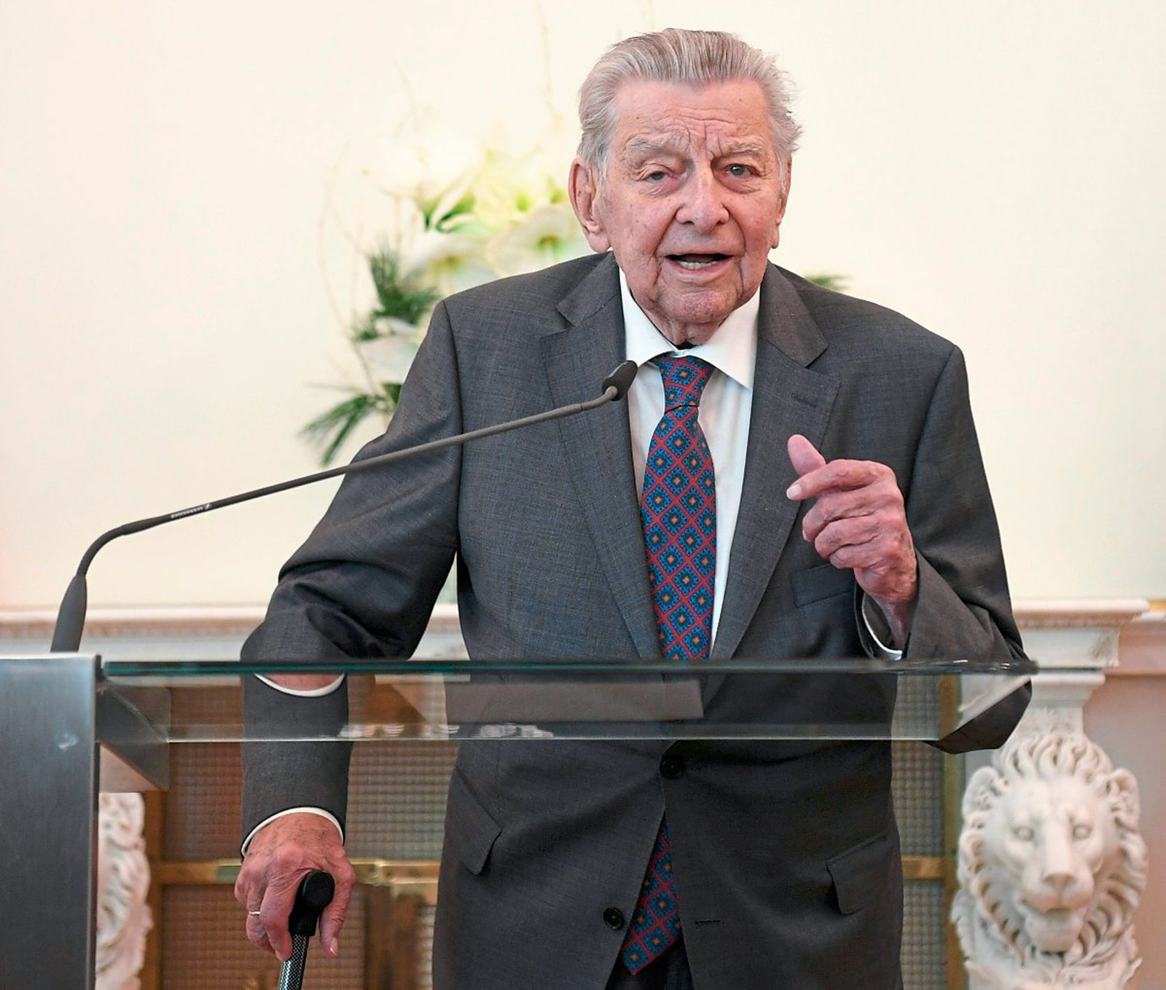 April 1: One of Austria’s most respected Journalist, Hugo Portisch, 95, passed away. He published several books, headed newspaper, was a regular commentator on TV. He emphasized with the common people. Was a vehement anti-Nazi and could bring news in an understandable and sometime humorous form everyone appreciated. He was very active until very recently – he even showcased his vaccination against Covid.
Portisch became known to the general public in the 1960s as the chief political commentator of the ORF (national television). Like no other, he mastered the art of explaining complicated issues in simple terms and conveying knowledge with a high level of competence, but without a raised index finger.
April 6: No direct talks between USA and Iran, but first international Iran Nuclear Deal discussions, including the European, Russian and Chinese and USA, get together in Vienna, Austria.
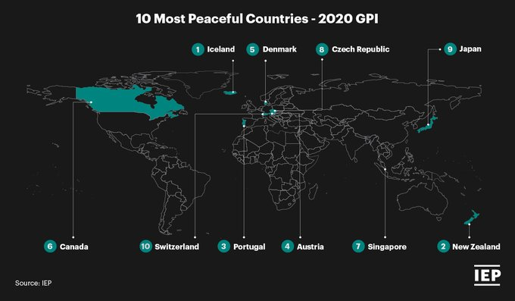 April 7: According to the 2020 Global Peace Index https://www.visionofhumanity.org/maps/#/ , Austria is the 4th most peaceful country in the world! Behind Iceland, New Zealand and Portugal. The United States ranks on 121th place out of 163.
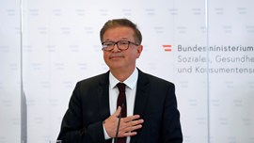 April 13: Austria’s Health minister, Rudolf Anschober, resigned because of health problems and burn out. “The last 15 months felt like 15 years”. He is very respected, and people honored his truthful and measured work in these trying times, wishing him speedy recovery. His successor is the general practitioner Dr. Wolfgang Mückstein who was already working on reforms together with the medical association.
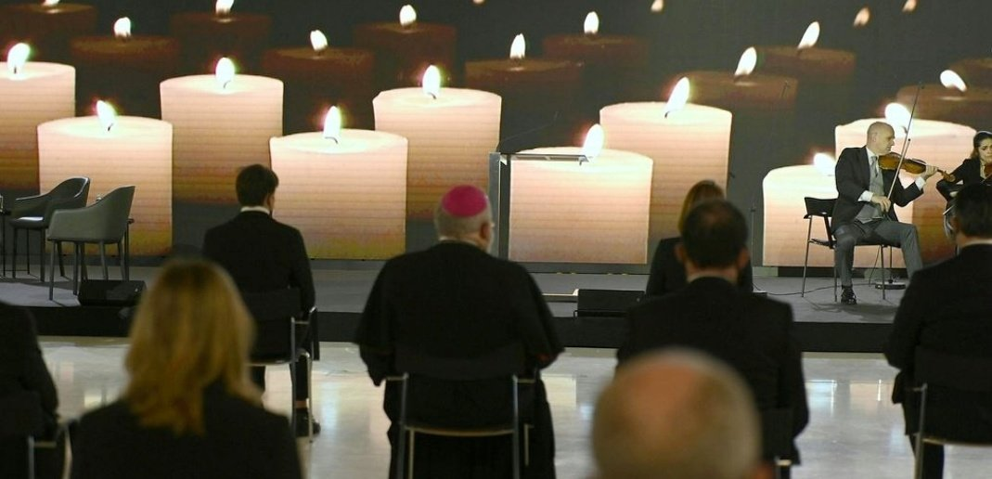 April 16: Austria is mourning its COVID victims today. Almost 10.000 Austrians have lost their lives during this pandemic. “Lassen Sie uns unsere Verstorbenen gemeinsam in liebender Erinnerung im Herzen behalten. Und lassen Sie uns das Leben schätzen.“ "They leave a painful void. Let us appreciate life" President Alexander VanDerBellen.
Wednesday. April 21st, 2021 at 6pm (Vienna time): Industry Roundtable: Spotlight Vienna
The Vienna Business Agency together with AHP International; Co. KG is excited to be hosting an Industry Roundtable focused on “ICT: Spotlight Vienna”.
Register Here at: https://lnkd.in/eTU8eRQ
Vienna is among the largest IT metropolises in Europe; home to leading global companies in LS, ICT, engineering,
Digital media; consumer brands. Vienna’s vibrant techscene is built on one of the strongest talent pipelines in the EU. Being part of the German speaking IT market, no Central European city offers better connectivity into the CEE region.

April 8 -18, 2021: Goethe Pop Up Seattle presents the German Film Selection at the 47th Seattle International Film Festival SIFF streaming on demand through the SIFF Channel: https://www.goethe.de/ins/us/en/sta/gps/ver.cfm?fuseaction=events.detail&event_id=22163137

Saturday, April 24, 2021; 7pm CET = 10am PT : live concert with Katie Mahan (http://katiemahan.de/; she performed the beautiful Mozart Birthday Concert and is currently residing in Salzburg): Beethoven live from Palais Lobkowitz, Vienna. This concert is sponsored by the Honorary Consulate of Austria in Denver. For more information and tickets: https://mailchi.mp/8d269de96658/kathie-mahans-concerts?e=ac2ad447f4
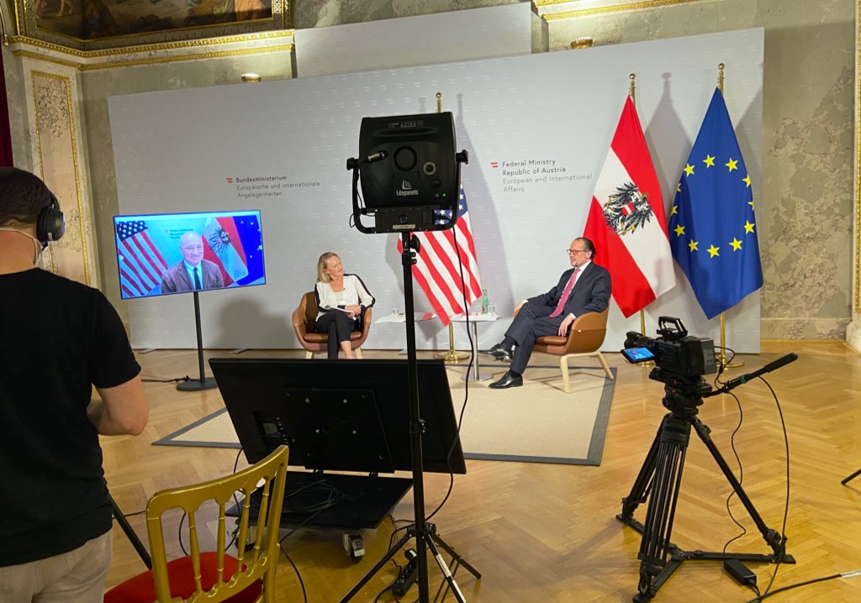April 27: “Digitaler Treff der Auslandsösterreicherinnen und Auslandsösterreicher" in the US. Virtual chat with Austria’s Minister of Foreign Affairs Alexander Schallenberg and Austria’s ambassador in the US Martin Weiss with Austrians Abroad in the USA. Many important questions (at midnight in Austria) were discussed, from dual citizenship (no major changes to be expected), travel restrictions (“green covid pass” in the EU), to standing of Austria in the world.

UPCOMING EVENTS
ViennaUP’21: 27.4.-12.5.2021 : largest decentralized and community-driven virtual start-up-event in Spring 2021 https://viennaup.com/
Initiated by the Vienna Business Agency, ViennaUP ́21 digital brings together all relevant stakeholders – both international and from the local scene – and covers in a series of online events pioneering topics in the field of innovation, creativity and technology. This is a unique opportunity to reach out and connect to a global audience of startups, investors, companies and talents from the comfort of your homes.

Austrian Cultural Forum:
for more information about these upcoming (digital) events: https://acfdc.org/events-2021
April 1-30: Online Concert : Sketchbook Quartet
April 1-30: Online Concert: Trio Artio
April 5-11: Online Film: Davos
April 13-30: Online Reading: After Us the Deluge?
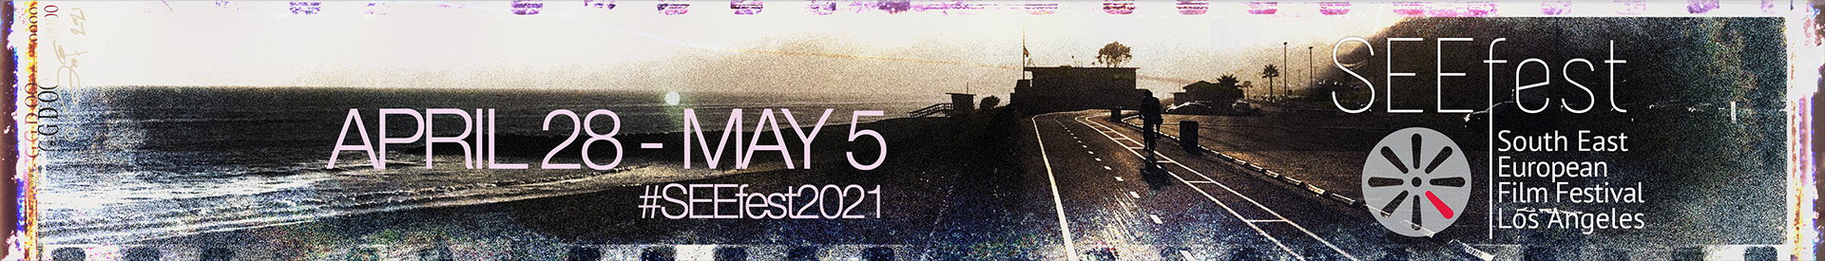April 28 – May 5: SEEfest2021: 16th South East European Film Festival: https://seefest21.eventive.org/welcome
Austria is contributing 3 films: “Glory to the Queen”; “Bitte Warten (Please hold the line); “Quo Vadis Aida”. Enjoy this special movie treats!
Monthly Stammtisch – 1st Thursday of the month: Mark your calendar!!
Virtual STAMMTISCH: Thursday, May 6, 2021: 7 – 9pm:
Hope many of you can join, bring your favorite drink and let’s enjoy time together! There is so much we can talk and chat and laugh about! For any questions, please contact Jürgen Schatzer: juergen.schatzer@gmail.com
zoom link: https://us02web.zoom.us/j/5845087371
MIt herzlichen Gruessen und einem Servus aus Wien!
Eva Kammel
Honorary Consul of Austria in Seattle
office@austrianconsulateseattle.org | www.austrianconsulateseattle.org

