HC of Austria in Seattle – news announcement : exciting new Physics result – April 7, 2021
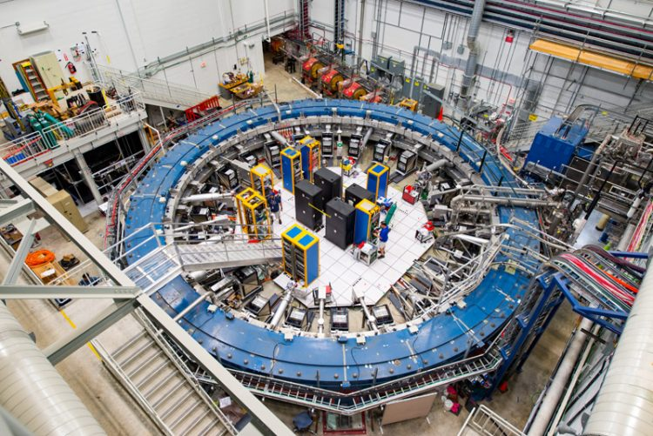

Dear Friends of Austria!

This time I am writing to you to share exciting news that dominates our house today as it concerns my husband and his research group:
today was the release of the first results of the so called muon g-2 experiment, carried out by an international collaboration where my husband, Prof. Peter Kammel (pkammel@uw.edu) as a senior faculty and scientist at the University of Washington in Seattle contributes considerably. The results, if they withstand further scrutiny, would question in a major way the fundamental "Standard Theory" which - since several decades - explains the subatomic world and is the fundamental pillar of particle physics. That explains the excitment and interest in the popular and scientific press!
Of course, there is a whole lot more work to be done to take more data and refine the analysis in the future, together with the world wide effort to sharpen the theoretical predictions.
After the release of the result in the morning the response was astounding, with the web server of Fermilab, the US National Laboraty site which hosts the experiment, overwhelmed during the announcement talk. Here are a few press releases and articles.

University of Washington:
https://www.washington.edu/news/2021/04/07/muon-g-2-first-results/
New York Times:
https://www.nytimes.com/2021/04/07/science/particle-physics-muon-fermilab-brookhaven.html

A vivid explanation can be found here:
https://physics.aps.org/articles/v14/47

My husband has contributed fundamental ideas for the design of the new experiment, countless hours of work, calculations, experimental hardware constructions, and also introduced a next generation of physicists into this topic by guiding his students.

Thank you for listening and sharing this excitement with us!

Herzlichst,
Eva Kammel
Honorary Consul of Austria in Seattle - for WA, ID, MT
Lake Forest Park, WA (new location)
* meetings by appointment only *
Email: office@austrianconsulateseattle.org | Tel: +1-425-395-4382 | www.austrianconsulateseattle.org

